XYZ Powered – IdentityNow Gold Build Configuration Guide

Version 1.0

**XYZ Powered – IdentityNow Gold Build Configuration Guide**

September 2020

______

**Intellectual Property Rights**

© 2020 KPMG LLP. This document contains and reflects KPMG’s proprietary technology, processes, and other information, and is being provided on a confidential basis. No permission is granted to disclose, distribute, copy, excerpt, adapt, modify, or prepare derivative works of this document or its contents. This document is provided as a guide only, and does not constitute a representation or warranty of any kind. Use of KPMG technology is subject to the terms of your license agreement.

kpmg.com

Table of Contents

1 Document Control 4

1.1 Revision History 4

1.2 Document Access Control 4

1.3 Acronyms 4

2 Overview 5

2.1 Summary 5

2.2 XYZ Powered IAM 5

2.3 XYZ Powered Taxonomy 6

2.3.1 Taxonomy Business Requirements 6

2.4 Architecture 18

3 Pre-Configuration 19

3.1 Requesting tenant and getting admin access to IdentityNow 19

3.2 **Setting up virtual appliance** 19

3.3 Setting up IQService 22

4 Configuration 24

4.1 Data Aggregation 24

4.1.1 Authoritative Sources 24

4.1.2 Application Sources 33

4.2 Identity Lifecycle Management 53

4.2.1 Lifecycle Management 54

4.3 Self-Service 62

4.3.1 Access Request 62

4.3.2 Password Management 81

4.4 Account Management 89

4.4.1 Provisioning 89

4.5 Access Review/Certifications 90

4.5.1 Certifications 90

4.6 Governance and Operations 107

4.6.1 Manage Process 107

4.6.2 System Governance 125

4.7 Email Notification 137

4.7.1 Access Requests 138

4.7.2 Certifications 139

4.7.3 User Life Cycle Events 140

4.8 Capabilities/User Permission 141

5 Limitations 143

5.1 Manage Service Account 143

5.2 Target Update 143

5.3 Task & Report scheduling 143

5.4 Process Mover Event 143

5.4.1 Requirement 143

5.4.2 Limitation 143

5.5 Update Application/Access Profile Owner 143

5.5.1 Requirement 143

5.5.2 Limitation 144

6 Appendix 145

6.1 Virtual Appliance Debugging 145

6.1.1 Log Files on the VA 145

6.1.2 VA and Source Configuration Status Definitions 146

6.1.3 Reference Link 147

# Document Control

## Revision History

All revisions of the document must be tracked by identifying a new version number, the date it was modified, the person making the change, and the reason for the change.

| **Version** | **Author** | **Review** | **Reason For Issue** | **Date** |
| --- | --- | --- | --- | --- |
| 0.1 | Ankit Bhandari | - | Initial draft | 05/05/2020 |
| 0.2 | Akshay Kamble | Ankit Bhandari | Updated requirements, pre-configuration, configuration and appendix sections. |  |
| 0.3 | Niharika Gurjar | Ankit Bhandari | Updated requirements, pre-configuration, configuration and appendix sections. |  |
| 0.4 | Ranganatha Thammineni | Ankit Bhandari | Updated requirements, pre-configuration, configuration and appendix sections. |  |
| 1.0 | Jason Wilson |  | Substantive Editing, Formatting, Structure, Technical Validation, etc. | 9/11/2020 |

## Document Access Control

| **Section** | **Access Restrictions** |
| --- | --- |
| All | Restricted XYZ internal team |

## Acronyms

|  |  |
| --- | --- |
| **IDNow/IDN** | SailPoint IdentityNow |
| **DB** | Database |
| **AD** | Active Directory |
| **OOTB** | Out of The Box |
| **VA** | Virtual Appliance |
| **VM** | Virtual machine |
| **NIC** | Network Interface Card |
| **DNS** | Domain Name System |
| **CIDR** | Classless Inter-Domain Routing |
| **SOD** | Segregation of Duties |
| **IP** | Internet Protocol |
| **REST** | Representational State Transfer |

# Overview

## Summary

Enabling access to technology resources in a secure and efficient manner is at the core of a strong cyber security program. An organization must provide its workforce (employees, contractors and business partners) with the required access to securely enable business operations and collaboration. The purpose of this document is to provide business use cases for a Client’s Identity and Access Management program that enable an organization to provide its workforce with required access.

The content of these use cases is based on client requirements, industry best practices, and the experience of XYZ at many clients. XYZ applies the following guiding principles to use cases definition:

* Positive user experience
* Reduction of risk
* Automation of processes
* Reduction in manual processes
* Operational efficiency
* Simplicity

## XYZ Powered IAM

This solution is based on XYZ’s *Powered* methodology which includes an accelerated, smarter way to achieve Identity and Access Management (IAM) transformation goals. XYZ’s Powered Identity Governance solution enabled by SailPoint IdentityNow (IDN), helps clients to accelerate their identity governance transformation projects. It brings leading practice operating models, process flows, role profiles and a standardized SailPoint IdentityNow configuration ready for validation. The result is an accelerated delivery, at lower risk, with pre-built templates to help launch the program with a higher degree of certainty and success.

This section describes the scope, in accordance with the XYZ powered IdentityNow.

## XYZ Powered Taxonomy

XYZ’s powered process taxonomy contains detailed process flows which we will review and validate applicability with client. Each tile below has a functional requirement and the configuration details in this document.

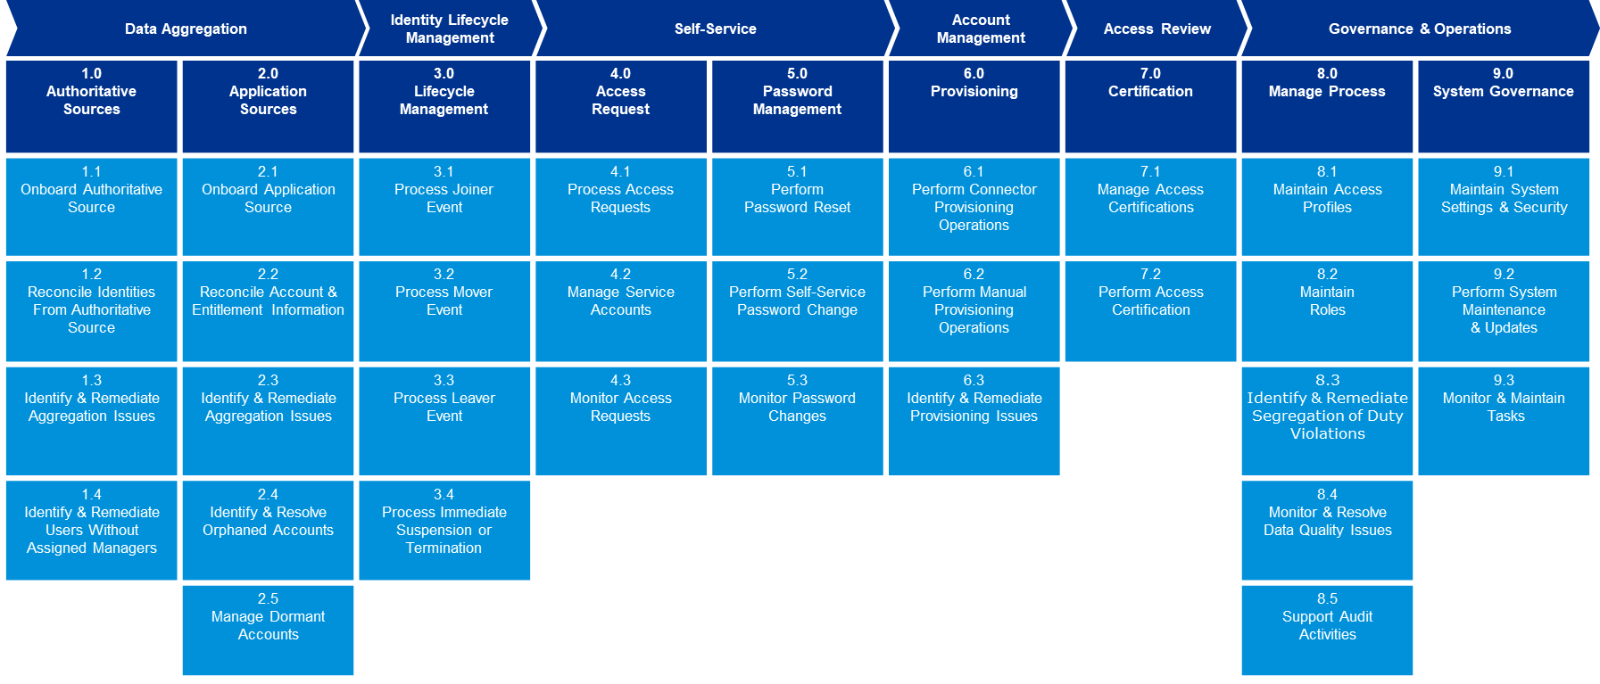

### Taxonomy Business Requirements

This section captures all the business requirements for an IDN implementation. Requirements include:

* IDN integration with authoritative and target applications
* Joiner, mover, and leaver user cases
* Certifications
* Self-service access requests

| Requirement ID | Requirement Description |
| --- | --- |
| 1.0 Authoritative Source | |
| AU-SRC-01 | **1.1 Onboard Authoritative Source**: Integrate with authoritative HR systems in IDN and aggregate the user data.   * Configure the HR system as an authoritative source containing all the required identity attributes in a feed file. * HR data should contain user details like first name, last name, email, address, location, department, user status. Refer to the table below. * Configure an Identity Profile and map the attributes from the HR data * Configure Manager Correlation through the use of the /beta/sources API. * The following table represents the mapping of SailPoint IDN and HR attributes  |  |  | | --- | --- | | HR Attribute | Description | | Account Name | Unique ID setup with each user that allows login | | Email | Email associated with the user | | LastName | User Last Name | | FirstName | User FirstName | | City | City of User | | Cost Centre | Department or function from where user operates | | Country | Country of user | | Department | Department Name of user | | Display Name | User’s Full Name | | Employee ID | Unique ID for the user | | TerminationDate | Last date of user in organization. | | HR Status | User’s current lifecycle state (Active/loa/Terminated) | | JobCode | User’s position code in organization. | | JobTitle | User’s job or position in organization | | Location | User Location | | ManagerID | User’s manager Id | | manager | User’s manager name | | MiddleName | User middle name | | Postal Code | User’s ZIP code | | HireDate | Start date of user in organization | | State | State of user | | WorkAddress | User’s working/organization address | | WorkPhone | User’s work phone number | | WorkerType | Worker category of user | | LocationID | Identifier that uniquely identifies user’s location |   Table 1: Identity Attribute Mapping Table |
| AU-SRC-02 | **1.2 Reconcile Identities from Authoritative Source**:   * Configure and reconcile the data from HR source * A full aggregation of the identity hub will be scheduled at least once a day to aggregate new users, and to identify potential movers and leavers. |
| AU-SRC-03 | **1.3**  **Identify & Remediate Aggregation Issues**:   * Configure **Source Activity** report and execute the report to export aggregation activities * Identify aggregation issues and remediate them |
| AU-SRC-04 | **1.4**  **Identify & Remediate Users Without Assigned Managers**:   * Search for the identities who doesn’t have managers and update the manager. |

| Requirement ID | Requirement Description |
| --- | --- |
| 2.0 Application Sources | |
| APP-SRC-01 | **2.1 Onboard Application Source**: Integrate with target systems in IDN and aggregate the user data.   * Configure the target application using the appropriate IDN connector (Ex: Delimited File Connector). * Application data should contain user details like first name, last name, email, address, location, department, user status, etc. * Configure an application data attributes. * Configure the correlation through the use of the /beta/sources API. |
| APP-SRC-02 | **2.2 Reconcile Account & Entitlement Information**:   * Configure and reconcile the data from target application * Full aggregation will be scheduled at least once a day to aggregate and sync the data between IDN and the application |
| APP-SRC-03 | **2.3 Identify & Remediate Aggregation Issues**:   * Configure **Source Activity** report for aggregation activities and execute the report to identify the aggregation issues. * Identify aggregation issues and remediate them |
| APP-SRC-04 | **2.4 Identify & Resolve Orphaned Accounts**:   * Search for the orphan identities and resolve them |
| APP-SRC-05 | **2.5 Manage Dormant Account**:   * Identify the dormant accounts through search query * Take the appropriate action on the dormant accounts |

| Requirement ID | Requirement Description |
| --- | --- |
| 3.0 Lifecycle Management | |
| HR-LCM-01 | **3.1 Process Joiner Event**  When a user joins the firm, IDN identifies the newly onboarded user and creates a record in IDN and provisions birthright access.   * HR enters the user information into the HR System. * IDN identifies and aggregate the new user from HR system. * IDN creates the user record based on the data received from the HR System. * IDN populates all the required user information like Employee ID, Account Name, Display Name, First Name, Last Name, Email, manager, HR Status, Hire Date, Location, City, etc. * The IDN assigns birthright access and provisions the accounts to the target system based on job function (employee type, department, location or other attributes) associated with the identity. |
| HR-LCM-02 | **3.2 Process Mover Event**  When the user moves from one job function to another, IDN identifies the changes and assigns the accesses based on new job function while removing accesses which are no longer needed.   * HR changes the user’s job function (Role, Title, Manager or Department) in the authoritative system based on the inputs from Manager or other reliable source * IDN aggregates the user changes in HR system and updates the user record based on the data received from the authoritative system. * IDN assigns and provisions the user accesses based on the new job function. * IDN removes and de-provisions the user accesses based on the old job function which are no longer needed |
| HR-LCM-03 | **3.3 Process Leaver Event**:  When the user leaves the firm, user is terminated in IDN and in all target systems   * HR terminates the user in HR system based on the inputs from Manager or other reliable source. * IDN identifies the user termination in HR system and update the employee status and termination date in IDN. * IDN triggers the leaver event and terminate the user end of the business day on user’s termination date.   IDN disables the user account in all target accounts. |
| HR-LCM-04 | **3.4 Process Immediate Suspension or Termination**:  User is terminated, and access is removed immediately.  **Note**: User could be active or on LOA.   * HR, or Manager initiates a request to an IDN Administrator for an immediate termination in IDN system * Administrator performs the immediate termination in IDN which terminates the user in IDN and disables the user account in all target accounts. |
| HR-LCM-05 | **Process Leave of Absence – LOA**: When the Active user goes on LOA, user’s AD account is disabled while the identity and other target systems still be active.   * HR systems changes the user’s HR status from **Active** to **LOA**. * IDN identifies the change in HR system and triggers the LOA event * IDN processes the LOA event and disables the AD account |
| HR-LCM-06 | **Process LOA Return**: When the user returns from LOA, user’s AD account is enabled.  **Note**: Identity and other target systems are already active and no changes are made.   * HR changes the user’s status from “LOA” to “Active” in HR system * IDN identifies the change and triggers the LOA Return * IDN processes the LOA Return and enables the AD account |

| **Requirement ID** | **Requirement Description** |
| --- | --- |
| 4.0 Access Request | |
| ACC-REQ-01 | **4.1 Process Access Request:**   * A common platform will be provided to support access requests for applications and entitlements that are configured as “requestable”. This functionality should allow users to request access either for themselves or for another user. * All in-scope applications or roles will leverage the native IDN interface for access requests. * Entitlements data file should be aggregated in the IDN system for the requestable applications. If manager is not specified, approvals should default to the application owner |
| ACC-REQ-02 | **4.2 Manage Service Account**   * Identify and mark the service accounts in IDN from the in scope target systems (applications that manage service accounts) * Certification of the service accounts. |
| ACC-REQ-03 | **4.3 Monitor Access Request**   * Once the access request is raised, If the request is rejected by any of the approvers, the workflow should be cancelled, and no further action is performed. * Managers and Application Access Administrators will receive a reminder to act on open access requests every 7 days. * If Approvers rejects the request, the IDN system marks the request as rejected, notifies the user, and access will not be assigned. * Manager (or the application owner where applicable) can re-assign the request from the Approvals page * If Approvers approves the request, the IDN system initiates the request to provision the access for the user. * If access requested for another user, a notification is sent to the user containing details about the request submitted on their behalf. * Once the manger (or the application owner where applicable) approves a request for a disconnected application, work items will be assigned to the application access administrator for manual fulfillment. * Once the manger (or the application owner where applicable) approves a request for a connected application, automatic provisioning will happen in target system. * The application administrators provision the requested accounts and/or access and mark the provisioning ticket as complete. * The IDN system aggregates data from the target application and verifies that the requested access has been provisioned for the user. * The IDN system updates the status of the provisioning to “Complete”. |

| **Requirement ID** | **Requirement Description** |
| --- | --- |
| **5.0 Password Management** | |
| PWD-MGMT-01 | **5.1 Perform Password Reset**   * If user forgets the password, he utilizes the Forgot Password feature provided by IDN in order to reset their password. * User initiates password reset by selecting the ‘Problems signing in?’ link on the IDN login page. |
| PWD-MGMT-02 | **5.2 Perform Self-Service Password Change**   * User should be able to self-request for his IDN or Application password change. * User should validate the authentication question/answers and changes the password as per password policy and IDN should changes the password in IDN. |
| PWD-MGMT-03 | **5.3 Monitor Password Changes**   * After password change, user should receive an email notification of User Password Change Successfully done. * IDN system should generate an Audit report for password change for all users at a specified frequency (ex: 1, 3, or 7 days). |

| **Requirement ID** | **Requirement Description** | |
| --- | --- | --- |
| 6.0 Provisioning | | |
| PROV-01 | | **6.1 Perform Connector Provisioning Operations**   * Load accounts and entitlements from at least one source in to IDN system and at least one access profile should be associated with it. * An application should be configured to IDN that can grant the application accounts to users. * A Create Profile and an application should be configured for a source that needs to be requested. * Provisioning and Access Requests should be set up for the IDN tenant. |
| PROV-02 | | **6.2 Perform Manual Provisioning Operations**   * The IDN System notifies the application administrators that an account or an access request requires manual provisioning. * The application administrators provision the requested accounts and access and mark the provisioning ticket complete. |
| PROV-03 | | **6.3 Identify & Remediate Provisioning Issues**   * Download Reports by configuring a search query from IDN system. * Troubleshoot and remediate provisioning issues |

| **Requirement ID** | **Requirement Description** |
| --- | --- |
| 7.0 Certification | |
| CERT-01 | **7.1 Manage Access Certification**   * Source Owner Certification * A source owner has been selected for all sources that needs to certify. * Before beginning the certification campaign, review the source configuration to verify that the appropriate person is identified as the source owner. * Manager Based Certification * Validate that all identities have a manager defined in IDN before creating a manager certification campaign. * Please note that campaigns are generated as a snapshot in time, so managers added after a campaign is generated will not apply. * Managers are only required to certify accounts that have been correlated to an identity of a user who reports to them. * All uncorrelated accounts will not be a part of certification campaign * Managers can delegate (re-assign) an access review to anyone in the system. * Application owners can elect to delegate (re-assign) to anyone in organization. |
| CERT-02 | **7.2 Perform Access Certification**   * Managers and Application Owners will have to take an action on a certification line item within due date. * The Manager/Owner certification completes the review by marking each piece of access as “Approve” or “Revoke” * The solution must notify the end user, his or her manager when an end user’s access to an application/system has been approved or revoked. * IDN shall send out periodic reminders (every 7 days) when the owners have pending certifications. * The notification should include a hyperlink that will automatically direct the owner to IDN action item. * Both manager and application owner can generate and download the following reports: * Campaign Composition Report - Describes the configuration of the certification campaign, including the name, description, due date, email settings, and campaign filter used for any certification campaign. This report is not available for campaigns that use exclusion rules created by SailPoint support. * Campaign Status Report​ - Contains the status of all access items in the campaign. * Campaign Remediation Status Report​ - After an administrator has completed a campaign, this report becomes available. It contains the current state of any items that were disapproved during the certification campaign. * Certification Sign Off Report​ - Lists each active and completed certification. Certifications that have been approved are listed at the top of the report and include the reviewer and the date they signed off on the certification. |

| **Requirement ID** | **Requirement Description** |
| --- | --- |
| 8.0  Manage Process | |
| MNG-PRO-01 | **8.1 Manage Access Profiles**   * Provisioning must be enabled and set up for organization’s IDN tenant. * All in-scope applications or roles will leverage the native IDN interface for access requests. * Load accounts and entitlements from at least one source in the IDN system. |
| MNG-PRO -02 | **8.2 Maintain Roles**   * A Role Owner receives an email notification of a pending Access Review. * The Role Owner completes the review by marking each piece of access “Acknowledge”. |
| MNG-PRO-03 | **8.3 Identify & Remediate Segregation of Duty Violations**   * The application owner will define and document entitlement level and account level System of Duties (SoD) Policies in the IDN system in the form of Search Queries. * IDN should provide a user interface to review and process SoD policy violations. When the user is requesting access, IDN will not indicate that the request violates a policy. * The Policy owner should launch appropriate certification campaign to revoke the violating access. * The Policy owner (or Access Admin) can generate reports for the SoD violations in form of csv files * Create subscriptions in IDN and set up for proactive governance. Configure subscriptions in IDN to generate automatic emails on a regular schedule that contain the results of a SoD policy or search query. Define the frequency of the email’s notifications. * The Policy and Violation owner will receive an email with the details of the user who violates any defined SoD Polices |
| MNG-PRO-04 | **8.4 Monitor & Resolve Data Quality Issues**   * Uncorrelated accounts refer to accounts that did not aggregate from authoritative source into IDN. * To resolve uncorrelated accounts, download the list of uncorrelated accounts, edit it to match those accounts with existing users, and then import the changes. * Identity exceptions usually occur if an account on that source is missing values for one or more attributes that an identity requires, IDN generates an identity exception. * Required attributes include:   + uid   + email   + lastname * Download and review the report to resolve an identity exception |
| MNG-PRO-05 | **8.5 Support Audit Activities**   * All IdentityNow audit activity can be found in Search. Download several readily available audits reports or download a custom report by modifying the search query. * Following default audit reports are available for download from Search: * **All Events** - All activity that IdentityNow tracks in audit events. * **Access Request Activity** - All activity related to access requests. * **Authentication Activity** - Events related to any kind of authentication, including into IdentityNow and into apps. * **Password Changes** - All password updates, including for apps, sources, and IdentityNow. * **Provisioning Activity** - See a basic audit report of provisioning events. * **All Source Activity (Non-Provisioning)** - All activity on all sources, not including provisioning activity. * **SSO Activity** - A report of all recent SSO activity. * The admin dashboard contains at-a-glance information about recent activity. * On the admin dashboard, following features are available depending on the services that were purchased including System Activity, System Components Status, Org Details, To Do Tasks etc. |

| **Requirement ID** | **Requirement Description** |
| --- | --- |
| 9.0  System Governance | |
| SYS-GOV-01 | **9.1 Maintain System Settings & Security**   * IDN should provide a user interface to review and process Branding and Logo. * IDN should provide a user interface to review and process Blacklist and whitelist countries. Blacklisting defines the countries that the organization considers untrusted. * IDN should provide a user interface to review and process whitelist countries. Whitelisting defines the countries that the organization considers trusted. * When a user's IP address is in a country that is designated as untrusted, it is possible to either: * Require strong authentication * Prevent the user from launching certain apps altogether * Prevent the user from signing in to IDN at all * Configure IDN to send an email notification when certain components of the organization aren't working properly. These emails can be customized to meet the needs of the organization for the following: * Applications * Identities * Sources * Virtual Appliance * Configure IDN to send an email to specific users. Following are the options available: * All SailPoint Admins - The notification is sent to the work email address of all users in the system with access to the Admin interface. * Specific Users by Email - The notification is sent to the specified email addresses. * IDN system allows users to answer security questions as a form of strong authentication. This might be appropriate for password resets or step-up authentication for apps that require it. * IDN system allows users to setup Pass-through authentication (PTA), for users to sign in to IDN using their network password. * IDN system allows users to setup Integrated Windows Authentication (IWA) for SSO (Single Sign-On) experience for all users' Launchpad apps without the need to enter a separate SailPoint password. |
| SYS-GOV-02 | **9.2 Perform Maintenance & Updates**   * For IDN system maintenance and updates, contact SailPoint Service Expert Team |
| SYS-GOV-03 | **9.3 Monitor & Maintain Tasks**   * Download Reports by configuring a search query from IDN system |

| **Requirement ID** | **Requirement Description** |
| --- | --- |
| **Email Notifications** | |
| EM-NOT-01 | **Access Request Decision email template**:  The IDN system must notify the end user, his or her manager when an end user’s access to an application/system has been approved or revoked through. |
| EM-NOT-02 | The IDN system must notify the user’s assigned manager when a user is terminated and disabled in Active Directory. |
| EM-NOT-03 | The IDN system must notify the appropriate assignees when a work item is generated for them. |
| EM-NOT-04 | Upon submission of an access request, the solution must send notifications in the following cases:   * Rejection of a request * Fulfillment of a request |
| EM-NOT-05 | IDN shall send out periodic reminders through *Certification Due* email template (7 days before and on the day the certification cycle ends) when users have pending certifications. |
| EM-NOT-06 | The notification should include a hyperlink that will automatically direct the user to IDN action item. |

| **Requirement ID** | **Requirement Description** |
| --- | --- |
| **User Permission** | |
| UP-01 | Configure a search-based certification and an email notification should go to respective owner when the certificate campaign is launched. |
| UP-02 | Configure IDN, when any user lifecycle state change to active, loa or terminated then lifecycle state change email notification should go to his manager. |
| UP-03 | Configure IDN, when any Access Request generate for a user then approval email notification will go to Users Manager and Access Profile Owner. |

## Architecture

The Architecture diagram is a high level overview of the different capabilities offered by IDN. It shows how IDN is integrated with different applications. **Virtual appliance** is the interface between IDN and the target applications.

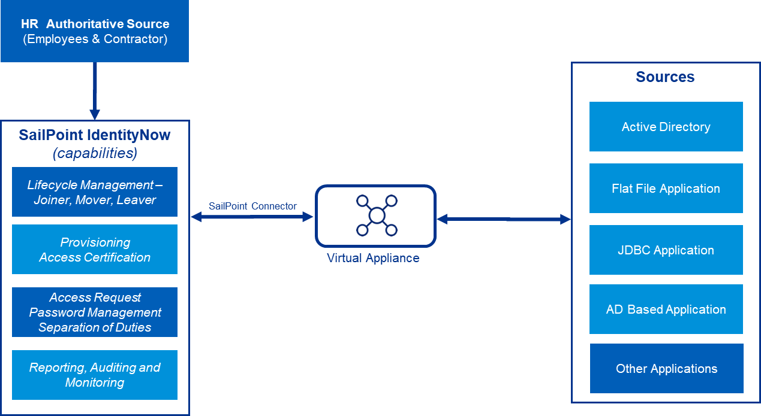

Figure 1: Architecture Diagram

# Pre-Configuration

## Requesting tenant and getting admin access to IdentityNow

1. To get started, ask the SailPoint account manager to provision an IDN tenant.

* By default they will add one application to the tenant and onboard one administrator from client, who can further configure and onboard team members.
* For any organization by default there will be two tenants provided by SailPoint, one for dev/test environment and other one will be production.
  1. **Setting up virtual appliance**

A Virtual Appliance (VA) is a Linux-based virtual machine that connects to sources and apps using APIs, connectors, and integrations available from SailPoint. While SailPoint doesn’t connect directly to the VA, each VA must be able to make continuous outbound-only calls to the cloud environment to execute actions such as installing patches and updating images

Begin by deploying a Virtual Appliance:

1. To download the virtual appliance package, click the following link:

**https://sppcbu-va-images.s3.amazonaws.com/va-latest.zip.**

1. Unzip the package and copy the files to the virtualization platform. Follow the standard process for platform.
2. Start the VM.
3. Sign in to the VM. The username is SailPoint and the password is *****.
4. Change password immediately as follows:
   1. At the command prompt, type **password**.
   2. Enter the current password *****.
   3. Provide a new password.
   4. Repeat the new password.
5. As a leading practice, set a static IP address for virtual appliance:
   1. First find the name of virtual NIC card for VA:
      1. In the command line, type ***ip addr***
      2. From the list of virtual NICs displayed, find the correct one.

**NOTE**: All virtual NIC names are dynamically assigned upon initial VA creation so one will need to perform this step for each VA to enter the right name into static.network file in the steps that follow.

* 1. Next edit the static.network file:
     1. Open the file **sudoedit /etc/systemd/network/static.network**
     2. Enter the following:

*[Match]*

*Name=<****NICname****>*

*[Network]*

*DNS=<DNS>*

*Address=<IPaddress and* ***CIDR****>*

*Gateway=<Gateway>*

where:

* **NICName** is the NIC card from step a above and the values under Network are the specific to VA's IP address.
* **CIDR** in the Address field is required if one want to set a subnet mask

1. Disable the ESX DHCP bump service: *sudo systemctl disable esx_dhcp_bump.service*
2. Reboot the VA: *sudo reboot*

**Create Virtual Appliance instance in IdentityNow:**

1. Sign into SailPoint IDN as an admin.
2. Point to the **Admin** menu, click **Connections**, then click **Virtual Appliances**.

The **Virtual Appliance** tab displays.

1. Click the **+New** button to create new VA and type a Name for the new VA (for example **IDN Powered**).

The **Virtual Appliance** is created.

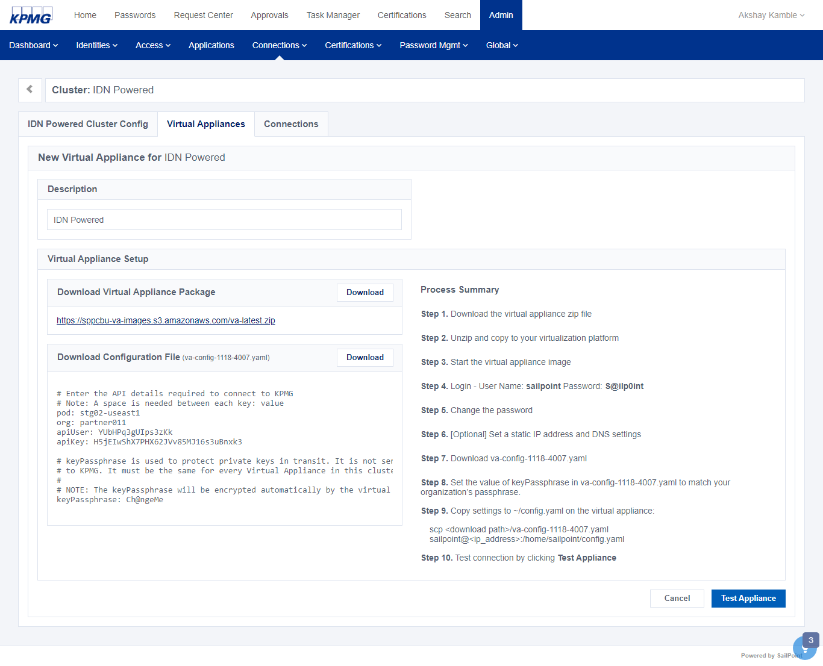

**Figure 2: Virtual Appliances Configuration Tab**

1. Make a note of the user name (**SailPoint)** and the password shown in the **Process Summery** section
2. Click the **Download** button in the **Virtual Appliance Setup** section to download a VA package.
3. Unzip the VA package using preferred utility.
4. Copy the unzipped VA package it to the virtualization platform following the standard process for platform.
5. Start the VM by and Log into the VM using the credentials noted above.

The VM displays a command prompt.

1. Change password immediately as follows:
   1. At the command prompt, type **password**.
   2. Enter the current password **\*\*\*\*\*.**
   3. Provide a new password.
   4. Repeat the new password.
2. From the IdentityNow **New Virtual Appliance** screen, click the **Download** button in the **Download Configuration Files** section.

The va-config-<va_id>.yaml file is downloaded to your workstation.

1. The full contents of the file displays. To access to a virtualization environment, create the **va-config-<va_id>.yaml** file by copying the contents to a text document. Save the file as **va-config-<va_id>.yaml** . Send it to a user who has access.

**Note**: Do not leave this page until the download and configuration process is complete.

1. Once the download and configuration is complete,click the **Test Appliance** button.

**Note**: Each.yaml file is unique and cannot be reused by other virtual appliances. Copying this file to workstation might result in a file with a.txt extension.

1. To communicate to the VA using TLS, see TLS Configuration on Virtual Appliances​.
2. Open ***va-config-<va_id>.yaml****.*
3. Change the value of keyPassphrase from **_ch@ngeMe_** to a unique value for organization.
4. On workstation, find the ***va-config-<va_id>.yaml*** file and copy it to the VM, using **scp**, as follows:
5. Find the IP address for the VA by running *ifconfig -a*
6. Copy the file by running the **scp** command on local workstation, as follows: **scp** <download_path>/va-config-<va_id>.yaml [SailPoint@<ip_address>:/home/SailPoint/config.yaml](mailto:SailPoint@%3cip_address%3e:/home/SailPoint/config.yaml)

* The **download_path** is the location of config.yaml on workstation.
* The **ip_address** is the IP address of the virtual appliance.

**NOTE:** Rename the file to config.yaml as it is required copy the file.

1. In **IdenityNow**, click **Test Appliance** to complete and validate the configuration.

**Note:** Clicking Test Appliance is required to use the credentials generated by this process. For assistance with test results, see Virtual Appliance and App Source Configuration Status Definitions.

**Figure 3: Virtual Appliances Configuration Success**

1. Monitor the state of the appliance from the **Virtual Applications** page. A status of **Connected** is required. Refer to the Virtual Appliance Reference Guide​ for detailed instructions.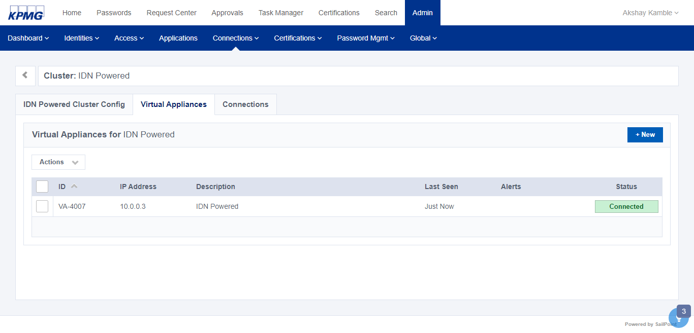

**Figure 4: Monitor State of VA**

**Note**: Compass ref: https://community.SailPoint.com/t5/Connectors/Local-Virtual-Appliance-Deployment-with-vSphere/ta-p/73919

## Setting up IQService

1. Sign into SailPoint IDN as an admin.
2. Point to **Admin**, click **Connections** and then click **Sources**.
3. Click a source that requires IQService. e.g. Active Directory
4. Find the panel labeled IQService or Integration Service.
5. Click **Download**.

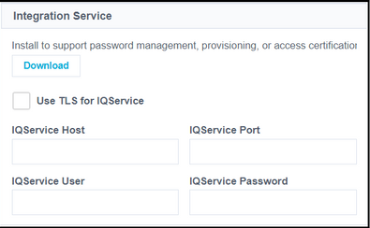

Figure 5: Download IQService

1. Unzip the downloaded **IQService.zip** archive into the created or desired location. For example, *C:\SailPoint\IQService*
2. To install IQService to communicate with IDN on a TLS and Non-TLS port execute the following command: ***IQService -i -p <Non-TLS Port> -o <TLS port>***

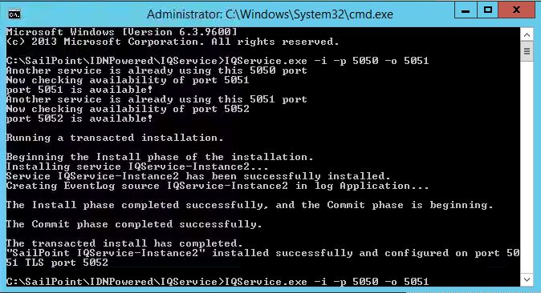

Figure 6: IQService Configuration

1. Registry Keys: The ***IQService.exe -i*** command installs and registers the service with the new registry path ***HKEY_LOCAL_MACHINE\SOFTWARE\SailPoint\IQService Instances\IQService-Instance1***
2. Start the service either from the Services Applet or from the command line by running the following command: ***IQService.exe –s***

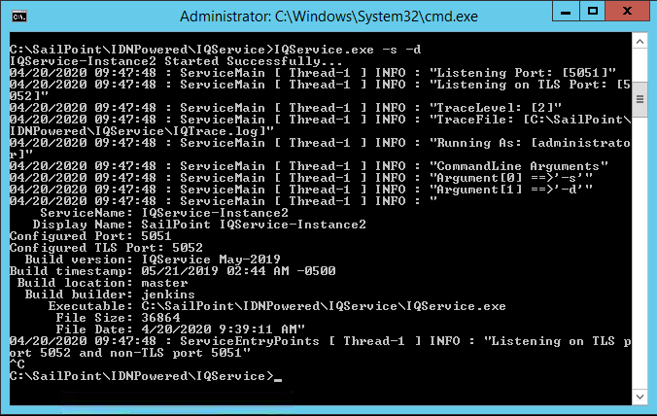

Figure 7: Start IQService

1. To set the log levels for IQService, type the following command:

***iqservice -l 3 -f “C:\SailPoint\IQService\iqtrace.log"***

# Configuration

This section covers the configuration details for the business requirements in IDN.

## Data Aggregation

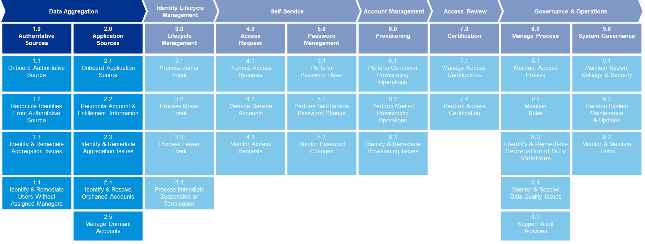

**Powered 1.0** Authoritative Sources

### Authoritative Sources

This section details the IDN integration with authoritative HR systems, user aggregation, and remediate the user aggregation and data issues (ex: users without managers).

#### Onboard Authoritative Source

**Powered 1.1**

##### HR Source Configuration

1. Sign into SailPoint IDN as an admin.
2. Point to **Admin**, click **Connections**, then select **Sources**

The **Sources** screen displays.

1. Click the **+New** button to create a new **Delimited File** source and enter details below:

|  |  |
| --- | --- |
| Name | *Value* |
| Source Type | *Delimited File* |
| Source Name | HR Source |
| Description | *Authoritative Source* |
| Source Owner | *<Select an Identity>* |

Table 2: Create Source Details

1. Click **Continue**.

The following configuration page displays

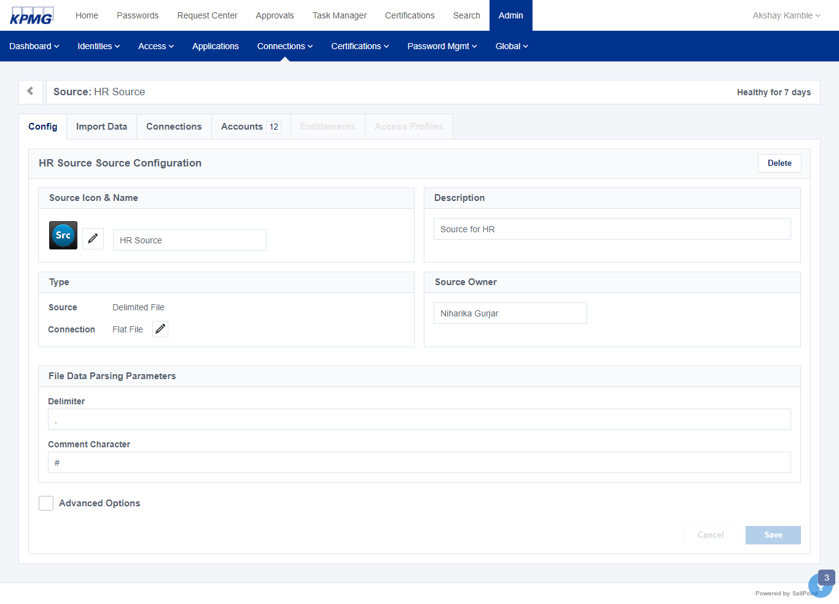

Figure 8: Authoritative Source Config Page

##### Manager Correlation Configuration

IDN doesn’t provide a **Manager Correlation** **Configuration** option. Manager correlation can be performed by using the /beta/sources API.

1. Use the following API's to get the Source ID :

**Get Source List :**

* 1. Open any REST API executer tool like ‘Postman’ and use the following API to get source list.

*GET -* [*https://orgName.api.identitynow.com/beta/sources*](https://orgName.api.identitynow.com/beta/sources)

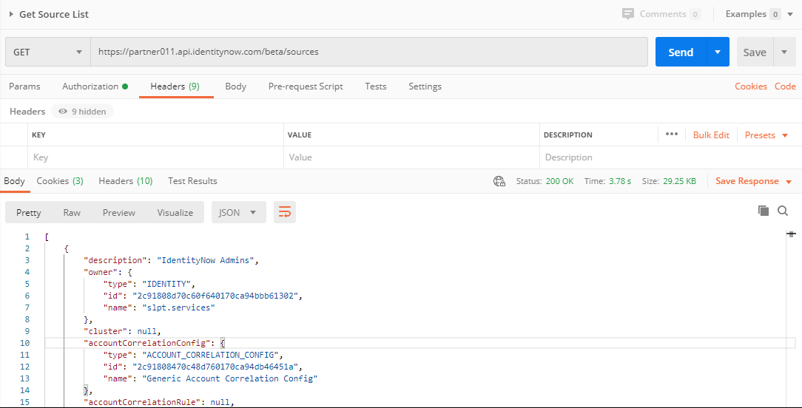

Figure 9: Get Source List

* 1. Copy the source ID from the **accountCorrelationConfig** section (For example: *2c91808470c48d760170ca94db46451a*) and paste it in the patch request as shown in step 4.

1. Update the Manager to associate it with data coming from the authoritative source and IDN.

|  |  |
| --- | --- |
| IDN Attribute | Account Attribute |
| uid | *manager* |

Table 3: Manager Correlation Attribute

* 1. Request Type and URL:

**PATCH** - <https://orgName.api.identitynow.com/beta/sources/3c236589741cbe5d5589n10g193f7789>

***Header****: Content-Type is application/json-patch+json*

***Body****:*

*[*

*{*

*"op": "replace",*

*"path": "/managerCorrelationMapping",*

*"value": {*

*"identityAttributeName": "uid",*

*"accountAttributeName": "manager"*

*}*

*}*

*]*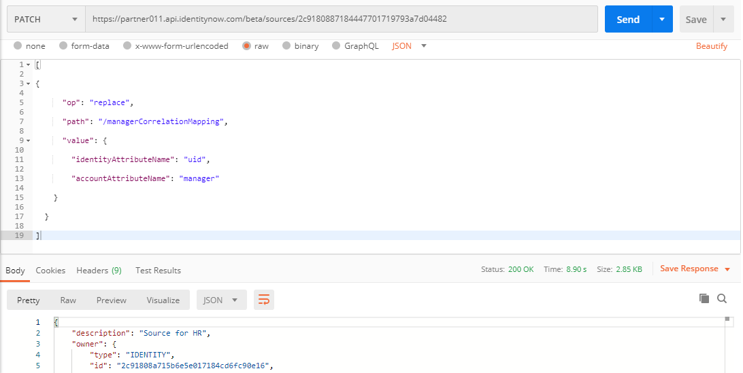

Figure 10: Set Manager Correlation

#### Reconcile Identities from Authoritative Source

**Powered 1.2**

1. Go the **Import Data** tab of **HR** **source** and validate the **Account Schema.**
2. Check that the correlation rules have been set as below in the **Correlation** option:

|  |  |
| --- | --- |
| IDN Attribute | Account Attribute |
| XYZ User Name | *Employee ID* |

Table 4: Account Correlation Attribute

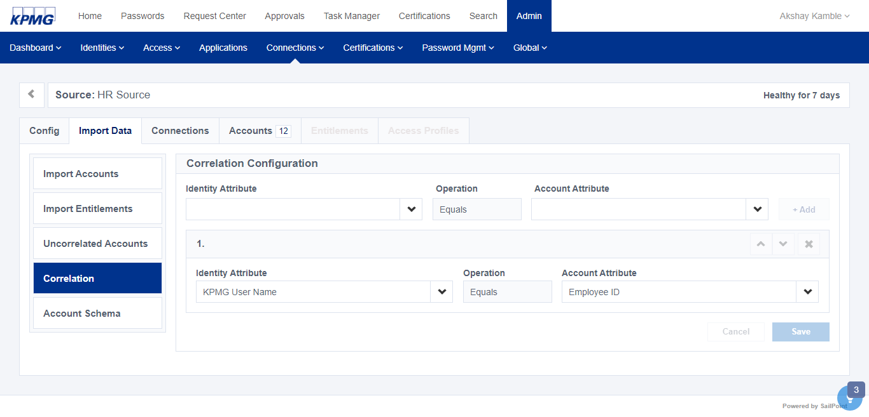

Figure 11: Correlation Configuration for Authoritative Source

1. Before starting the **Account Aggregation,** configure the **Identity Profile** for **HR Source** to map user account attribute with IDN attribute. From the **Admin** menu, point to **Identities** and select **Identity Profiles.**
2. Click +**New** to create new Identity Profile and enter below details.

|  |  |
| --- | --- |
| Name | Value |
| Name | *HR Source Identity Profile* |
| Account Source | *HR Source* |

Table 5: Create Identity Profile Details

1. On the same screen, click the **Mappings** tab to create a mapping for the HR Source using the followng values.

|  |  |  |
| --- | --- | --- |
| IDN Attribute Name | IDN Attribute Technical Name | HR Attribute |
| IdentityNow Username | **uid** | *Account Name* |
| Work Email | **email** | *Email* |
| Last Name | **lastname** | *LastName* |
| First Name | **firstname** | *FirstName* |
| Account Name | **accountName** | *Account Name* |
| City | **city** | *City* |
| Cost Center | **costCenter** | *Cost Centre* |
| Country | **country** | *Country* |
| Department | **department** | *Department* |
| Display Name | **displayName** | *Display Name* |
| Employee Number | **identificationNumber** | *Employee ID* |
| End Date | **endDate** | *TerminationDate* |
| HR Status | **hrStatus** | *HR Status* |
| Job Code | **jobCode** | *JobCode* |
| Job Title | **jobTitle** | *JobTitle* |
| Lifecycle State | **cloudLifecycleState** | *HR Status* |
| Location | **location** | *Location* |
| Manager ID | **managerId** | *ManagerID* |
| Manager Name | **manager** | *manager* |
| Middle Name | **middleName** | *MiddleName* |
| Mobile Number | **mobileNumber** | *WorkPhone* |
| Postal Code | **postalCode** | *Postal Code* |
| Start Date | **startDate** | *HireDate* |
| State | **state** | *State* |
| Work Address | **workAddress** | *WorkAddress* |
| Work Phone Number | **workPhone** | *WorkPhone* |
| Worker Type | **workerType** | *Worker Type* |
| location ID | **locationId** | *LocationID* |

Table 6: Identity Attribute Mapping

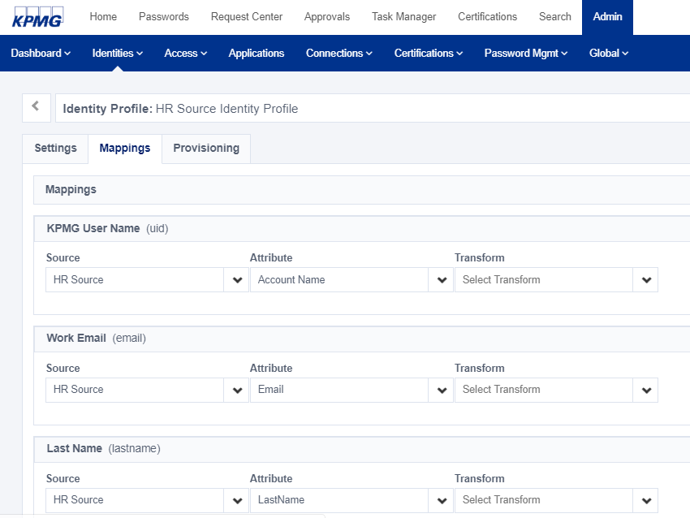

Figure 12: Sample Identity Attribute Mapping Page

1. Click the **Save** button at the top of the screen to save your changes.
2. Point to **Connections** and click **Sources**. Click the **HR** **source** tile.

The **Source: HR Source** page displays.

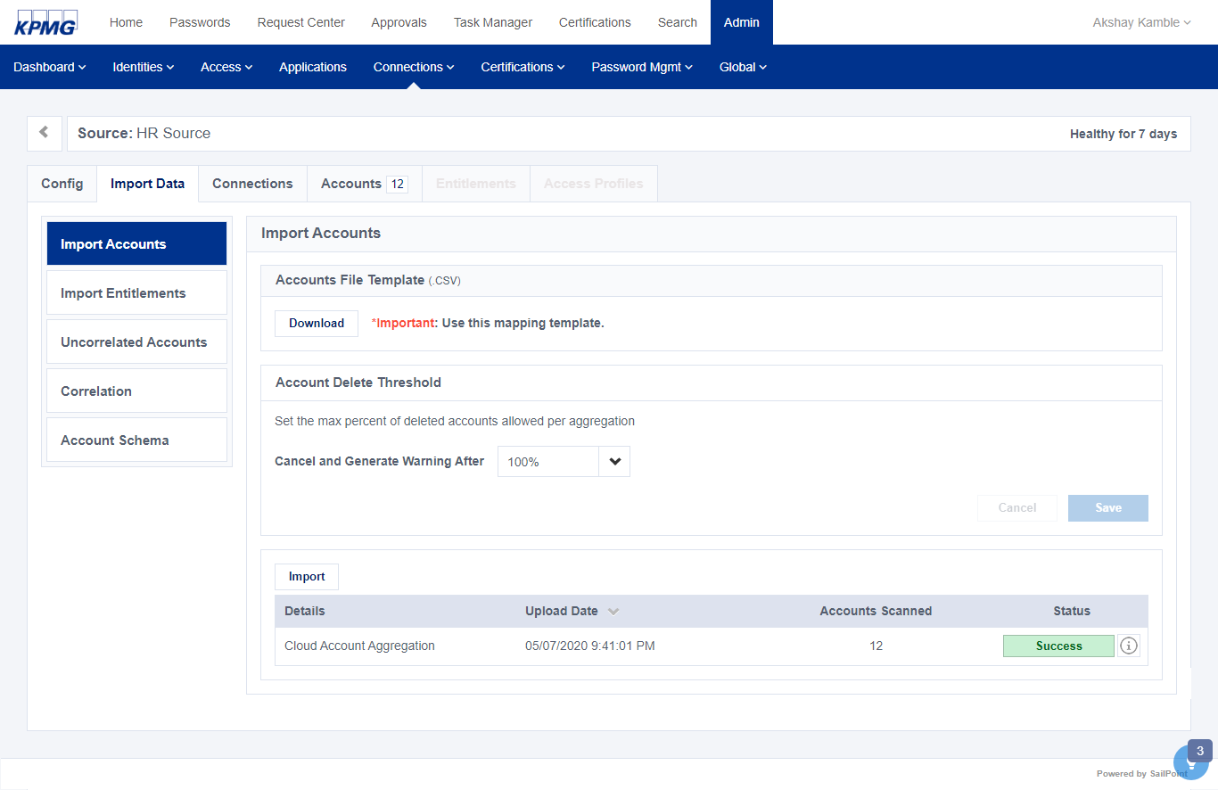

Figure 13: Import Account Data

1. Manually aggregate the accounts in the HR feed file. See Aggregate Accounts.

The accounts are aggregated.

1. To validate the aggregation completed as expected, click the **Accounts** tab and check the user accounts that were created in IDN. For example, Adam Kennedy, Amanda Ross, etc.

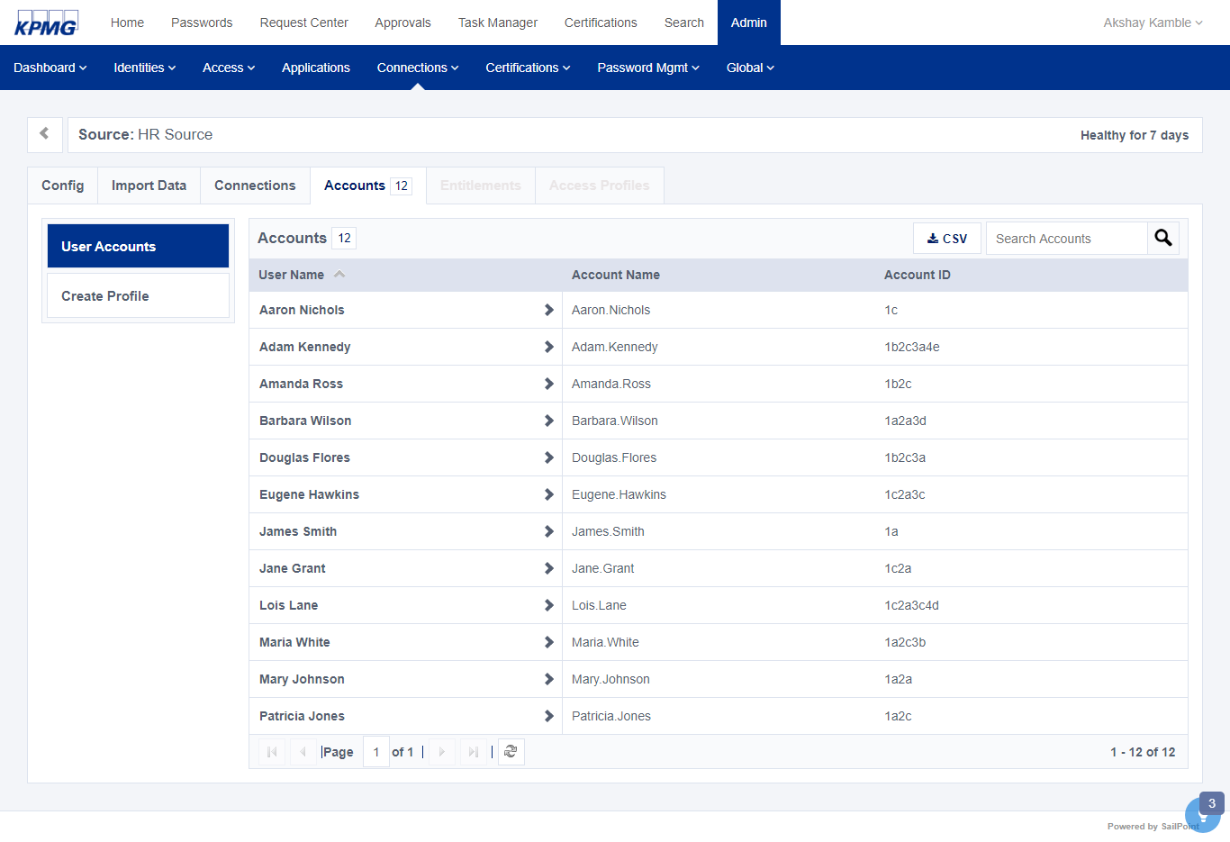

Figure 14: Sample Aggregated User Accounts

#### Identify & Remediate Aggregation Issues

**Powered 1.3**

IDN provides a **Source Activity** report showing activities like Aggregation, Password Change, Disable Account, etc.,

1. To generate a **Source Activity** report, sign into IDN as an admin and click **Search**.

The search screen displays.

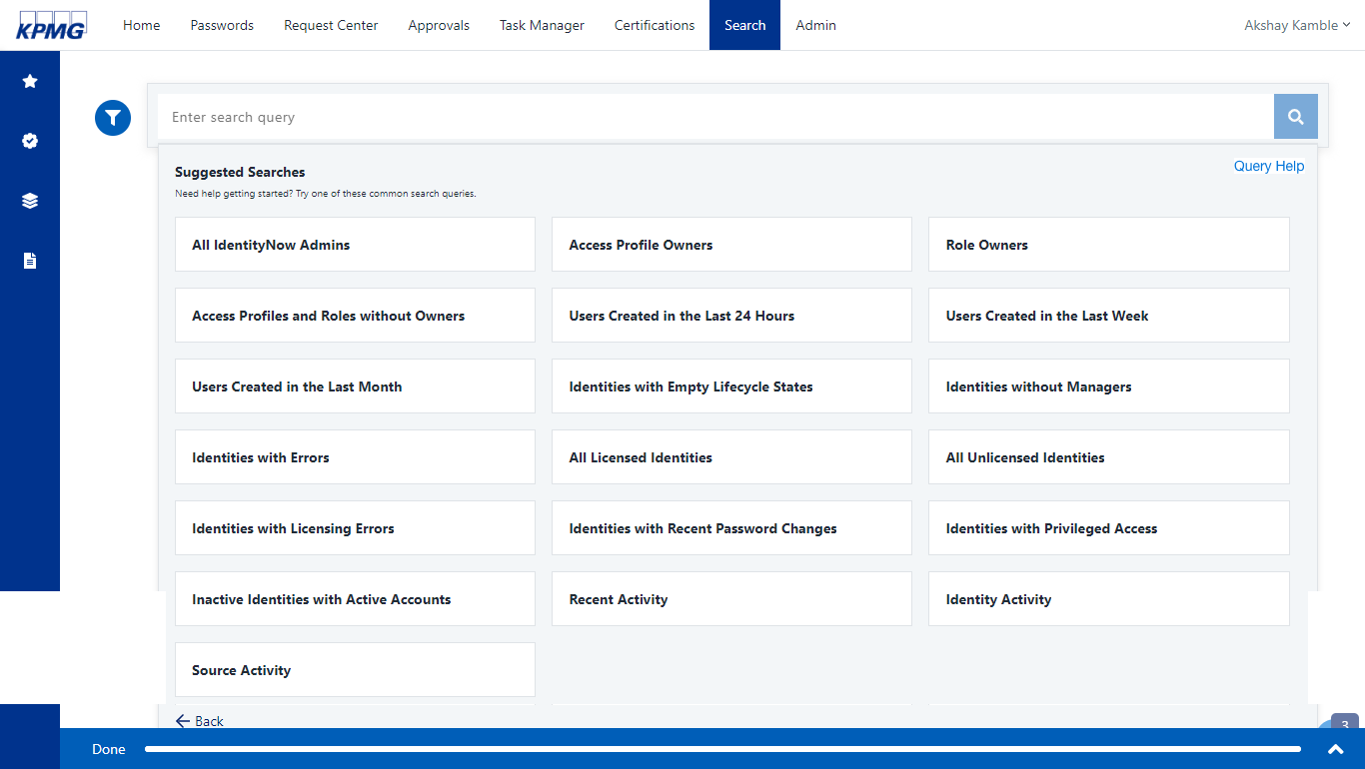

Figure 15: Search Tab

1. Click the search bar then click the **See all** link at the bottom of the Suggested Searches list.
2. Select **Source Activity**.

The search query generates a report that contains source activity details.

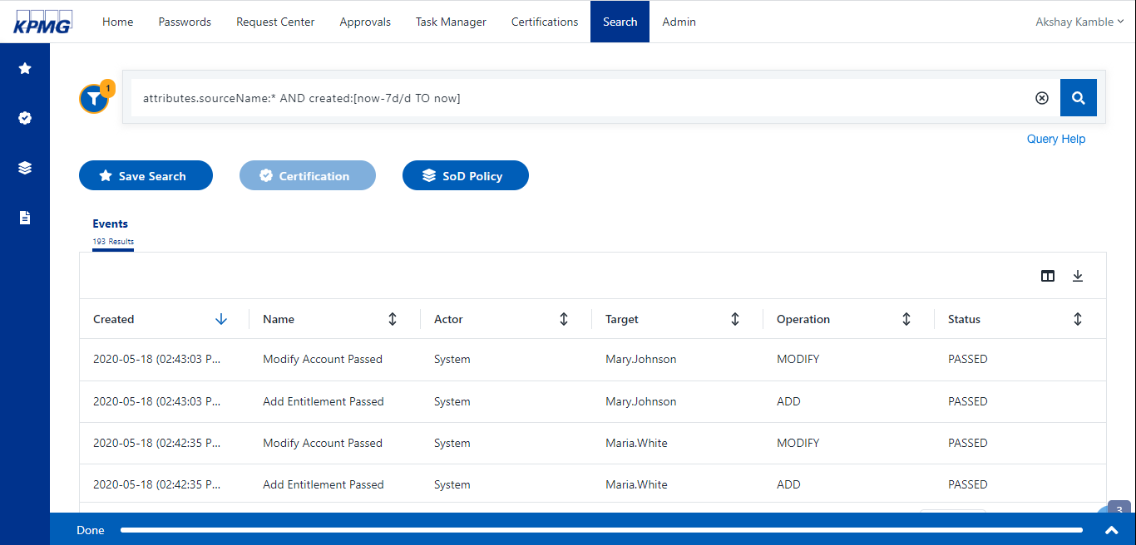

Figure 16: Sample Source Activity Report

1. Check the **Status** column and resolve issues for the activities that have not passed.
2. Click the **download** icon  to save the report.

**Note**: To generate a report for a specific source, type the following command in the Search bar:

*attributes.sourceName:HR Source*

#### Identify & Remediate Users Without Assigned Managers

**Powered 1.4**

Users are required to have a manager in the target platform. To remediate this issue, start by identify the users then add a manager.

1. To identify users that do not have a manager, sign into IDN using as an Administrator.

The home screen displays.

1. In the **Search** box, and type *NOT _exists_:manager.id* in the search field and click the **Search** icon.

Users without a manager display in a list on the screen.

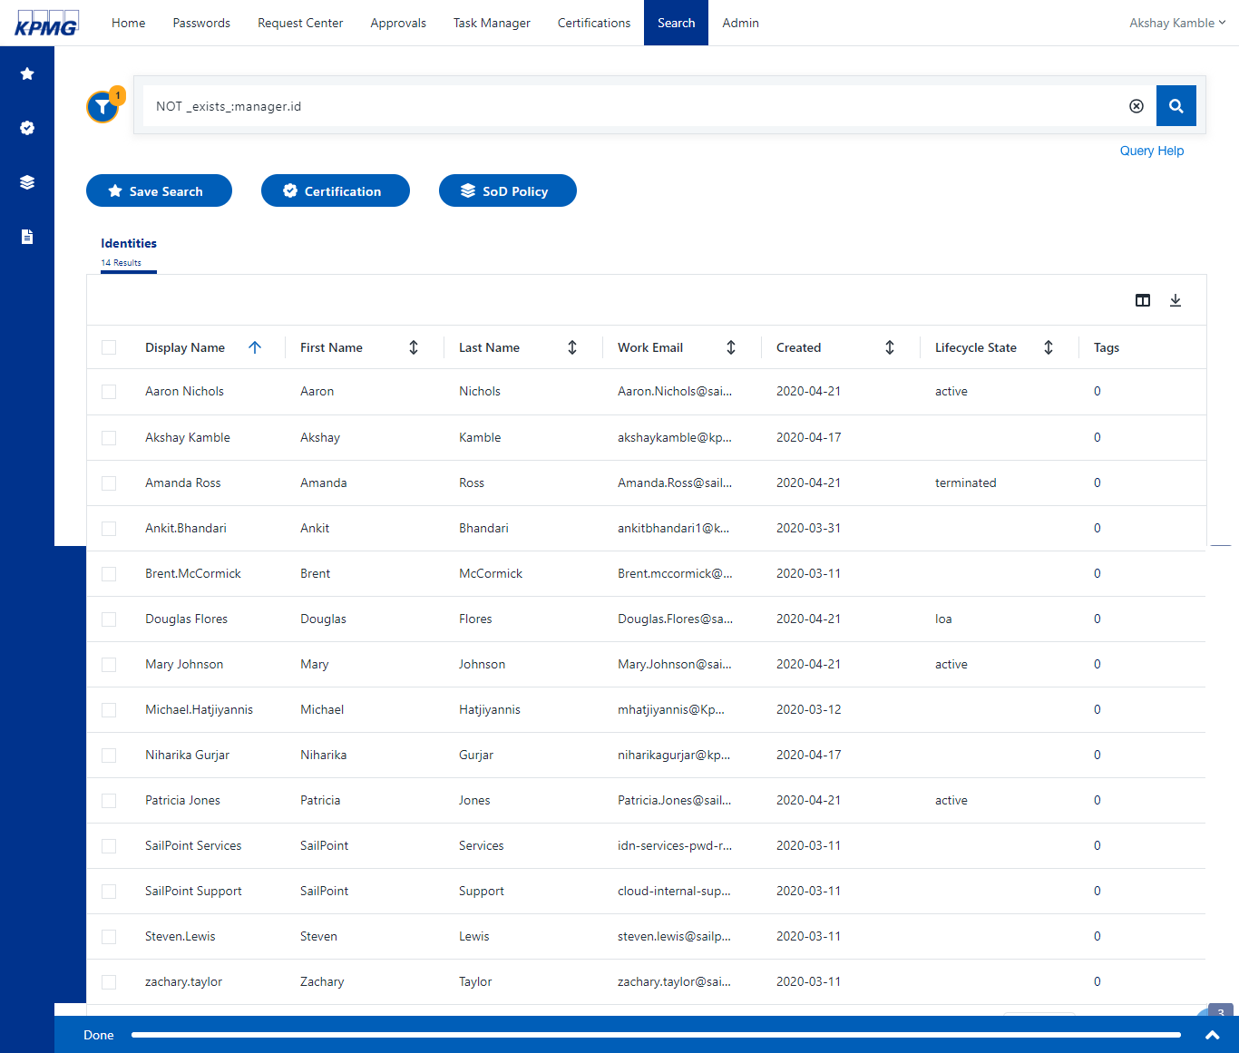

Figure 17: Sample Search Report showing users who don’t have a manager in system

1. Update/Add the manager for the listed users. For example, add a manager for Aaron Nichols.
2. Now that the manager has been updated, manually aggregate the HR Source with the updated manager information for the updated user (Aaron Nichols in this example).
3. To validate that a user has a manager after aggregation, generate the search report again.

In our example, notice that user Aaron Nichols does not exist in the following report because a manager was added.

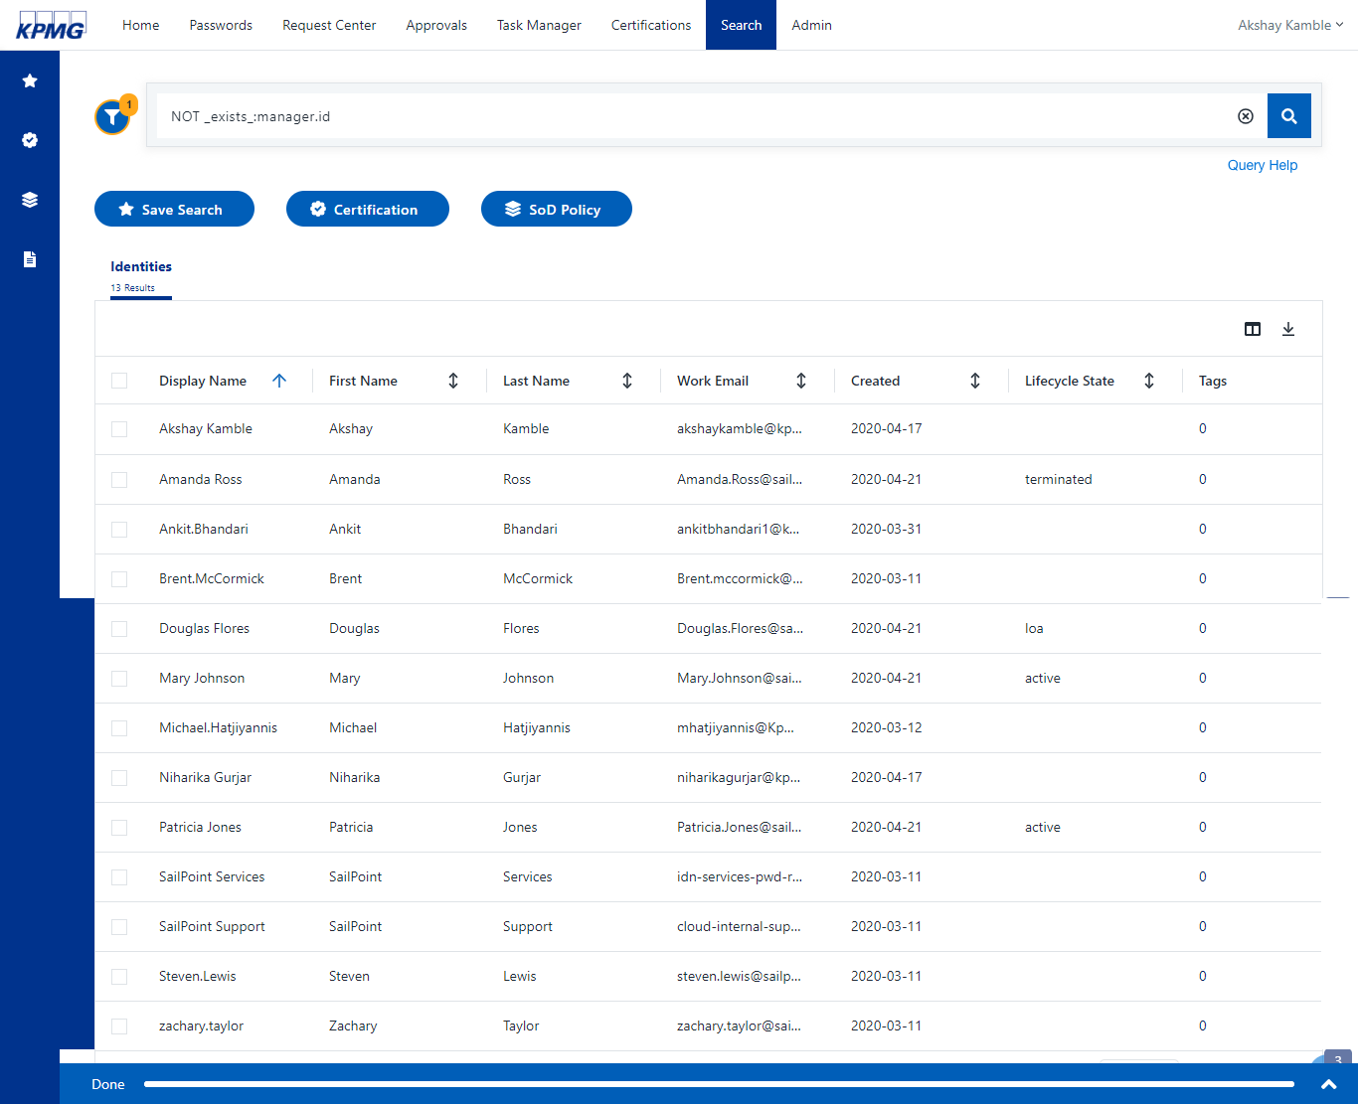

Figure 18: After HR Source Aggregation Search Report (user who don’t have manager in system)

**Powered 2.0** Application Sources

### Application Sources

This section details section 2.0 of the powered taxonomy (Application Sources) which is the IDN integration with Active Directory (AD). It describes how to aggregate user and entitlement data. Furthermore, it explains how to in identify & remediate aggregation issues and how to identify and manage dormant and/or orphaned accounts.

#### Onboard Application Source

**Powered 2.1** **Powered2_1**

#### Active Directory Integration

This section explains IDN integration with Active Directory. Active Directory (AD) Integration prerequisites:

* Configure at least one virtual appliance cluster and successfully test the connection. See Setting up a virtual appliance for more information.
* Configure IQService on target machine. See Setting up IQService for more information.

**Configure Active Directory Source**

1. Sign into SailPoint as an admin.
2. Point to the **Admin** menu, and click **Connections**, then select **Sources**.
3. Click the **+New** button to create a new **Active Directory** direct source using the following:

The source is created and displays on the **Config** tab.

|  |  |
| --- | --- |
| Name | *Value* |
| Source Type | *Active Directory* |
| Source Name | *Active Directory* |
| Description | *Enterprise directory* |
| Source Owner | *Owner* |
| Connection type | *Direct Connection* |

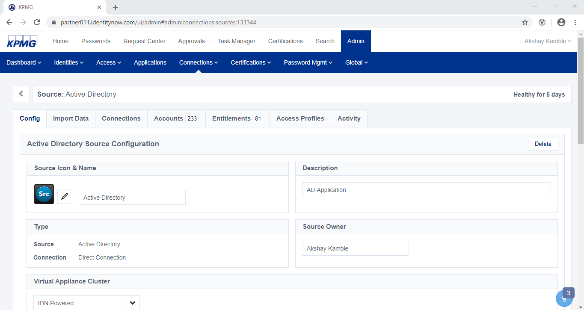

Figure 19: Active Directory Source Configuration

1. Click the **Config** tab and configure the connection details using the following:

|  |  |
| --- | --- |
| Name | *Value* |
| Source Owner | *<Select an identity>* |
| Virtual Appliance Cluster | IDN Powered VA |

1. In **Forest** Section, click the +**New** button to add a new entry using the following and click **Create**.

The **Forest** is added to the configuration.

|  |  |
| --- | --- |
| Name | *Value* |
| Forest Name | *Default <enter forest name>* |
| Service Account | SERI\Administrator |
| Password | *<password of service account>* |

Table 7: AD Forest configuration Attributes

1. In **Domain Configuration**, click the +**New** button to add a new domain configuration using the following attributes and click **Create**.

The domain configuration is added

|  |  |
| --- | --- |
| Name | *Value* |
| Forest Name | *Use the forest created in the previous step.* |
| Domain DN | DC=seri,DC=sailpointdemo,DC=com |
| Service Account | SERI\Administrator |
| Connection Password | <password of service account> |
| Servers | 10.0.0.1 <IP address of AD server> |

Table 8: AD Domain Configuration Attribute

1. In the **Account Settings** section, click the +**New** button to add an account setting using the following and click **Create**.

The new account setting pop-up screen display**s.**

|  |  |
| --- | --- |
| Name | *Value* |
| Search DN | OU=Demo,DC=seri,DC=sailpointdemo,DC=com |
| LDAP Search Filter | *< Leave field blank set the configuration if required>* |
| Group Membership Search DN | *< Leave field blank set the configuration if required>* |
| Group Membership Search Filter | *<Leave field blank set the configuration if required>* |

Table 9: AD Account Settings Attribute

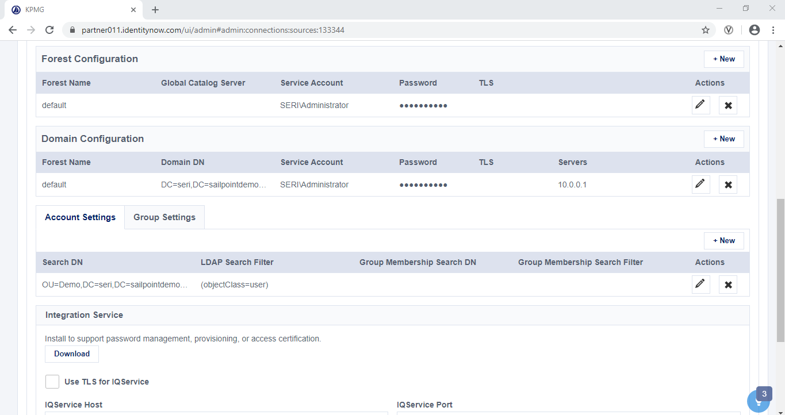

Figure 20: Active Directory Configuration

1. In **Integration Service** section, enter the following **IQService** details and click **Save**.

|  |  |
| --- | --- |
| Name | *Value* |
| Use TLS for IQService | *enable* |
| IQService Host | *10.0.0.1* |
| IQService Port | *<Enter TLS Port> 5051* |
| IQService User | *Seri\administrator* |
| IQService Password | *<Password of service account>* |

Table 10: IQService Configuration

1. **Test** the connection by clicking the **Test Connection** button on the bottom left side of the page.
2. If successful, 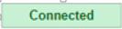 (connected) displays in a green box next to the test connection button. Continue to the next section.

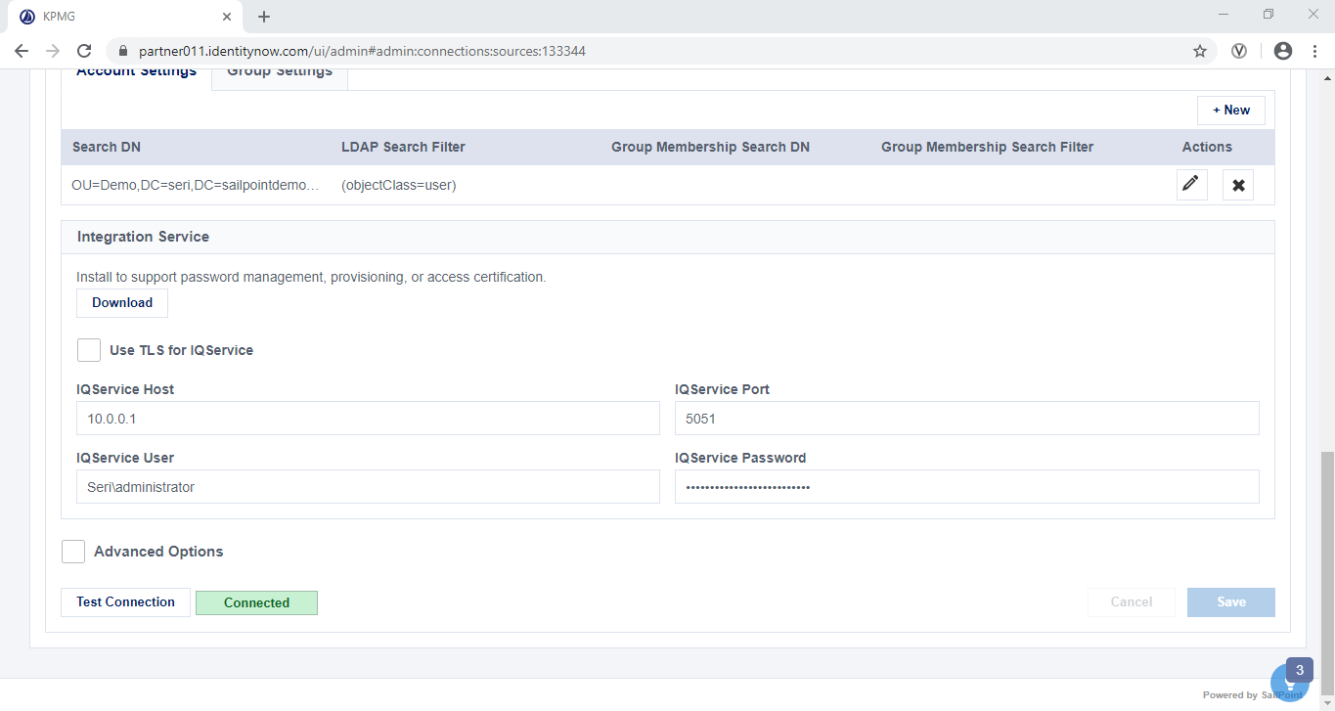

Figure 21: AD Test Connection

**Aggregate Active directory User and Entitlement**

1. Click the **Import Data** tab for the Active Directory source, then click the **Correlation** tab from the left vertical menu to check that the Account Schema is populated. The correlation rules are as follows:

|  |  |
| --- | --- |
| IDN Attribute | Account Attribute |
| Name | *sAMAccountName* |
| Work Email | *mail* |
| Display Name | *displayName* |

Table 11: AD Correlation Configuration

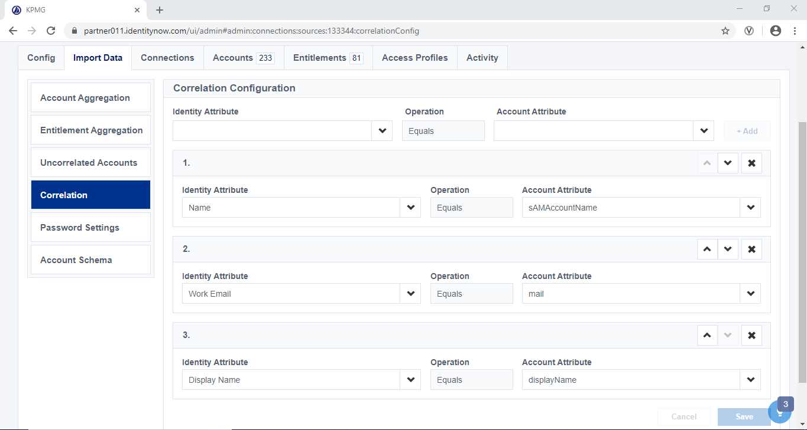

Figure 22: AD Correlation Configuration

1. On the same Ppage, click the **Account Schema** tab from the left vertical menu bar to verify each account schema attributes are as follows:

|  |  |  |  |
| --- | --- | --- | --- |
| Attribute | Description | Account Schema Attribute Setting(s) | Type |
| sAMAccountName | business category | memberOf | String |
| carLicense | vehicle license or registration plate | Multi-Valued | String |
| ou | organizational unit this object belongs to | Multi-Valued | String |
| memberOf | Entitlement Multi-Valued | Group Membership | String |
| msNPCallingStationID | CallingStationID | Multi-Valued | String |
| msRADIUSFramedRoute | Static Routes for Dial-In connection | Multi-Valued | String |
| accountFlags | List of the flags enabled on an account | Multi-Valued | String |
| facsimileTelephoneNumber | Facsimile (Fax) Telephone Number | Multi-Valued | String |
| objectClass | object classes of the entity | Multi-Valued | String |
| msExchHideFromAddressLists | Hide from Exchange address lists | N/A | Boolean |
| msRTCSIP-UserEnabled | User enabled for Lync Server | N/A | Boolean |
| cn | common name(s) for which the entity is known by | N/A | N/A |
| departmentNumber | identifies a department within an organization | N/A | N/A |
| description | descriptive information | N/A | N/A |
| destinationIndicator | destination indicator | N/A | N/A |
| displayName | preferred name to be used when displaying entries | N/A | N/A |
| distinguishedName | distinguished name for which the entity is known by | N/A | N/A |
| employeeNumber | numerically identifies an employee within an organization | N/A | N/A |
| employeeType | type of employment for a person | N/A | N/A |
| givenName | first name(s) for which the entity is known by | N/A | N/A |
| homePhone | home telephone number | N/A | N/A |
| homePostalAddress | home postal address | N/A | N/A |
| initials | initials of some or all of names, but not the surname(s). | N/A | N/A |
| internationaliSDNNumber | international ISDN number | N/A | N/A |
| l | city | N/A | N/A |
| mail | RFC822 Mailbox | N/A | N/A |
| manager | DN of manager | N/A | N/A |
| mobile | mobile telephone number | N/A | N/A |
| o | organization this object belongs to | N/A | N/A |
| pager | pager telephone number | N/A | N/A |
| physicalDeliveryOfficeName | Physical Delivery Office Name | N/A | N/A |
| postOfficeBox | Post Office Box | N/A | N/A |
| postalAddress | postal address | N/A | N/A |
| postalCode | postal code | N/A | N/A |
| preferredDeliveryMethod | preferred delivery method | N/A | N/A |
| preferredLanguage | preferred written or spoken language for a person | N/A | N/A |
| registeredAddress | registered postal address | N/A | N/A |
| roomNumber | room number | N/A | N/A |
| secretary | DN of secretary | N/A | N/A |
| seeAlso | DN of related object | N/A | N/A |
| sn | last (family) name(s) for which the entity is known by | N/A | N/A |
| st | state or province which this object resides in | N/A | N/A |
| street | street address of this object | N/A | N/A |
| telephoneNumber | Telephone Number | N/A | N/A |
| teletexTerminalIdentifier | Teletex Terminal Identifier | N/A | N/A |
| telexNumber | Telex Number | N/A | N/A |
| title | title associated with the entity | N/A | N/A |
| uid | user identifier | N/A | N/A |
| objectSid | Windows Security Identifier | N/A | N/A |
| objectguid | Object globally unique identifier | N/A | N/A |
| sAMAccountName | sAMAccountName | N/A | N/A |
| primaryGroupID | RID of users primary group | N/A | N/A |
| primaryGroupDN | DN of users primary group | N/A | N/A |
| department | User's department | N/A | N/A |
| msNPAllowDialin | Is dial-in allowed | N/A | N/A |
| msRADIUSCallbackNumber | Callback Number | N/A | N/A |
| msRADIUSFramedIPAddress | Define Static IP Address | N/A | N/A |
| mailNickname | Exchange Alias | N/A | N/A |
| homeMDB | Exchange Database | N/A | N/A |
| SipAddress | Lync sipAddress | N/A | N/A |
| RegistrarPool | Lync Registrar pool | N/A | N/A |
| LyncPinSet | Lync user pin set status | N/A | N/A |
| LyncPinLockedOut | Lync user pin lock status | N/A | N/A |
| pwdLastSet | Time of last password reset | N/A | N/A |
| msDS-PrincipalName | Name of the entity in the format NetBIOS domain name\sAMAccountName | N/A | N/A |
| userPrincipalName | The unique name of the entity within the domain, in the format name@domain | N/A | N/A |

Table 12: AD Schema Attributes

1. Click the **Entitlement Aggregation** tab from the left vertical menu bar and select the manual aggregation **Start** button to manually aggregate the AD groups.

The AD group aggregation process begins.

1. Click the **Account** **Aggregation** tab from the left vertical menu bar and select the manual aggregation **Start** button to manually aggregate the accounts.

The account aggregation process begins.

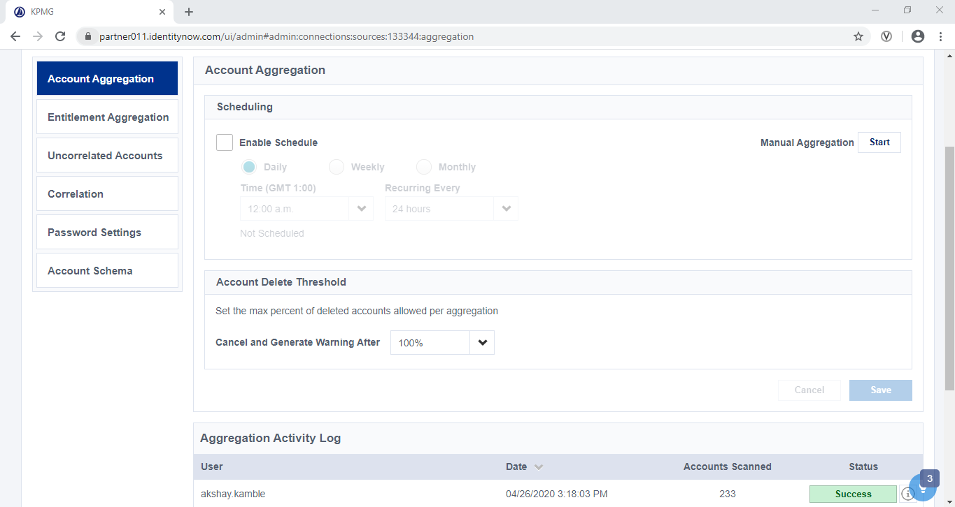

Figure 23: AD Account Aggregation

1. Click the **Accounts** tab from the grey navigation bar then click the **User Accounts** tabfrom the vertical navigation bar to check that the AD accounts have aggregated to the existing cubes. e.g. look at Adam Kennedy, Amanda Ross, etc.

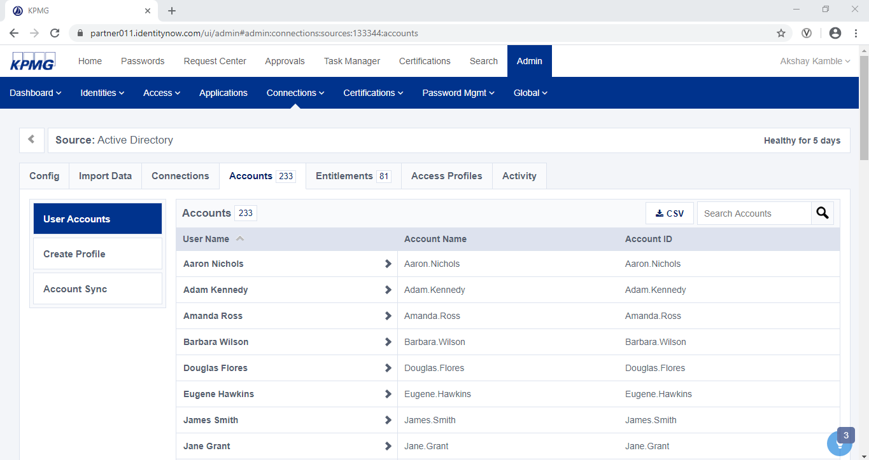

Figure 24: AD User Accounts

##### Black Line Integration

###### Source Configuration

1. Sign into SailPoint as an admin.
2. Point to the **Admin** menu, click **Connections**, then select **Sources**.
3. Click +**New** button to create a new delimited file source using the following then click the **Continue** button.

The new source is created and the source displays on the source detail screen.

|  |  |
| --- | --- |
| Name | *Value* |
| Source Type | *Delimited File* |
| Source Name | Black Line |
| Description | *Blackline is an application that used as a centralized repository for reconciliations and related documents.* |
| Source Owner | *<Select an Identity>* |

Table 13: BlackLine Source Configuration Attribute

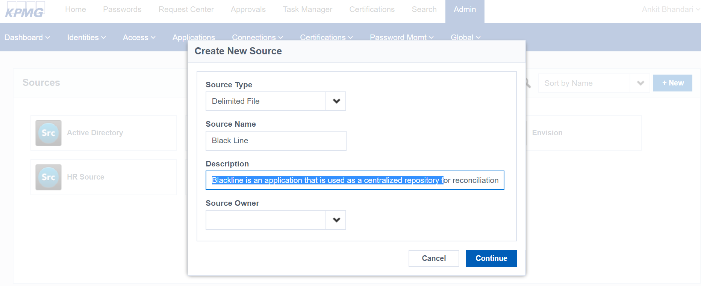

Figure 25: BlackLine Source Configuration

1. Click the **Import Data** tab on the grey navigation bar, then click **Account Schema** to verify the Black Line account schema is as follows:

|  |  |  |
| --- | --- | --- |
| Blackline User File Attribute | Attribute Description | Account Schema Attribute Setting(s) |
| User Name | *Name of user* | *Name* |
| UserID | *Unique ID setup with each user that allows login* | *Account ID* |
| email | *Users e-mail address for password setup and other communication* | *N/A* |
| IIQDisabled | *Active/Inactive status shows if the user has the ability to log into the system* | *N/A* |
| Department | *User department* | *N/A* |
| groups | *Combination of “Role – Comboname” to form entitlement* | *Entitlement*  *Multi-Valued* |

Table 14: BlackLine Account Schema Attributes

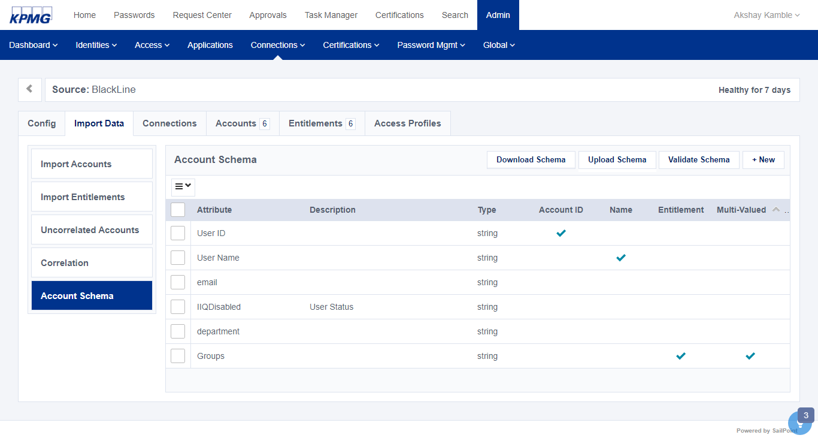

Figure 26: BlackLine Account Schema

1. Click the **Correlation** tab from the horizontal menu to validate the correlation rules are as follows:

|  |  |
| --- | --- |
| IDN Attribute | Account Attribute |
| XYZ User Name | *User Name* |

Table 15: BlackLine Account Correlation Attribute

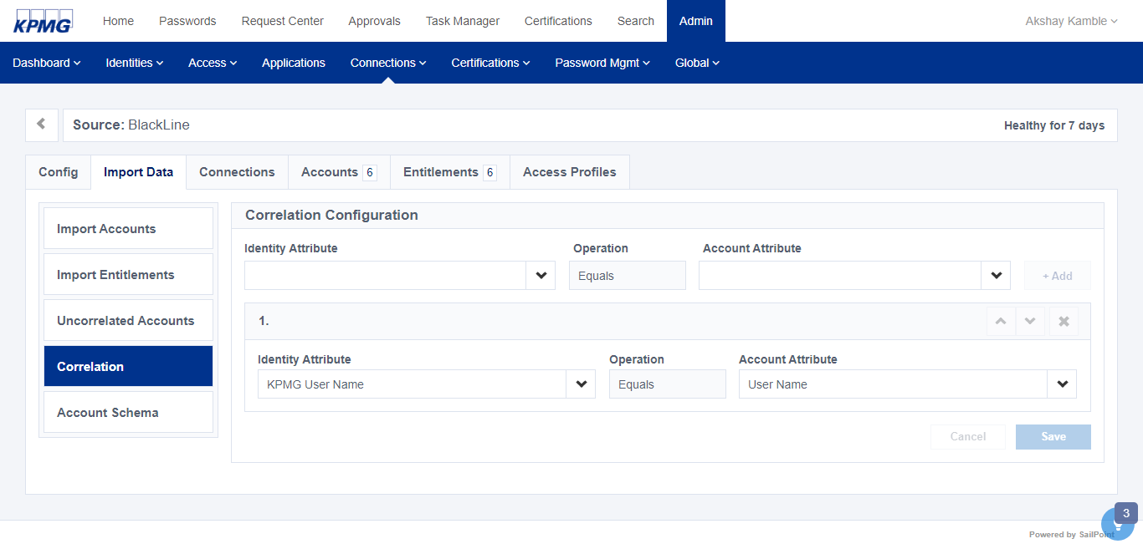

Figure 27: BlackLine Configuration

###### Application Configuration

1. From to **Admin** menu**,** click the **Applications** tab.
2. Click the **+New** buttonto create application using the following attributes; then click the **Continue** button.

The application is created and details for the new application display.

|  |  |
| --- | --- |
| Name | Value |
| Name | Black Line |
| Description | Black line is an application that is used as a centralized repository for reconciliations and related documents*.* |

Table 16: Create BlackLine Application Configuration Attribute

1. From the **Configuration** tab, configure the new application using the following attributes; the click the **Save** button.

|  |  |
| --- | --- |
| Name | Value |
| Select Source | *Black Line* |
| All Users from Source | *True* |
| Allow Access Requests | *True* |
| Enable for Users | *ON* |

Table 17: BlackLine Application Configuration Attribute

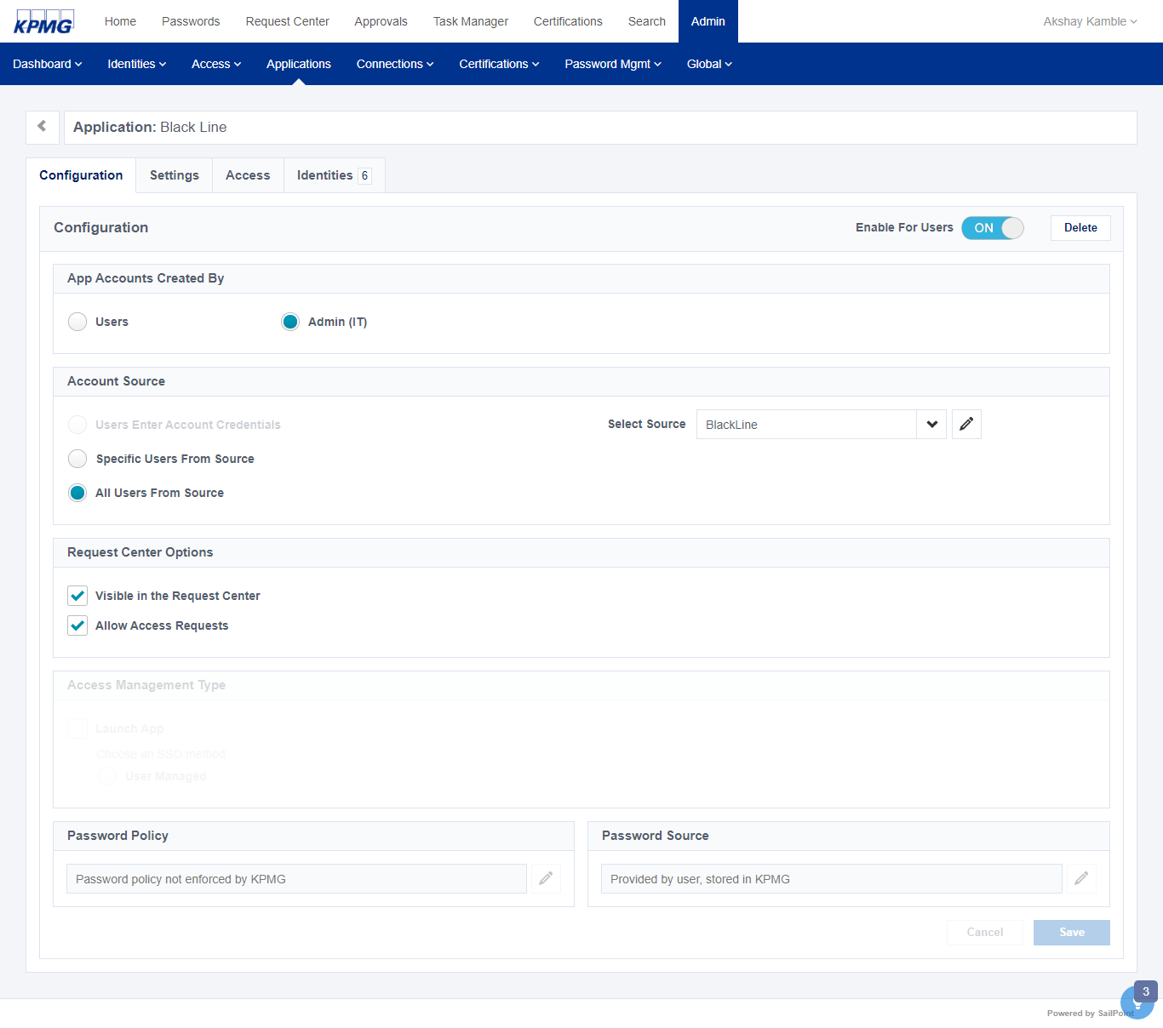

Figure 28: BlackLIne Application Configuration

1. Click the **Access** tab from the grey bar.

The access tab displays.

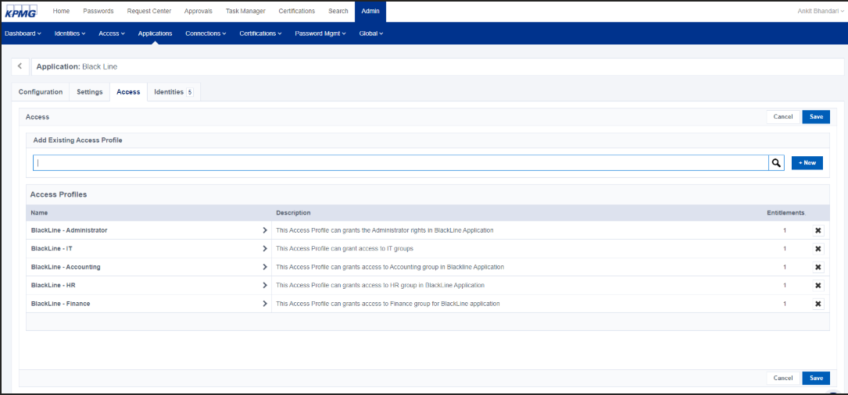

1. In the **Add Existing Access Profiles** search box, type the name of an access profile and select it to add it to the application configuration.
2. Click the **Save button** to save theconfiguration.

The access profile is added to the application

1. To allow the application to be requested, click the **Settings** tab from the grey menu and change the value for **Enable for Users** to **ON** then click the **Save** button.

The configuration is saved.

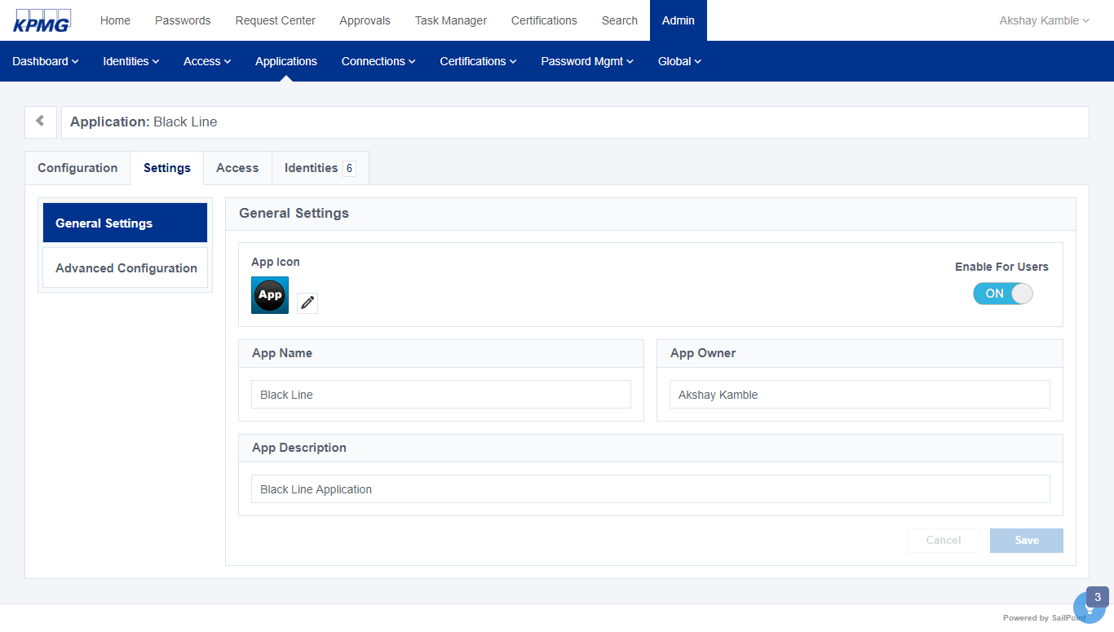

Figure 29: BlackLIne Configure General Settings

##### Demandware Integration

IDN integration with delimited file application Demandware application

###### Source Configuration

1. Sign into SailPoint using an admin user.
2. Point to the **Admin** menu, click **Connections**, then select **Sources**.

The **Sources** tab displays.

1. Click the **+New** button to create a new **Delimited File** source using the following attributes then click the **Continue** button.

The **config** folder displays.

|  |  |
| --- | --- |
| Name | *Value* |
| Source Type | *Delimited File* |
| Source Name | *Demandware* |
| Description | *Demandware is a cloud system that's used as our e-commerce platform.* |
| Source Owner | *<Select an Identity>* |

Table : New Delimited File

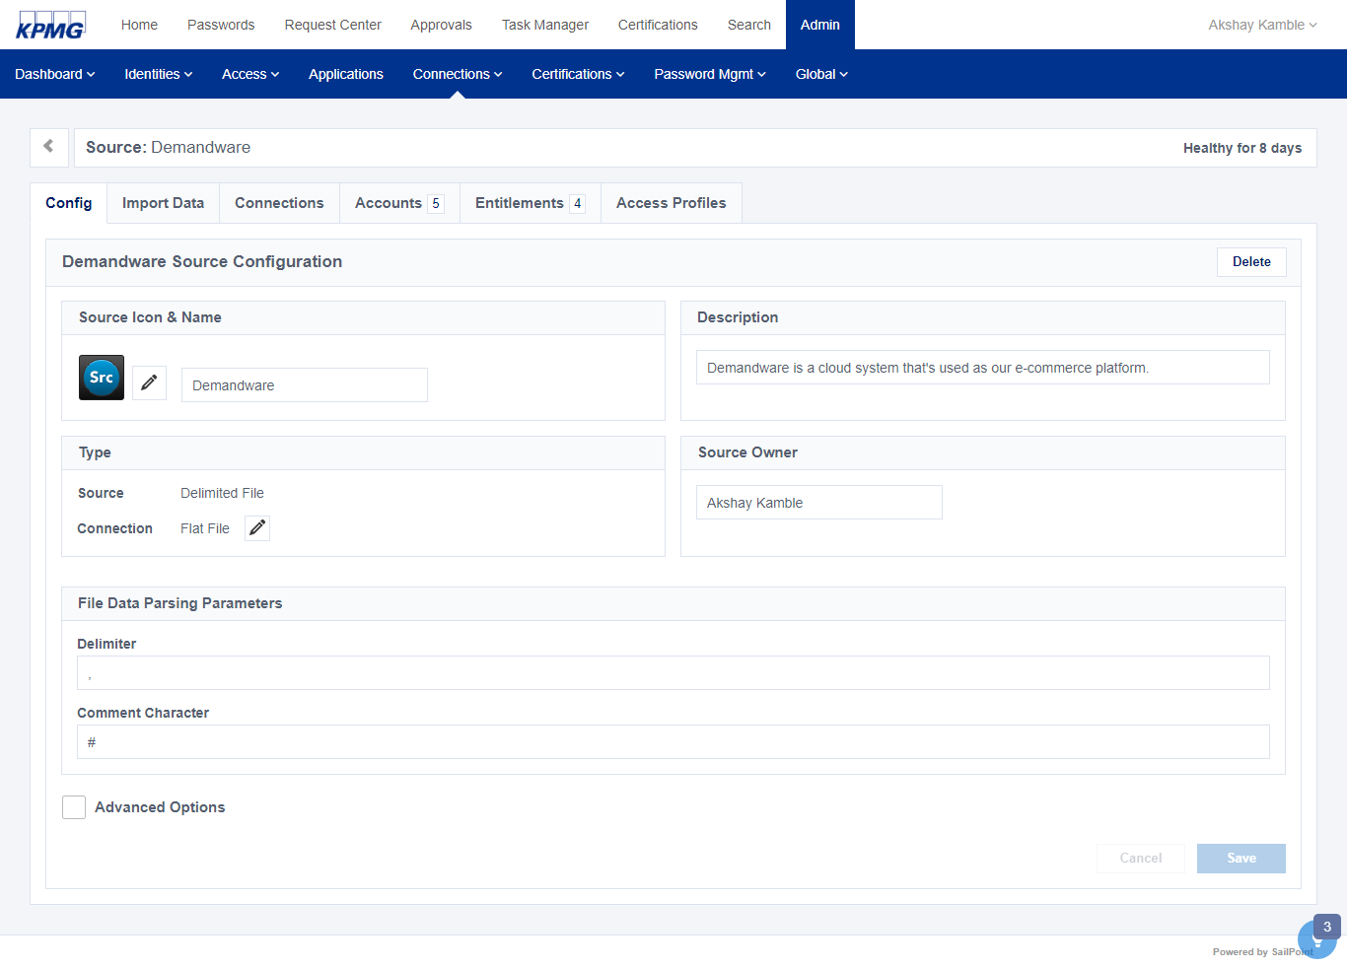

Figure 30: Demandware Source Configuration

1. Click the **Import Data** folder from the grey menu then click the **Account Schema** tab to validate the account schema is as follows:

|  |  |  |  |  |  |
| --- | --- | --- | --- | --- | --- |
| Blackline User File Attribute | | Attribute Description | | Account Schema Attribute Setting(s) | |
| employeeId | Unique ID of Employee | | Account ID | |
| fullName | Name of user. | | Name | |
| userID | login ID of user. | | N/A | |
| Department | User department | | N/A | |
| email | Users e-mail address for password setup and other communication | | N/A | |
| IIQDisabled | Active/Inactive status shows if the user has the ability to log into the system | | N/A | |
| groups | Combination of “Role – Comboname” to form entitlement | | Entitlement  Multi-Valued | |

Table : BlackLine Schema Attribute

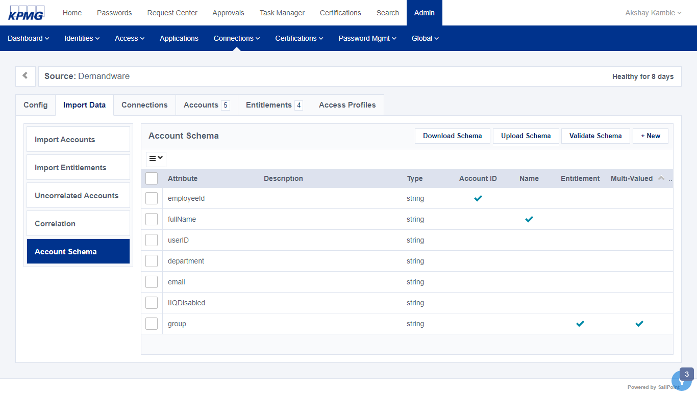

Figure 31: Demandware Account Schema

1. Click the **Correlation** tab from the left vertical menu and modify the correlation as follows:

The **Correlation** tab displays

|  |  |
| --- | --- |
| IDN Attribute | Account Attribute |
| XYZ User Name | *employeeId* |

Table 18: Demandware Account Correlation

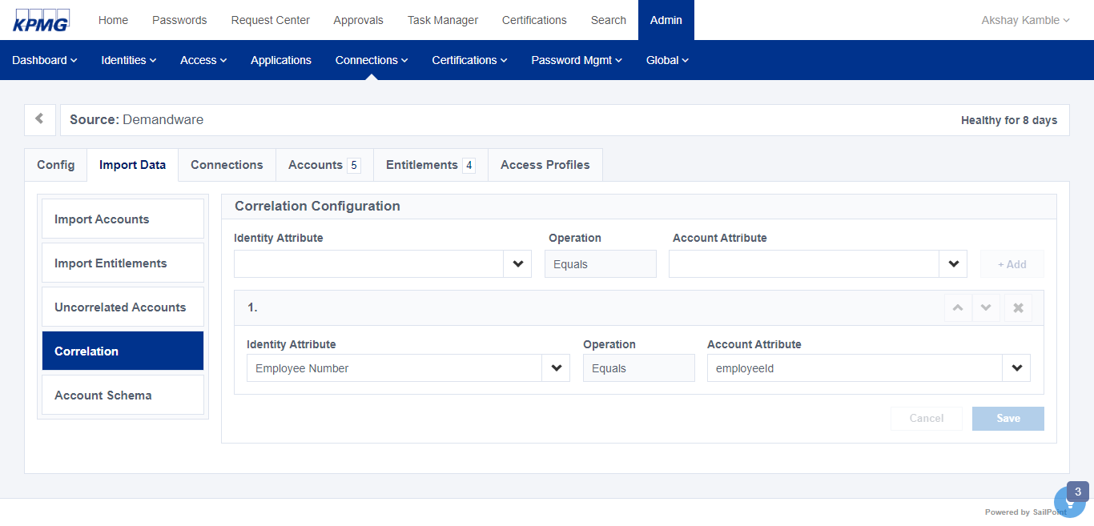

Figure 32: Demandware Account Correlation

1. Click the **Save** button.

The configuration is saved.

###### Reconcile Account & Entitlement Information (2.2)

1. Click the **Import Data** folder fro the grey menu and select **Import Accounts**

The **Import Accounts** screen displays.

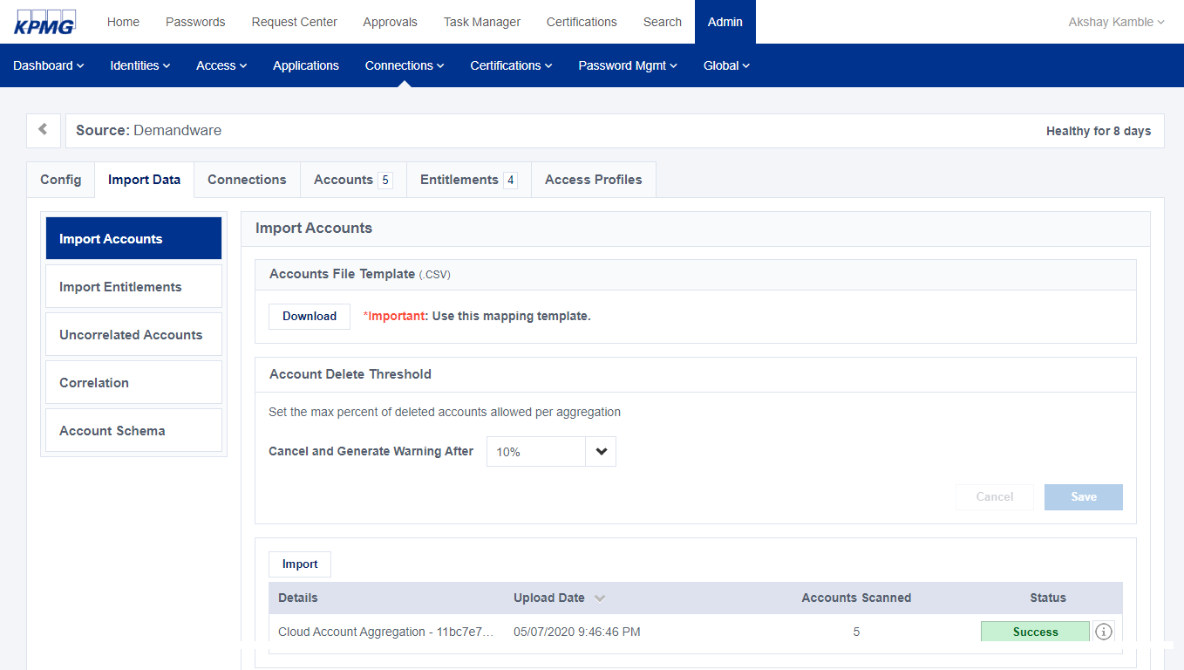

Figure 33: Demandware Import Accounts

1. Click the **Import** button and select the **Demandware** feed file and click the **open** button.

The data from the Demandware feed file is aggregated.

1. Once the aggregation process is complete, click the **Identities** tab and select **Identity List** to validate the Demandware accounts have aggregated to the existing cubes. For example, look at Adam Kennedy, Amanda Ross, etc.

###### Application Configuration.

1. Click the **Admin** menuandselect **Application** from the main menu.

The application screen displays.

1. Click the **+New** buttonto create an application using the following then click **Continue**.

|  |  |
| --- | --- |
| Name | Value |
| Name | *Demandware* |
| Description | *Demandware is a cloud system that's used as our e-commerce platform.* |

Table 19: Create Demandware Application Configuration Attribute

1. Click the **Config** folder to configure the new application using the following attributes. Then click the **Save** button.

|  |  |
| --- | --- |
| Name | Value |
| Select Source | *Demandware* |
| All Users from Source | *True* |
| Allow Access Requests | *True* |
| Enable for Users | *ON* |

Table 20: Demandware Application Configuration

.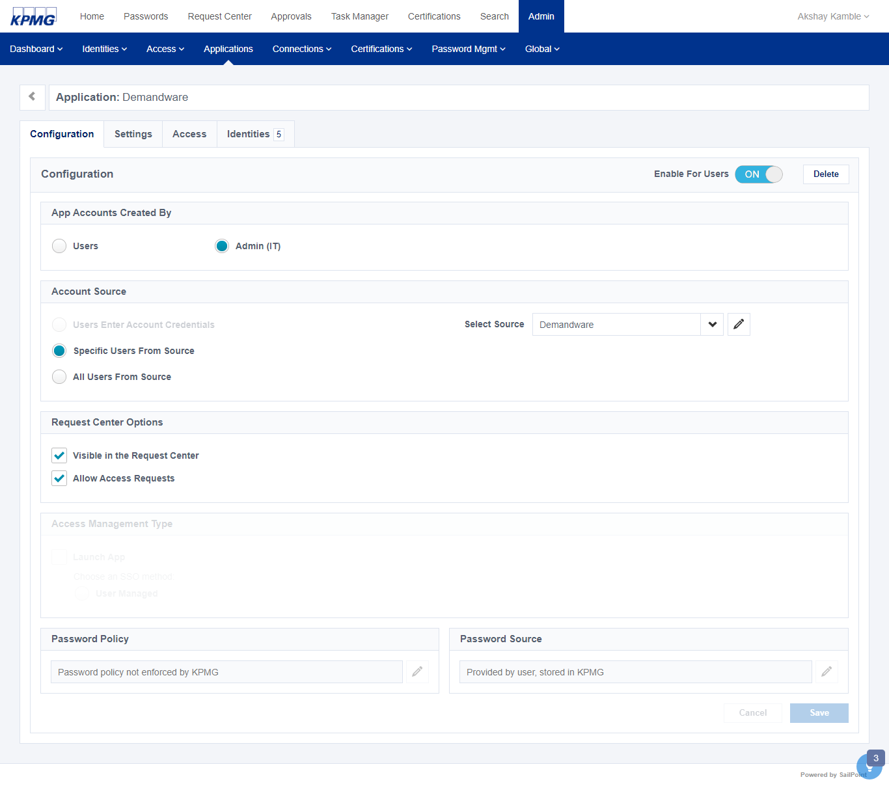

Figure 34: Demandware Application Configuration

1. On the **Access** folder, click the **+New** button to add an **Access Profile** for Demandware then click the **Save** button.

The access profile is added to the new application

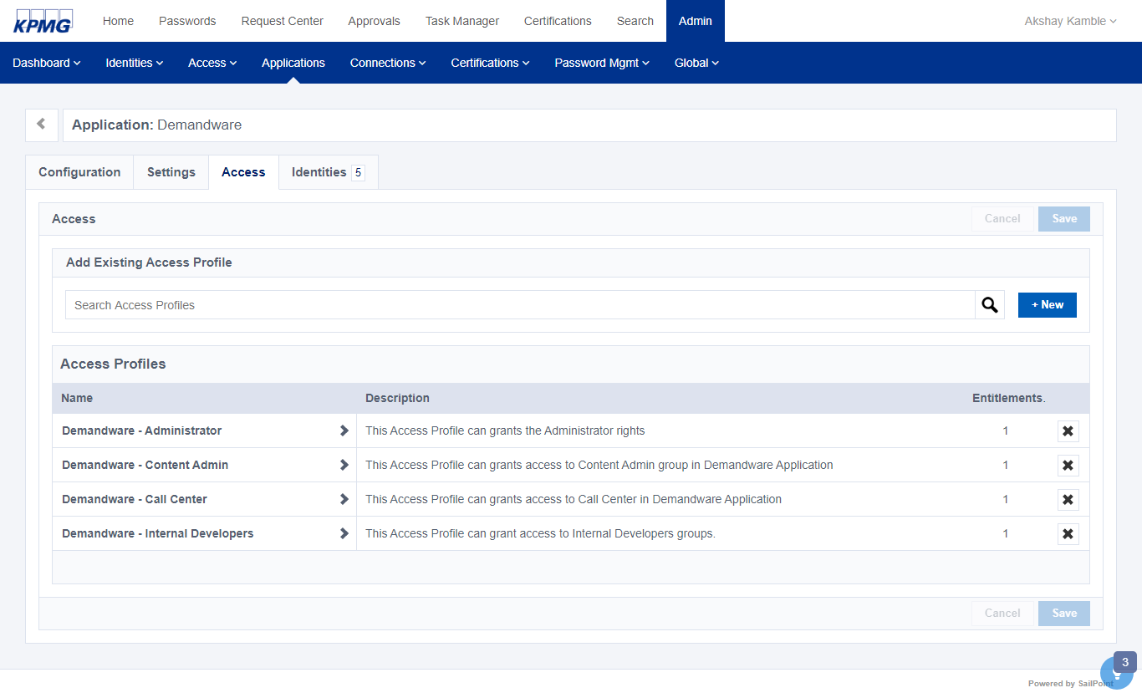

Figure 35: Access Profile of Demandware

1. To allow the application to be requested, click the Settings foder and change the value for Enable for Users to ON. Click the Save button.

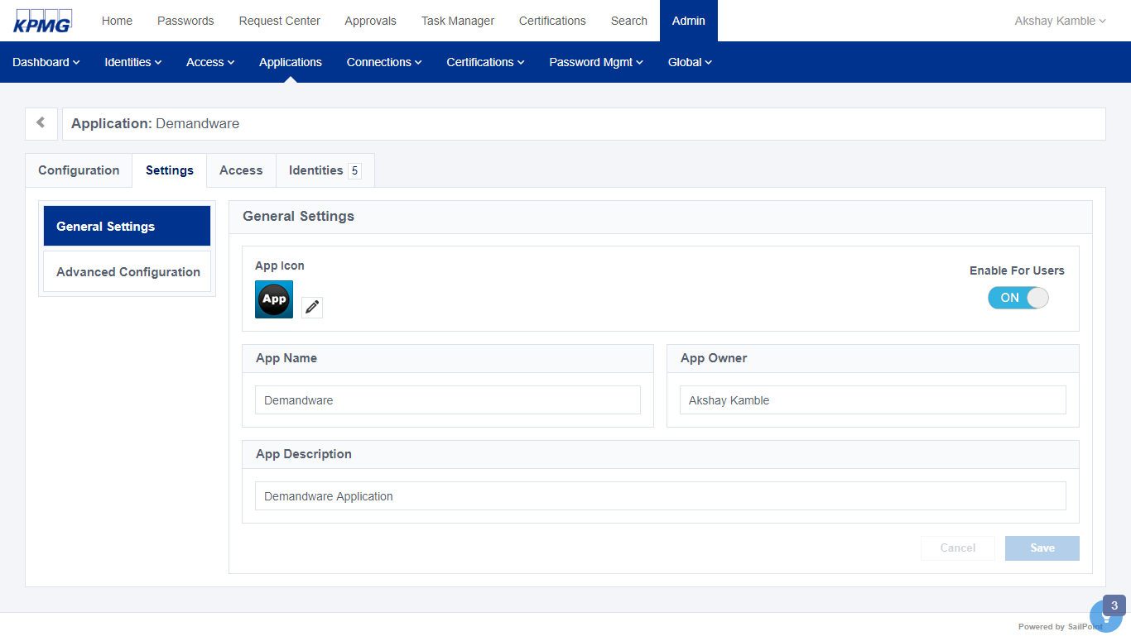

Figure 36: Demandware Application General Settings

#### Reconcile Account & Entitlement Information

**Powered 2.2**

1. Before stating the account aggregation, import the Black Line entitlementfeed file.
2. From the **Connections** menu, select **Sources**.
3. Click the **BlackLine** tile to open.
4. Click the **Import Data** folder and select **Import Entitlements** tab.

The **Import Entitlement** screen displays

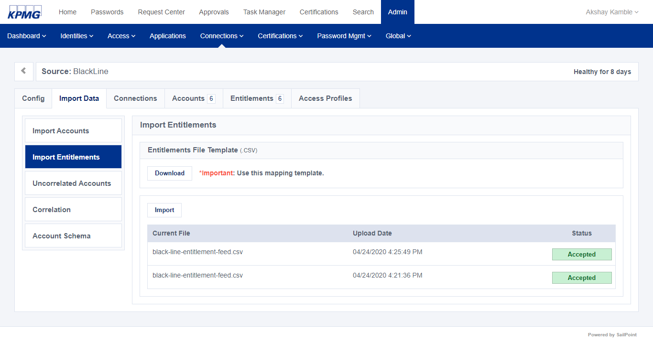

Figure 37: BlackLine Import Entitlement Screen

1. Click the **Import** button and select the black line entitlement feed file.
2. Click the **Entitlements** tab and view all populated entitlements.
3. To manuallyaggregate the accounts, start by clicking the **Import Accounts** tab.

The **Import Accounts** screen displays.

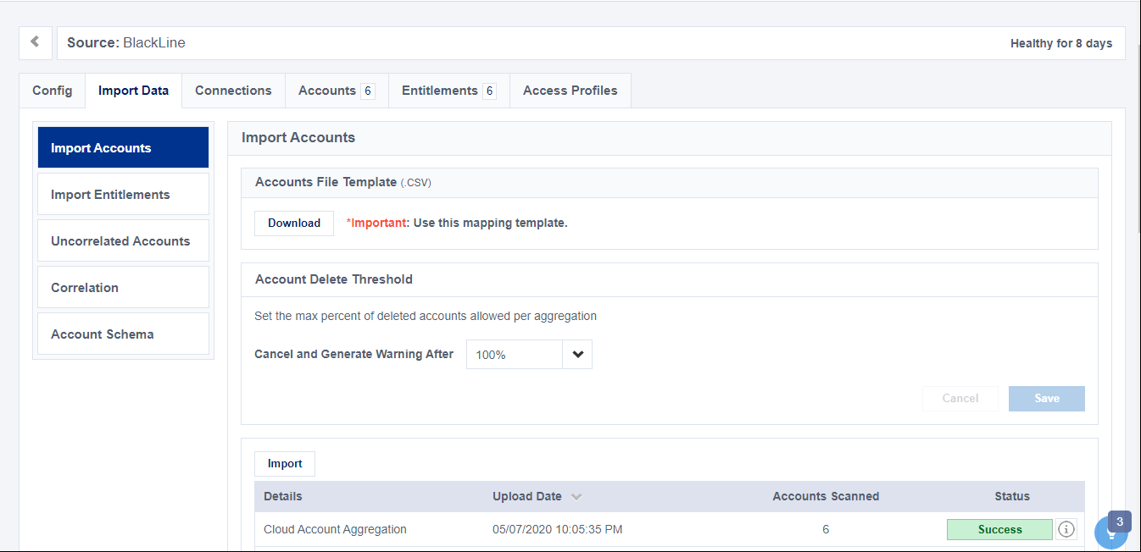

Figure 38: BlackLine Account Aggregation

1. Click the **Import** button, select the **Black Line** feed file and click **open**.

The data from the **Black Line** feed file is aggregated.

1. Once the aggregation process is complete, click the **Identities** menu and select **Identity List** to validate the Blackline accounts have aggregated to the existing cubes. For example, look at Amanda Ross, etc.

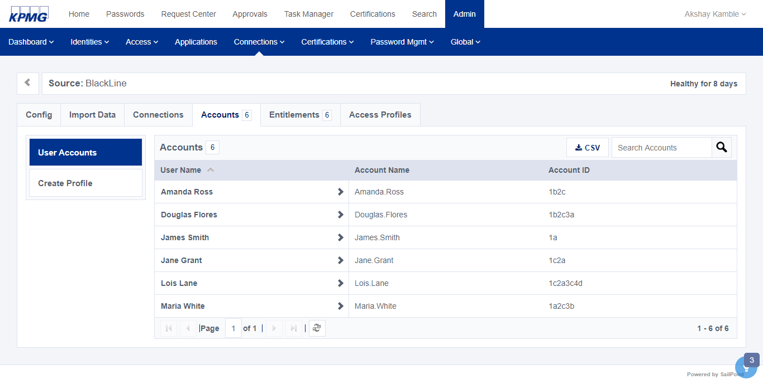

Figure 39: BlackLine User Accounts

#### Identify & Remediate Aggregation Issues

**Powered 2.3**

#### Identify & Resolve Orphaned Accounts

**Powered 2.4**

Uncorrelated accounts m**i**ght exist when accounts are loaded into SailPoint using a direct connector or flat file feed. This refers to accounts from that source that did not automatically link or correlate to any of the identities already loaded into system. For example:

* **System** **accounts** (e.g. sysadmin or dba)
* **Orphan** **accounts** belonging to former employees
* Accounts created with unusual IDs that were not automatically linked to their owner by standard account correlation rules.

To resolve these accounts, download the list of uncorrelated accounts, edit them to match accounts with existing users, and import the changes.

1. Click the **Connections** menu then select **Sources.**

The **Sources** tiles display

1. Click an **Active Directory** source tile.
2. From the **Import Data** folder, click **Uncorrelated Accounts.** Click the **Export** button

The uncorrelated accounts are added to the CSV file

1. Download the csv file which contains all uncorrelated account of source by clicking the **Save** file button.

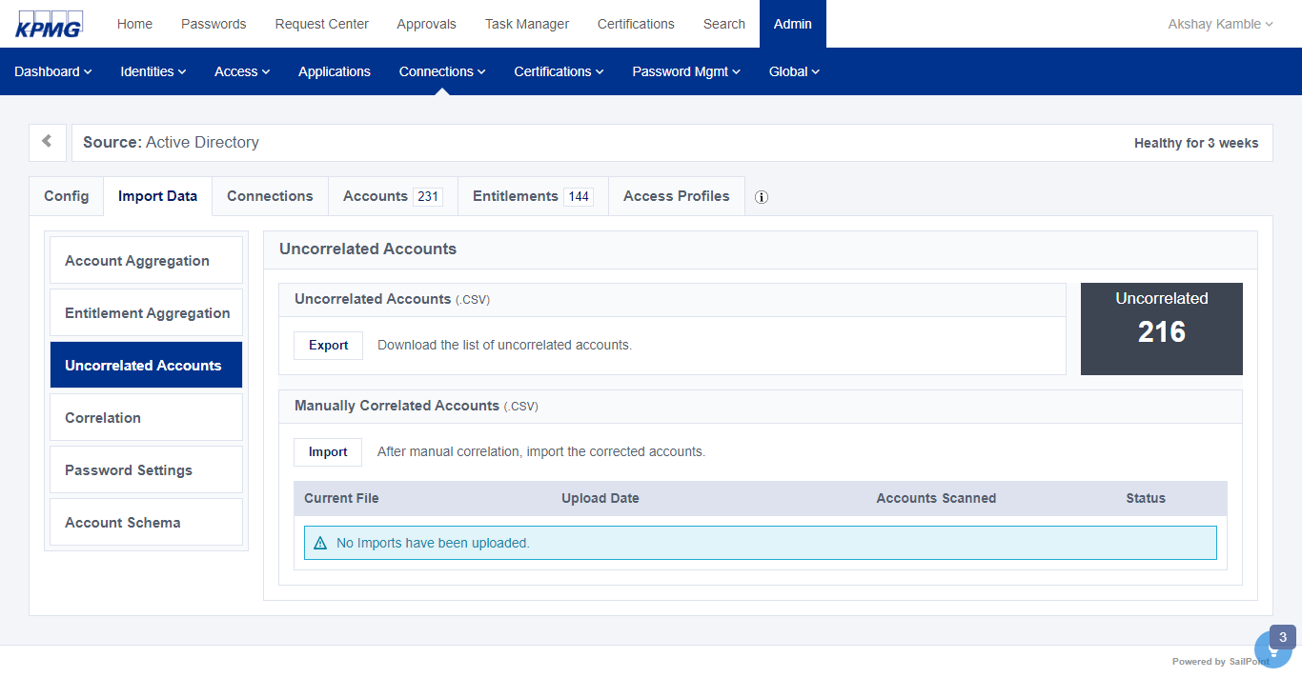

Figure 40: AD Uncorrelated Account Tab

1. Edit the CSV file to resolve the uncorrelated accounts by adding the Account ID of the associated identity:
   1. Click the **Identities** menu and select **Identity List**.
   2. Find an identity in the CSV file to correlate to an account. Find the name of that identity in the list and click to open the identity.
   3. On the **Details** tab, scroll down to find the Attributes list.
   4. Find the value of the **Account** **ID** for the identity.
   5. Add the Account ID to the **userName** column of the appropriate account to the .CSV file.
   6. **Save** the file.
2. Now that the uncorrelated accounts have been corrected, we need to import the .csv file.
   1. Open the source by clicking k the **Connections** menu then select **Sources**  then click the **Active Directory** source tile to open it.
   2. Click the **Import Data** folder and click **Uncorrelated** accounts. Click **Import** buttonin the Manually Correlated Accounts section to load the corrected accounts into IDN.

The number of uncorrelated accounts will adjust to reflect changes. A table displays that includes information about the imported correlated accounts. This includes summary information about activity along with a badge that indicates if there were any issues with the file imported.

1. Click the **Information icon** to view more details.

#### Manage Dormant Account

**Powered 2.5**

IDN provides an out of the box report of active accounts that are not active in system (Dormant Accounts). To identify these accounts:

1. Click the **Search** tab and enter the following search query:

*status:"UNREGISTERED"*

Dormant users display.

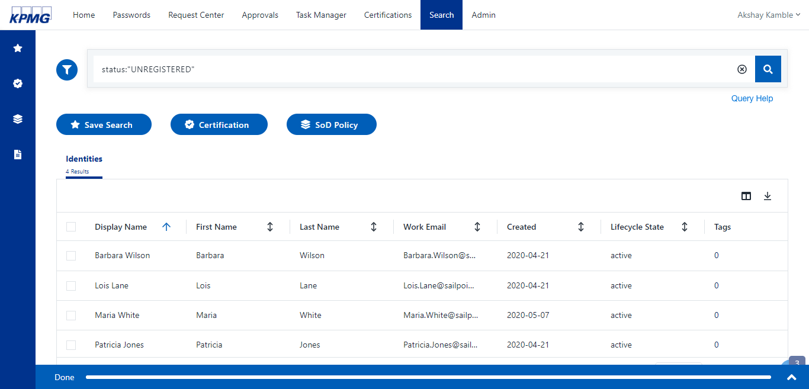

Figure 41: Dormant Account Report

1. Download a report from download link and ask the application team to clean up the accounts in the report.

## Identity Lifecycle Management

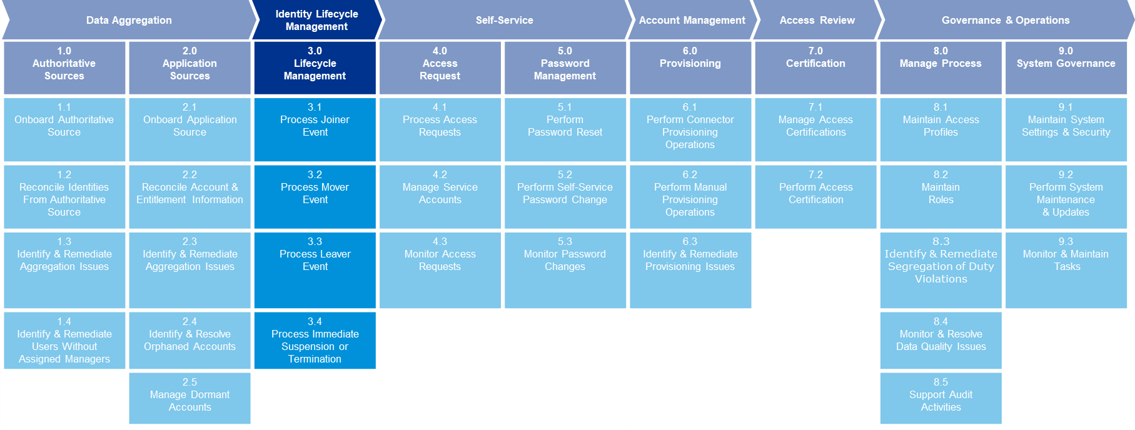

3.0

Lifecycle Management

### Lifecycle Management

This section contains an overview of the lifecycle events configured in IDN. The following user lifecycle events will be configured.

* Joiner
* Mover
* Leaver
* Leave of Absence (LOA)
* LOA Return
* Immediate Suspension or Termination

#### Process Joiner Event

**Powered 3.1**

##### Joiner Lifecycle State Configuration

1. Sign into IDN as an admin.
2. From the **Identities** menu, click **Identity Profile.** Select **H**R **Source Identity Profile**.

The identity profile details display.

**Note**: Select the Identity Profile created for HR Application (Authoritative Application).

1. From the Identity Profile details page, click the **Provisioning** folder.

The profile provisioning details display.

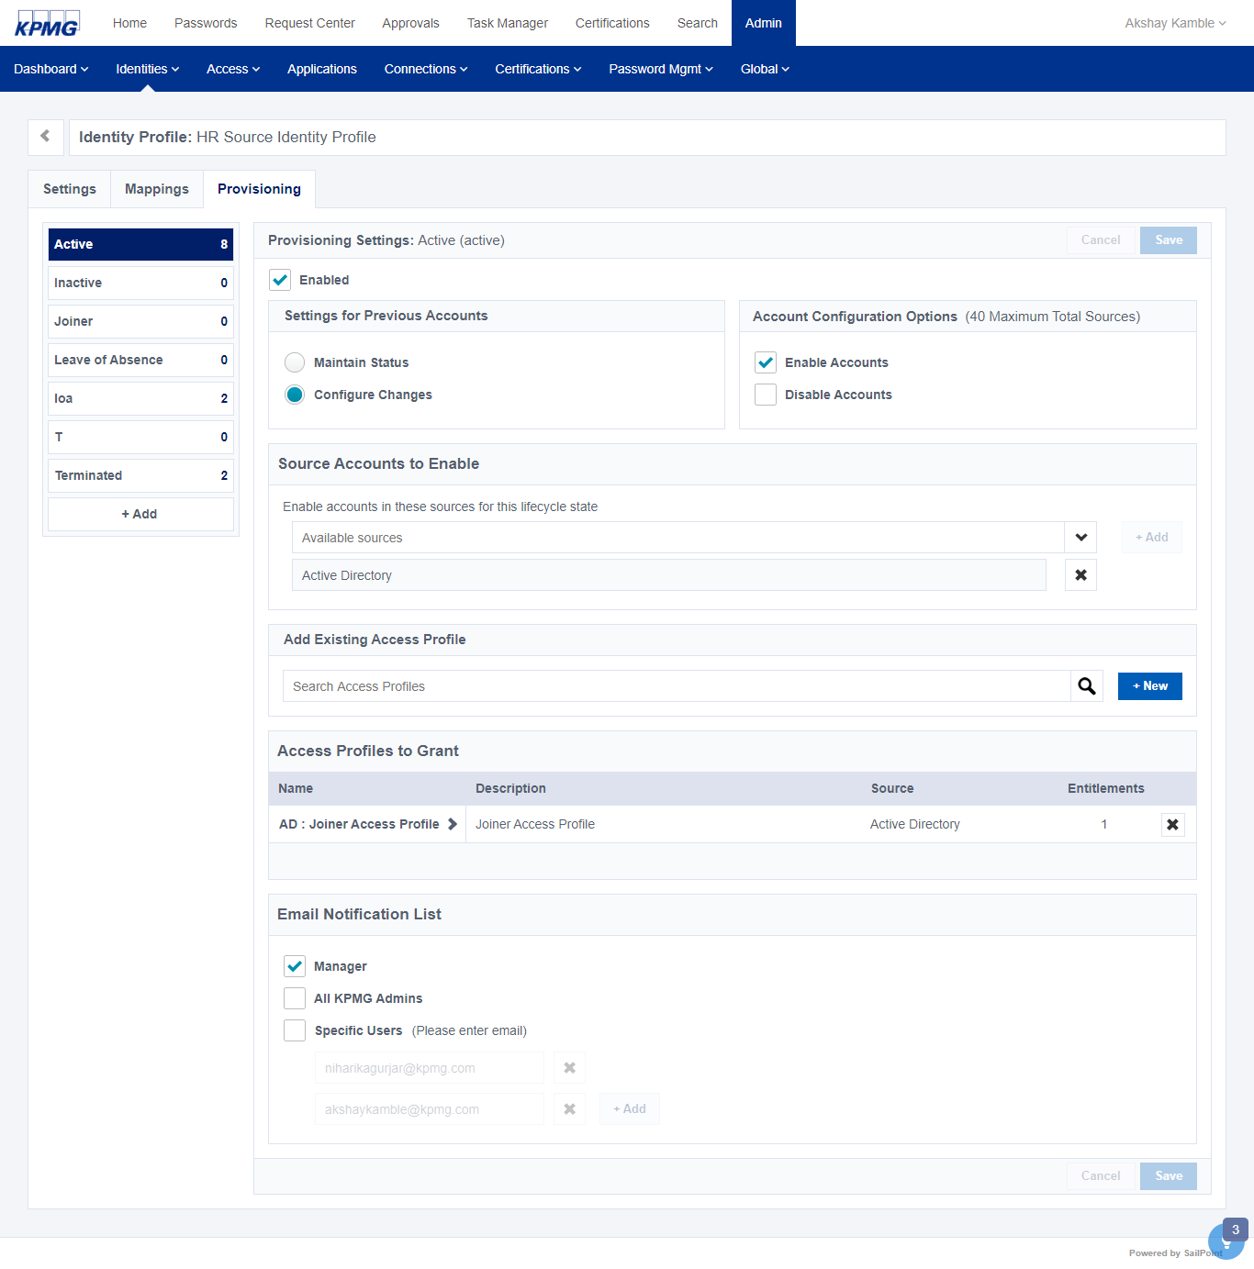

Figure 42: Lifecycle State Configuration

1. Change the lifecycle state to Active.
2. Click **+New** button in the Add Existing Access Profile section to add a new Identity Profile (Lifecycle State).

A new lifecycle state is created.

1. Modify the Lifecycle state using the following and click **Save**.

The lifecycle state is updated.

|  |  |
| --- | --- |
| Name | Value |
| Enabled | *true* |
| Setting for Previous Accounts | *Configure Changes* |
| Account Configuration Option | *Enable Accounts* |
| Source Account to Enable | *Active Directory* |
| Access Profile to Grant | *AD: Joiner Access Profile* |
| Email Notification List | *Manager* |

Table 21: Cloner Configure Lifecycle State for Joiner Configuration

#### Onboard a New User

1. Sign into SailPoint as an admin.
2. From the **Connections** menu, click **Sources,** then select the **HR** **Source** tile.
3. Select **Import Data** tab, then click the **Import Accounts** tab to open the section.
4. Click the **Import** button, select the **HR feed file (Authoritative Data)**, then click the **open** button.

The HR aggregation or authoritative source aggregation process into SailPoint begins.

1. After the account aggregation completes, click the **Account** tab to validate the account.

All new Identity Active Directory accounts should be created.

1. Select a new Identity, and click the **Accounts** tab to validate the **Active Directory** application is linked to the user.
2. From the **Roles** tab, validate the **Birthright** roles are assigned to user.

#### Process Mover Event

**Powered 3.2**

IDN does not provide an out of the box workflow feature or custom task to configure a flow that can trigger a certification for user that has a department change.

#### Process Leaver Event

**Powered 3.3**

##### Leaver Lifecycle State Configuration

1. Sign into SailPoint as an admin.
2. From the **Identities** menu, click **Identity Profile.** Select **H**R **Source Identity Profile**.

The identity profile details display.

**Note**: Select the Identity Profile created for HR Application (Authoritative Application).

1. Click the **Provisioning** tab and click the **Terminated** link.
2. Click **+New** button in the Add Existing Access Profile section to add a new Identity Profile (Lifecycle State).

A new lifecycle state is added.

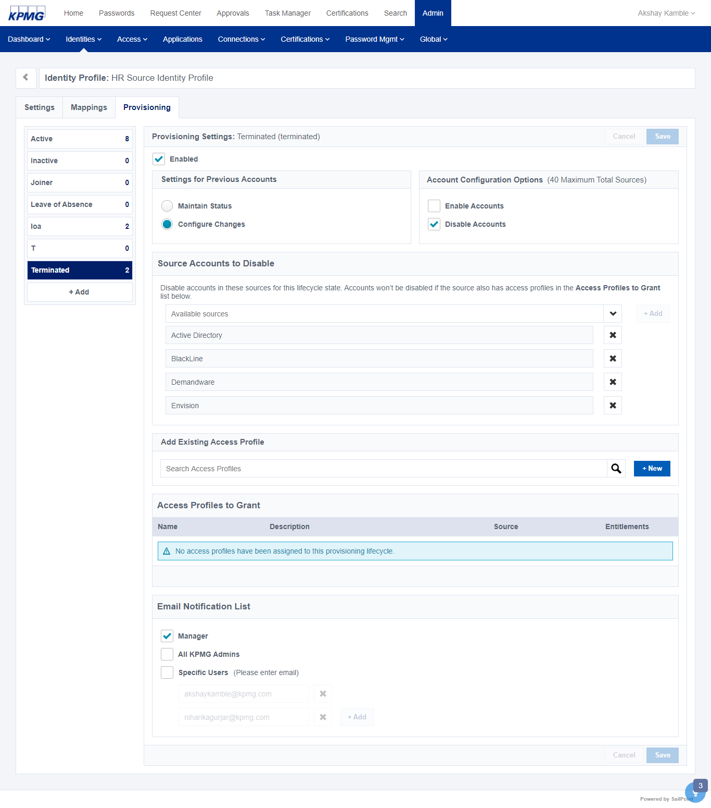

Figure 43: Terminated Lifecycle State

1. Modify the Lifecycle state using the following and click **Save**.

The new lifecycle state is updated.

|  |  |
| --- | --- |
| Name | Value |
| Enabled | *true* |
| Setting for Previous Accounts | *Configure Changes* |
| Account Configuration Option | *Disabled Accounts* |
| Source Account to Enable | *Active Directory*  *Black Line*  *Envision*  *Demandware*  *<Add All Accounts>* |
| Email Notification List | *Manager* |

Table 22: Leaver Configure Lifecycle State for LeaverConfiguration

##### Aggregate HR Data

1. Sign into SailPoint using admin user.
2. From **Connection** menu, click **Sources,** then select a Source (**HR** **Source).**
3. Click the **Import Data** folder and click **Import Accounts.**

The **Import Account**s section displays.

1. Click the **Import** button, select the **HR feed file** (Authoritative Data), then click the **Open** button.

The account aggregation process begins.

##### Analyze aggregated data for lifecycle event

The account aggregation process identifies disabled accounts for terminated users.

* If a disconnected application is associated with user (for example delimited or jdbc applications), instead of direct automated provisioning, manual work items will be generated in IDN and will be assigned to corresponding application team for manual fulfillment.
* An Email notification is sent to source owner to take action on the pending manual work item.

1. The Source owner completes required actions manually. For example set “IIQDisabled” to true for the user and perform aggregation task of the respective application.
2. Aggregation will disable the users account and an email notification will be sent to Users’ manager (for example the Lifecycle state change for <Users>).

#### Process Immediate Suspension or Termination

**Powered 3.4**

##### Immediate Suspension or Termination Configuration

1. Sign into IDN as an admin.
2. From **Admin** menu, click **Identities,** then select **Identity List.**
3. Select an Identity to terminate or suspend. For example, Mary Johnson.

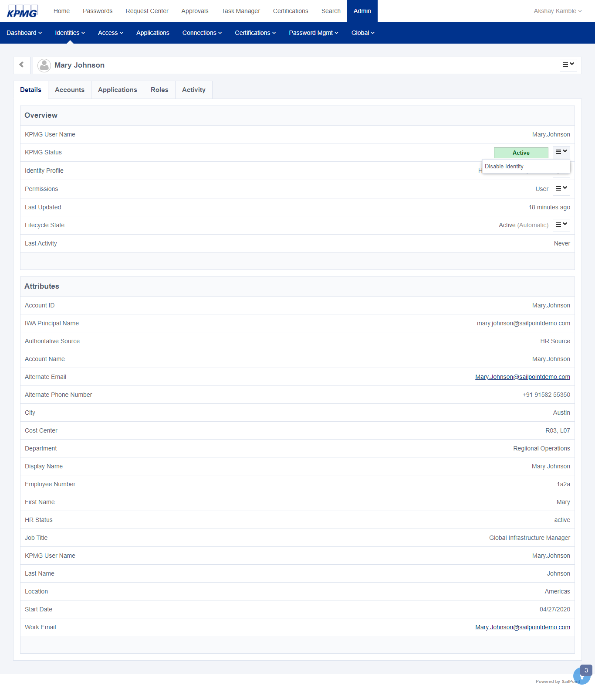

Figure 44: Mary Johnson User Account Details

1. Select **Disable Identity** option from **XYZ Status.**

The identity is disabled.

1. Select Terminatedfrom **Lifecycle State**

Thetermination lifecycle executes that will disable all user accounts from the system.

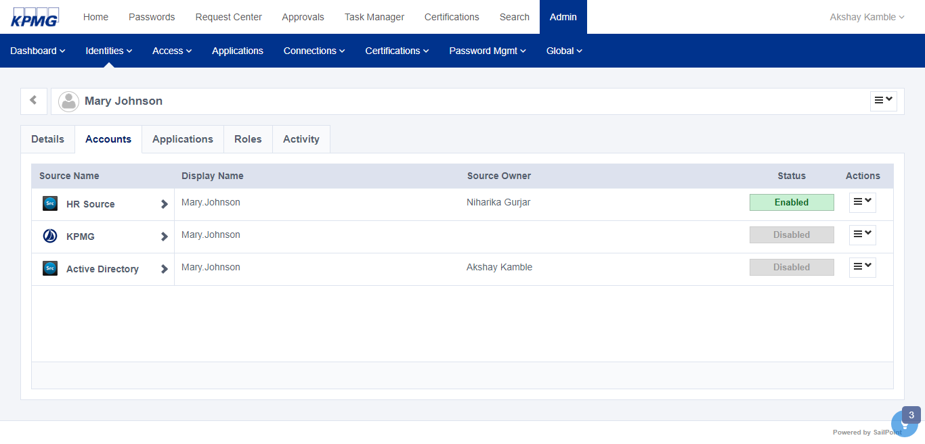

Figure 45: Mary Johnson Accounts

#### Leave of Absence – LOA

##### Prepare HR Data

To set the status of a user to leave of absence, change the HR status to “loa” in the HR feed file and save the changes.

##### LOA Lifecycle State Configuration

1. Sign into SailPoint as an admin.
2. From the **Identities** menu, click **Identity Profile.** Select **H**R **Source Identity Profile**.

The identity profile details display.

**Note**: Select the Identity Profile created for HR Application (Authoritative Application).

1. Click the **Provisioning** tab and click the **LOA** link.
2. Click **+New** button in the Add Existing Access Profile section to add a new Identity Profile (Lifecycle State).

A new lifecycle state is added.

1. Modify the Lifecycle state using the following and click **Save**.

The new lifecycle state is updated.

|  |  |
| --- | --- |
| Name | Value |
| Enabled | *true* |
| Setting for Previous Accounts | *Configure Changes* |
| Account Configuration Option | *Disable Accounts* |
| Source Account to Enable | *Active Directory* |
| Email Notification List | *Manager* |

Table 23: LOA Lifecycle State Configuration

##### Aggregate HR Data

See Aggregate HR Data

##### Analyze Aggregated Data for LOA

1. After the aggregation process completes, click the **Accounts** tab to validate the state of the account is **LOA**.
2. Select an Identity with an HR Status of **LOA.**
3. Click the **Accounts** tab and validate the **Active Directory** application status has changed or is in the **Disabled** state.

An email notification is sent to the Users manager i.e. **Lifecycle state change for <Users>.**

#### Process LOA Return Event

##### Prepare HR Data

When a user returns from a leave of absence event, change the users’ HR status from **LOA** to **active** in the HR Feed file and Save the changes.

##### Configure Lifecycle State for LOA

1. Sign into IDN using as an admin user.
2. Point to the **Identities** tab, click **Identity list**, click I**dentity Profile**, then select **Identity Profile (HR Source Identity Profile).**
3. From the **Identity Profile** section, click the **Provisioning** tab.
4. Click **+Add** button to add a lifecycle.
5. Name the lifecycle state **Active** and click the **OK** button.

A new lifecycle state is added.



Figure 46: Active LifeCycle State

**Note**: To use the existing “Active lifecycle State” for this LOA Return scenario refer to section 4.2.1.1.1

1. Modify the Lifecycle state using the following and click **Save**.

The new lifecycle state is updated.

|  |  |
| --- | --- |
| Name | Value |
| Enabled | *true* |
| Setting for Previous Accounts | *Configure Changes* |
| Account Configuration Option | *Enable Accounts* |
| Source Account to Enable | *Active Directory* |
| Access Profile to Grant | *AD: Joiner Access Profile* |
| Email Notification List | *Manager* |

Table 24: Active Lifecycle State Configuration

##### Aggregate HR Data

See Aggregate HR Data

##### Analyze aggregated data for LOA Return

1. After the aggregation process completes, click the **Accounts** tab to validate the state of the account is **LOA**.
2. Select any Identity whose HR Status has changed from **LOA** to **active**
3. Click the **Accounts** tab and validate the **Active Directory** application status is in the **Enabled** state.

An email notification is to the Users manager i.e. **Lifecycle state change for <Users>.**

## Self-Service

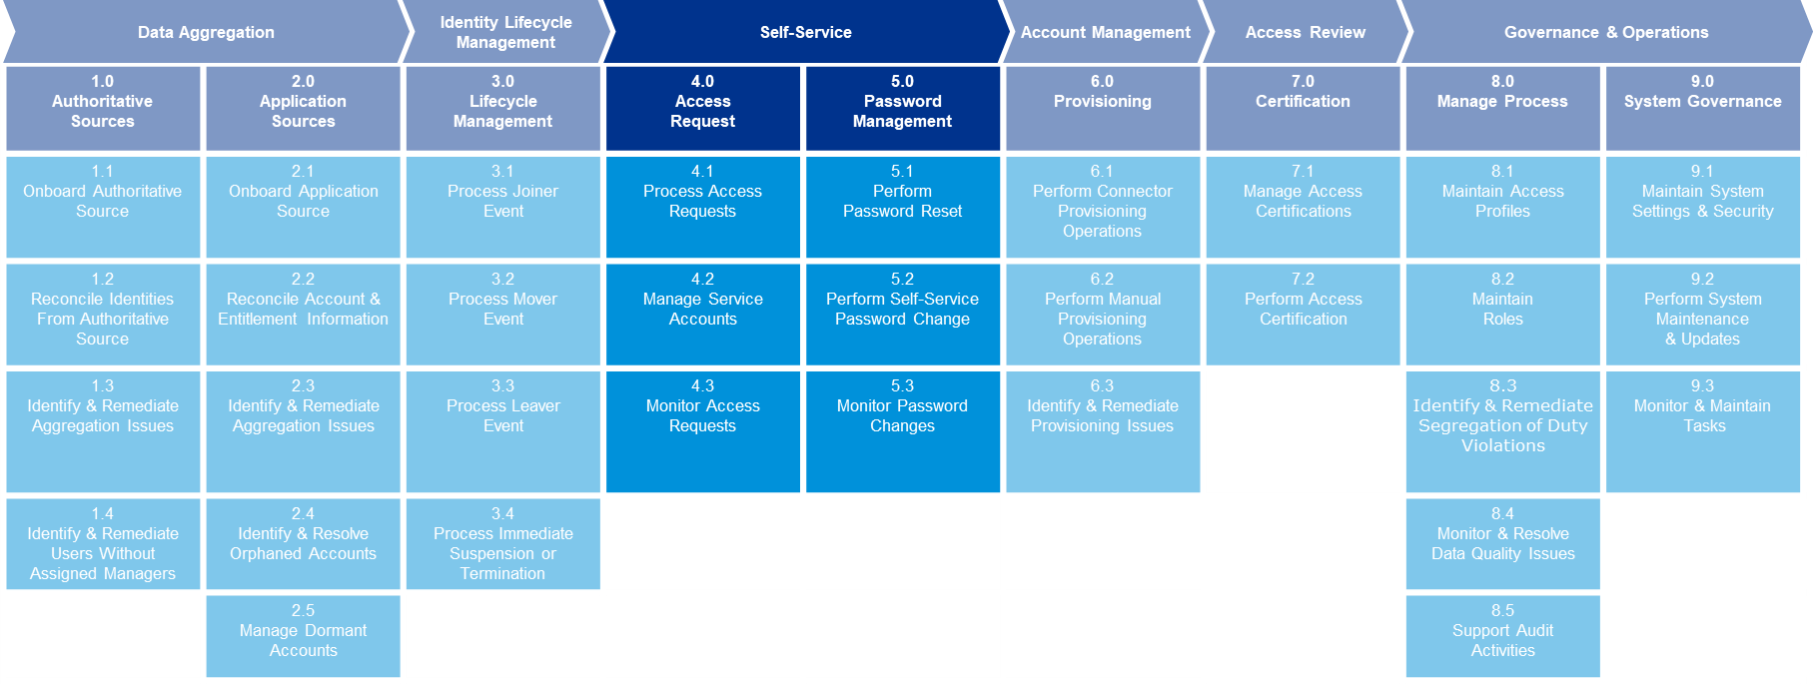

Powered 4.0

Access Request

### Access Request

This section is an overview of configuring and monitoring access requests.

#### Process Access Request

**Powered 4.1**

##### Creating Access Profile

1. From the IDN home screen, point to the **Admin** menu, click **Access**, then select **Access Profiles.**

Access profiles currently configured display.

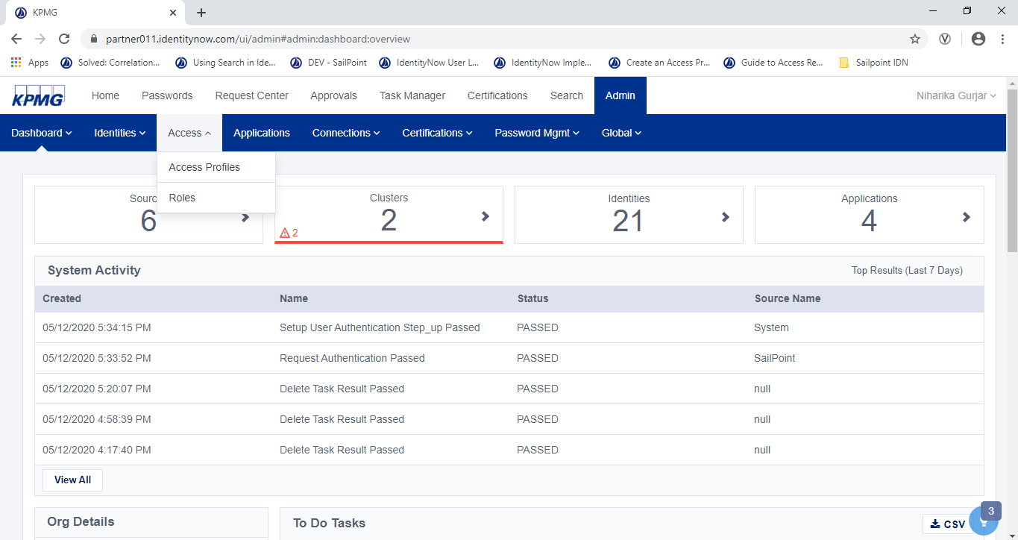

Figure 47: Access Profile Navigation

1. Click the **New** button and enter a Name and Description for the access profile. For example, type XXX for name and XXX for description.

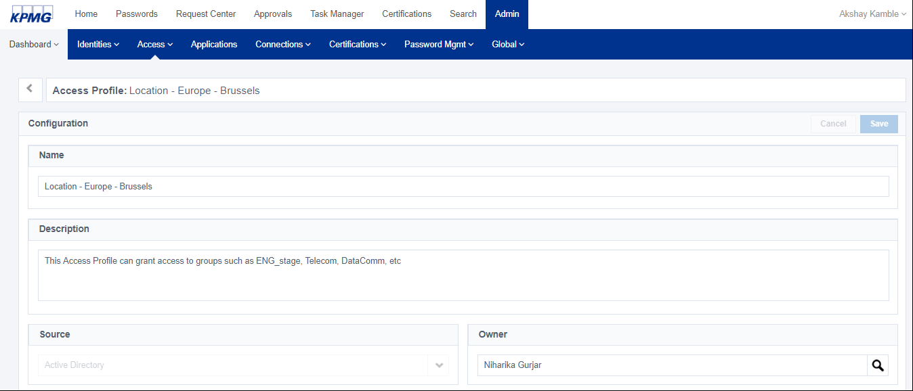

Figure 48: Creating Access Profile

1. From the **Source** text box, choose the **source** containing the entitlements for the access profile.
2. From the **Owner** text box, select an **owner** for the access profile.
3. An approval process is often required to ensure that user is requesting appropriate access, and any unauthorized access is not granted. If needed, configure an approval process for the access profile using the following process.
   * 1. In the Access Request Approval Process box, deselect (remove the check mark) **No Approval Required.**
     2. In the **Required Approvers** box, select an approver or governance group. Click the **Add** button. Repeat this step to add additional approvers or governance groups.
     3. If necessary, rearrange the approvers to reflect the approval order. For example, the primary approver is first in the list.
     4. To require the reviewer to add a comment or a reason for requesting the access, check the **When User Requests** checkbox in the **Require Comments** section.
     5. To require reviewers to provide comments when they reject a request, check the **When Approver Denies** checkbox.
4. Profile can contain one or more entitlements. Select one or more entitlements for the access profile.
5. Click the **save** button.

The access profile is saved.

##### Configure an Application

An application is a business wrapper on top of the source. Because end users can’t request a source directly , we create and application and link that application to corresponding source. Complete the following steps to configure an application.

1. From the **Admin** menu, click **Applications**.

The **Applications** display.

1. Select an existing app by clicking an **Application tile** or create​ a new app by clicking the **+New** button.
2. From the **Accounts Created By** list, select **Admin/IT**
3. Click the **Configuration** tab and select **Enable for Users**

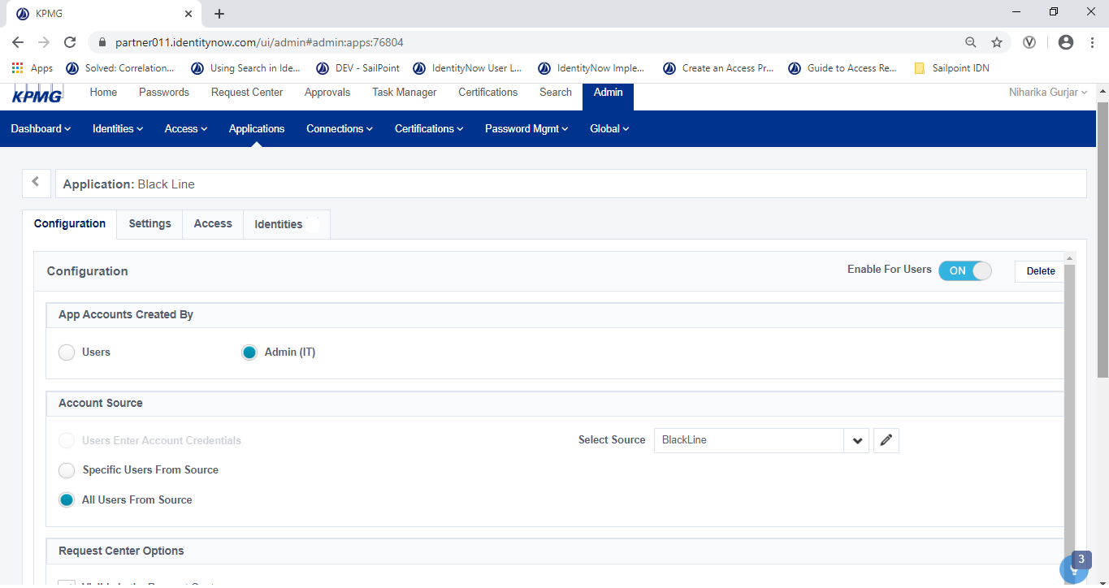

Figure 49: Application Configuration UI

1. From the **Account Source** box, select **All Users from Source.**
2. In **Select Source,** select the source for the user accounts.
   * If the Password Management feature in IDN is enabled and you do not have SSO, select sources that have Password Management enabled.
   * To make changes to the source selected, click the Edit icon to the right of the field.
3. Click **Save**.

The application is saved.

1. Click the **Access** tab for the app to associate access profiles to the app.

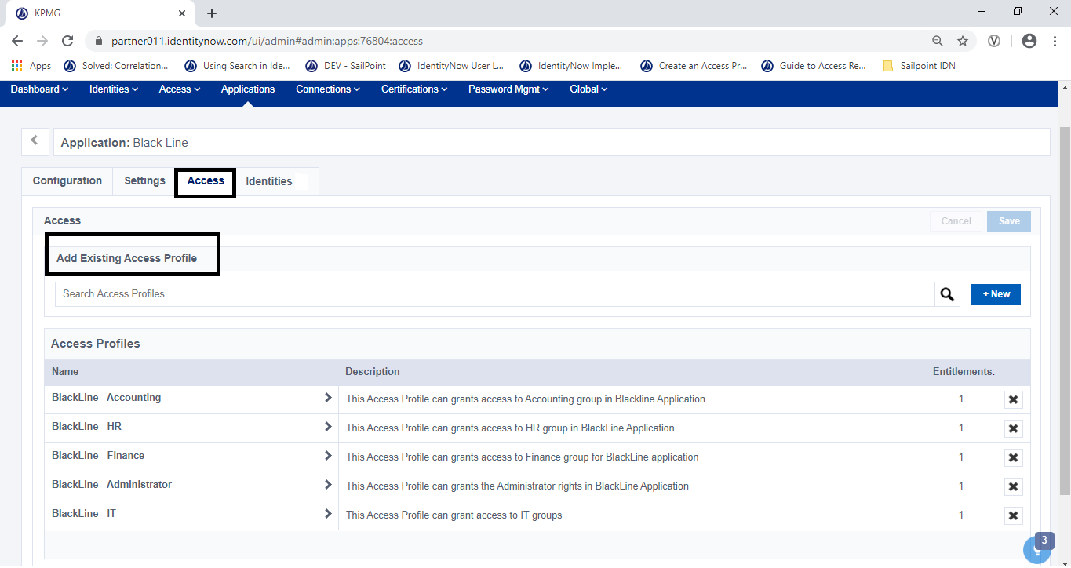

Figure 50: Add Access Profile

1. Add access profile(s) to the application from the **Access** section.

* To add an existing application, select one or more access profiles in the **Access Profiles** section.
* Click the **+New** button to create a new access profile

1. Click the **Save** button to save the Application Configuration.

#### Configuring App Requests for Others

The following explains how to specify who is allowed to make application request for others.

1. From the IDN home screen, point to the **Admin** menu, click **Global**, then select **System Settings.**

The **System Settings** screen displays.

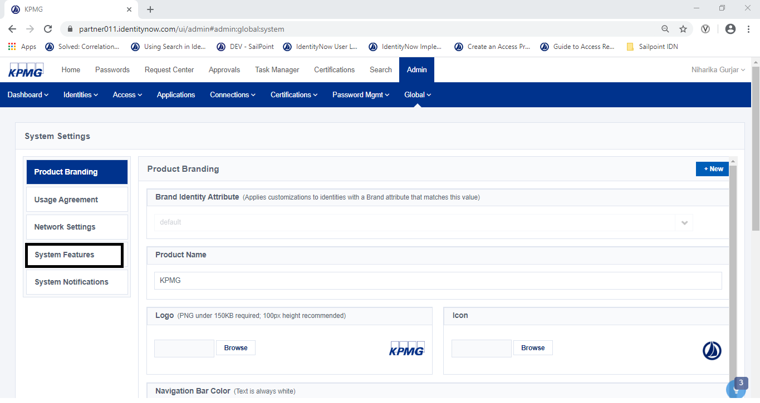

Figure 51: Navigate to System Settings

1. Click **System Feature** the select the box for **Enable Request on Behalf Of** in the **Access Requests** section.

The Managers Only and Everyone options become active.

* To allow only managers to submit access requests for others, select **Managers Only.**
* To allow anybody submit access requests for others, select **Everyone**.

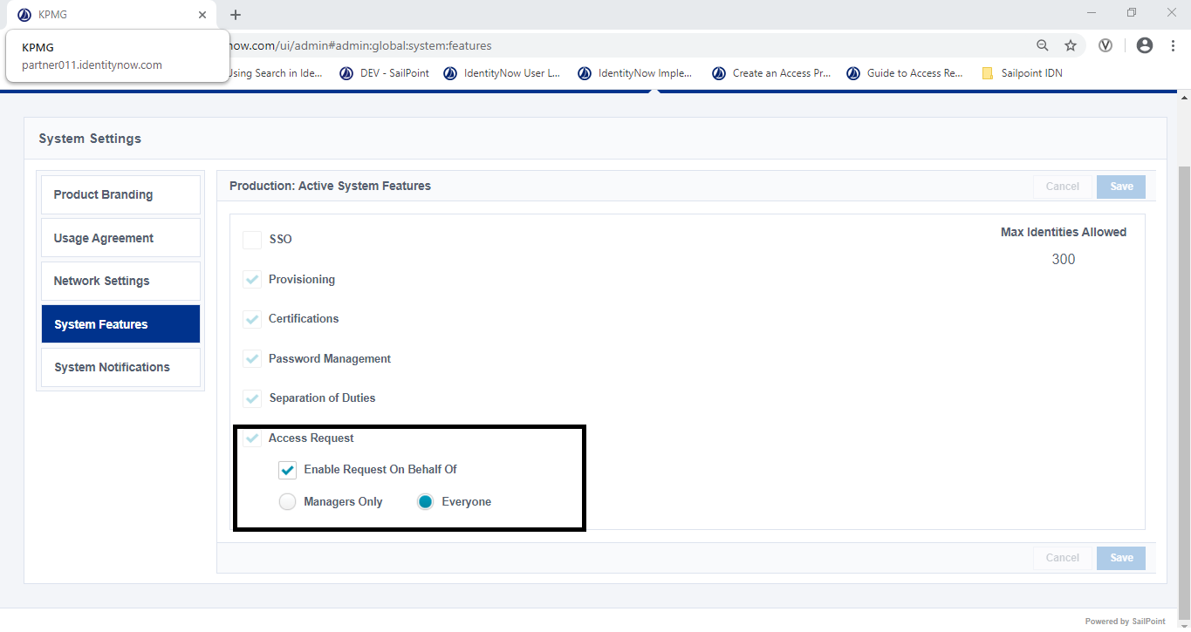

Figure 52: Configuring Access Request for everyone

#### Configuring Requests for Roles

1. From the IDN home screen, point to the **Admin** menu, click **Access**, then select **Roles**.



Figure 53: Navigate to Roles

1. Create a new role by clicking the +**New** button or select one from the list.

The **Config** screen displays for the role.

1. In the **Configuration** section, select **Enable Role** (if it is not already selected) and select **Request**able.

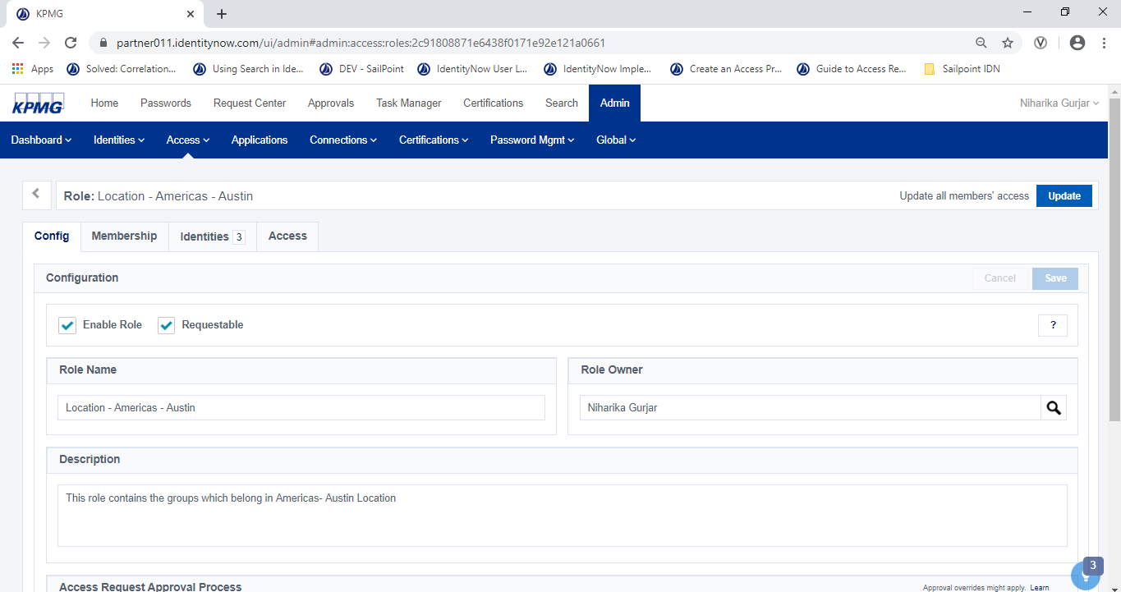

Figure 54: Configuring Request for Roles UI

1. Enter additional required information for role such as Role Name, Role Owner, and Description.
2. In the **Access Request Approval Process** section, deselect **No Approval Required**.
3. Select a reviewer or governance group in the **Required Approvers** list box and click the **Add** button. If required, repeat this step to add additional reviewers or groups.

The reviewer or governance group(s) is added.

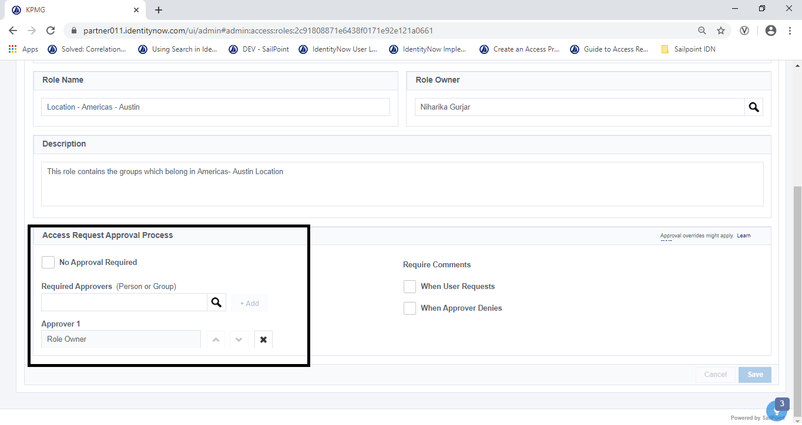

Figure 55: Role Approver Configuration

1. To require the reviewer to add a comment or a reason for requesting the access, select the **When User Requests** checkbox in the Require Comments section.
2. Select the **When Approver Denies** checkbox to require comments when a request is denied.

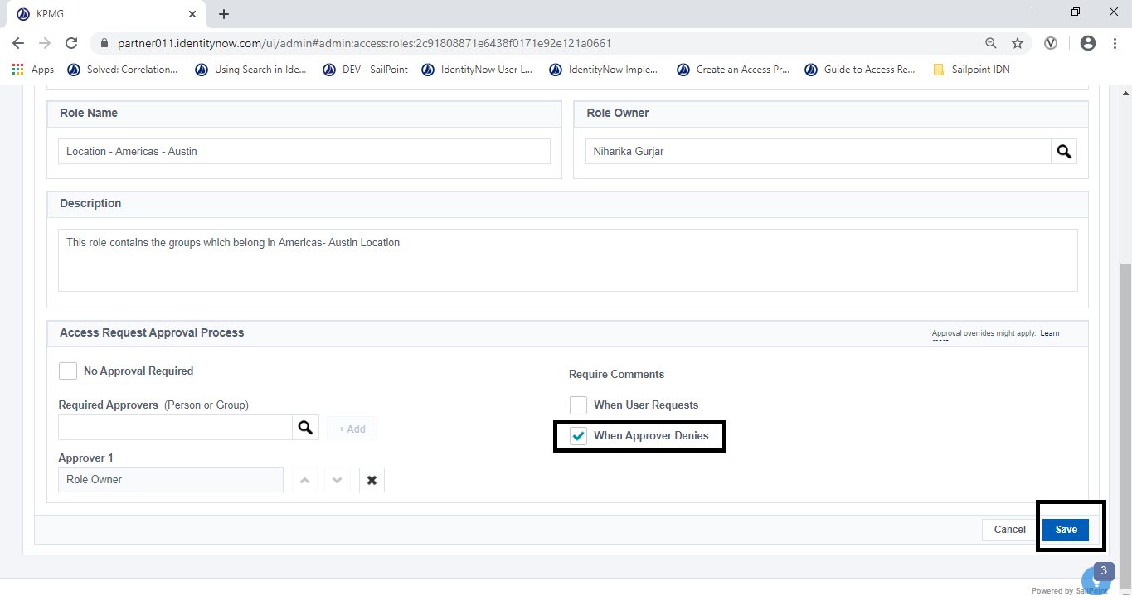

Figure 56: Role Comments Configuration

1. Click **Save** to save the role configuration.

#### Adding and Requesting Applications

1. From the IDN home screen, click the **Request Center** tab.

The request center screen displays.

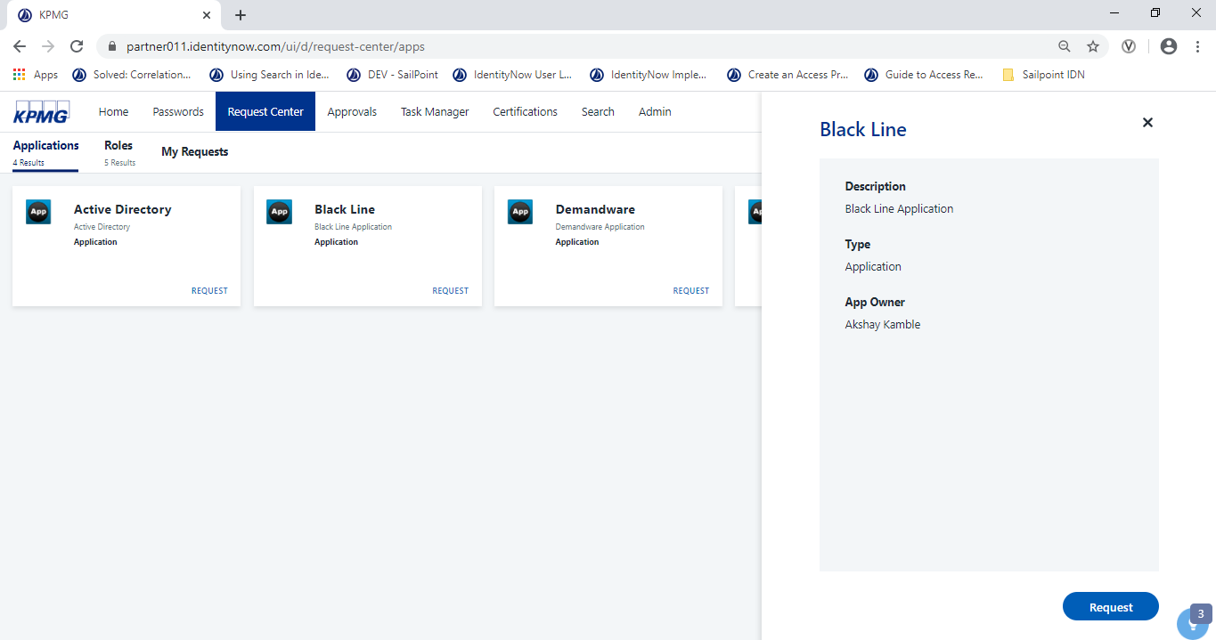

Figure 57: Adding and Requesting Application UI

1. Click the **Applications** tab and select an app card to view more details about the app.

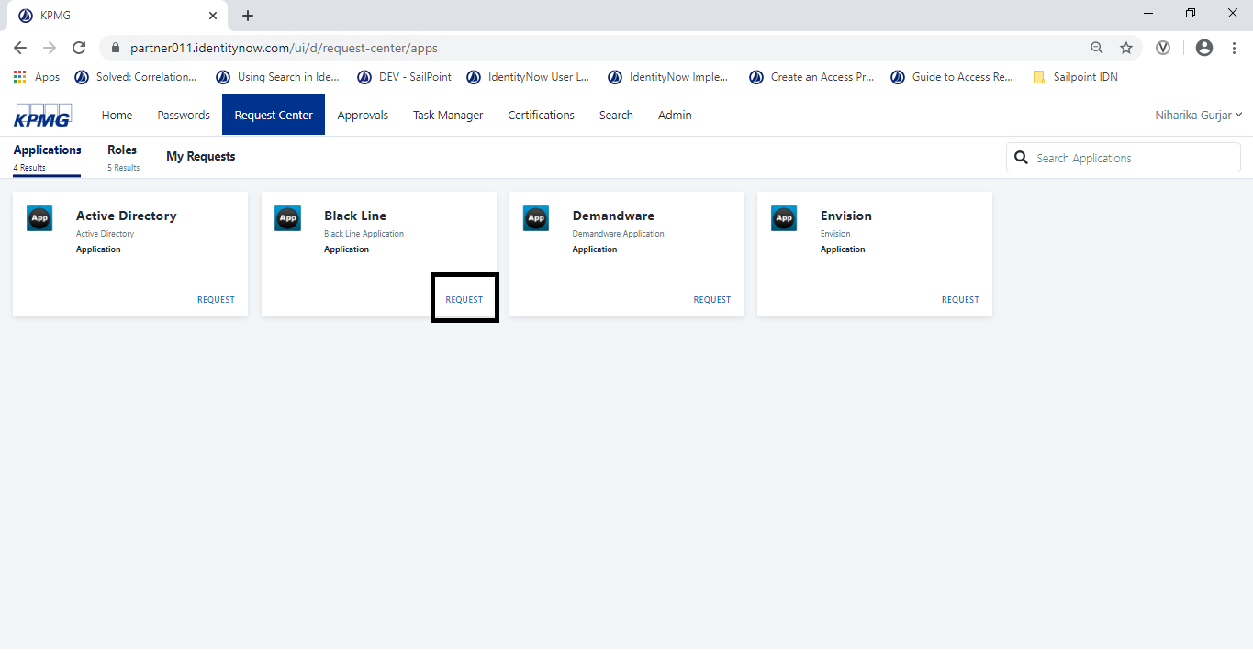

Figure 58: Application Request List

1. Click the **Request** link located on bottom right corner of the App card.

The **Request** screen displays for the application.

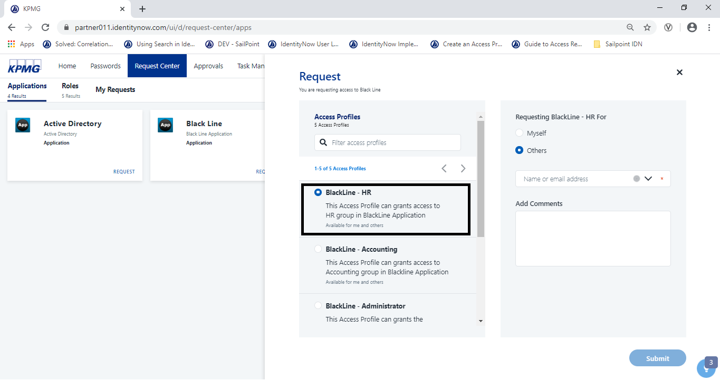

Figure 59: Choosing Access Profile

1. From the **Request** screen, select an access profile for the application in the Access Profiles section.
2. Select Myself or Others from **Requesting *Application* For**. If **Others** is selected, enter their name(s) using the drop-down.

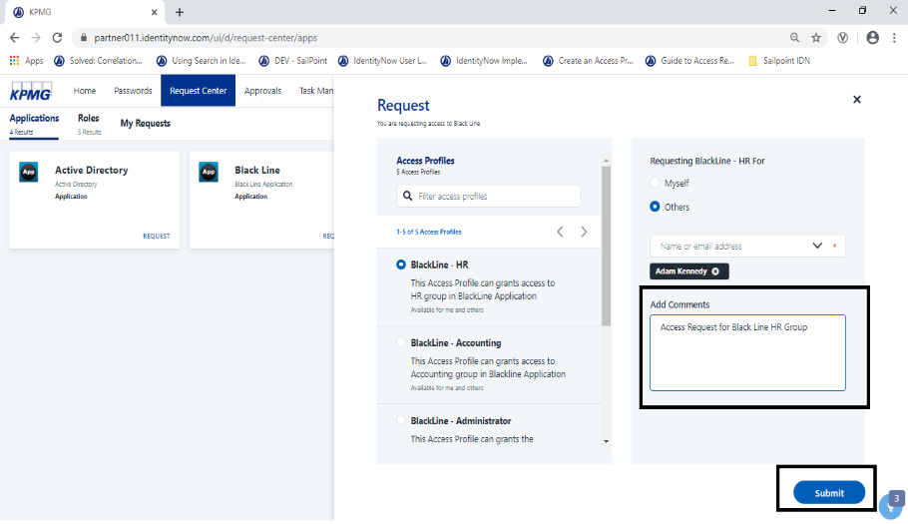

Figure 60: Add comments for New Request

1. If required, type comments about the request in the **Add Comments** box.
2. Click the **Submit** button

The request is submitted and sent for approval.

**NOTE**: Requesting Applications for a connected sources (E.g. Active Directory) follows the same process.

#### Requesting Roles

1. From the IDN home screen, click the **Request Center** tab.

The request center screen displays.

1. To request a role, click the **Roles** tab and use the **Search** bar to find the role to be requested.

To see details about a role, click the role card.

1. Click the **Request** link located on bottom right corner of the role card.

The **Request** screen displays for the role.

1. Select Myself or Others from **Requesting For**.

If **Others** is selected, enter their name(s) using the drop-down.

1. If requesting for others, enter their name(s) using the drop-down.

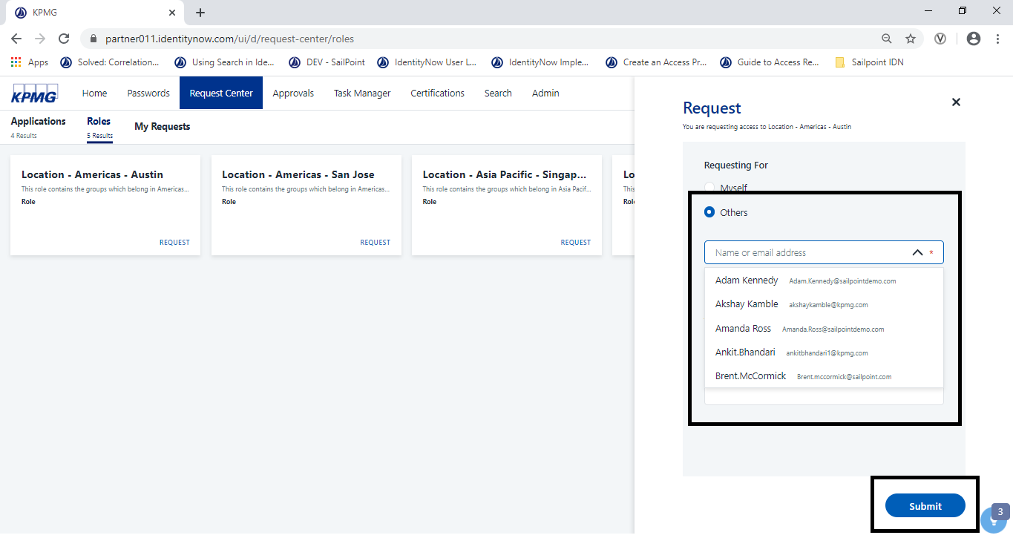

Figure 61: Select User to Request Role

1. If required, type comments about the request in the **Add Comments** box.
2. Click the **Submit** button

The role request is submitted

#### Manage Service Accounts

**Powered 4.2**

IDN does not provide a feature to mark an account as a Service Account. However, accounts can be configured to function as a Service Account (E.g. Granting User with Admin rights)

#### Monitor Access Request

**Powered 4.3**

Requests can be tracked from the Dashboard.

1. From the IDN home screen, click **Dashboard**.

The **Dashboard** displays.

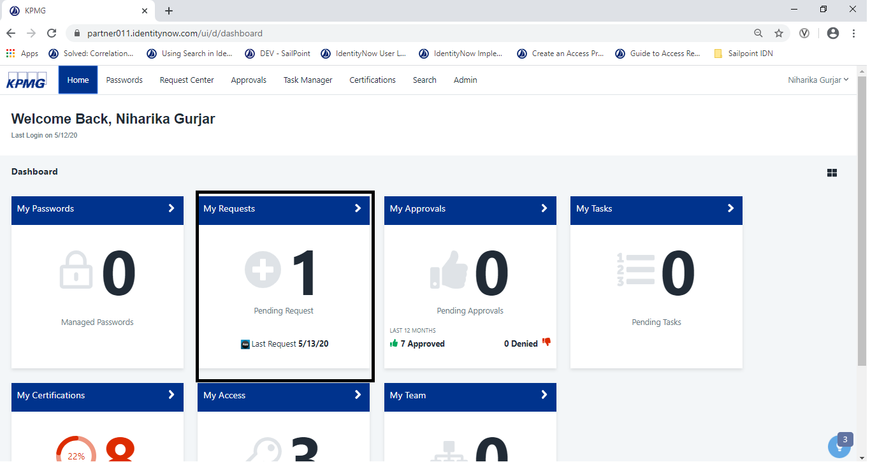

Figure 62: Monitoring Access Request

1. Click the **My Requests** card to view the total number of pending access requests and date of last request.
2. Click a **request card** to view additional information.

The **Request Status Tracker** displays the status and workflow details about each step in the access review process.

#### My Requests in the Request Center

1. From the IDN home screen, click **Request Center** from the top level menu, then click **My Requests**.

The **My Requests** screen displays.

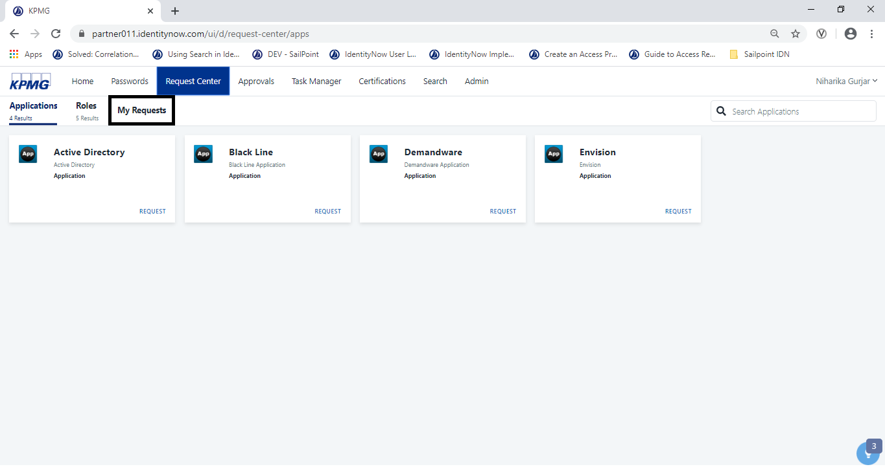

Figure 63: All Request List

1. Click a **request card** for an access request to view additional information.

The **Request Status Tracker** displays the status and workflow details about each step in the access review process.

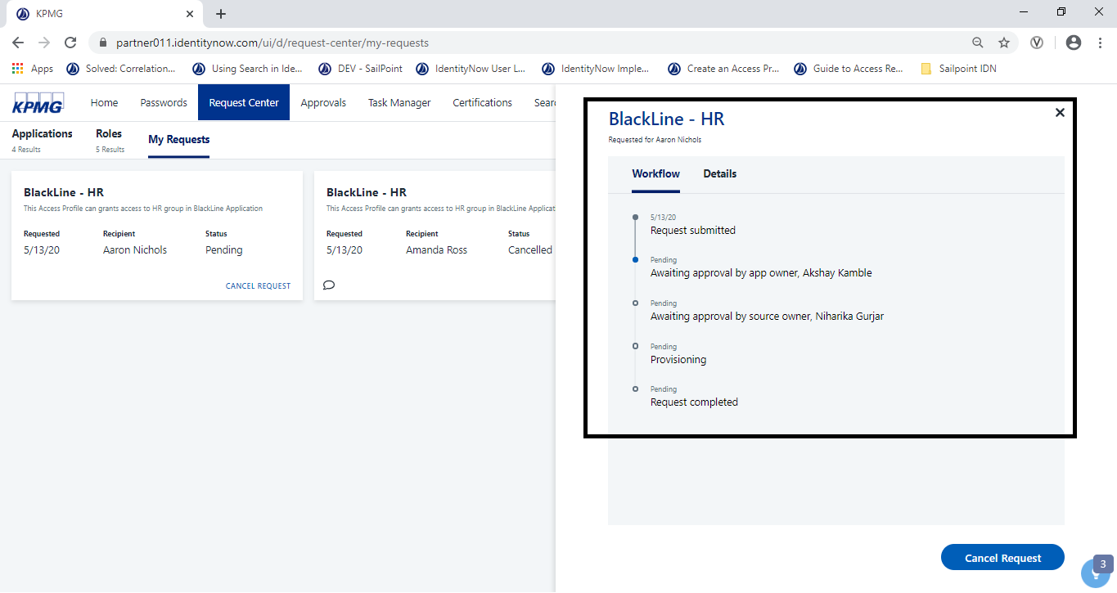

Figure 64: Request Workflow

1. Click the **Details** tab.

Additional information about the access request display such as:

* Completion dates for completed steps and reassignments
* The current status
* Reviewer type (manager, owner, or governance group)
* Reviewer name or governance group name

1. To cancel a request, click **Cancel Request.** The status is updated to reflect this change.

#### Reviewing Request for Connected and Disconnected Applications (Powered Taxonomy 6.2)

1. **Reviewing Disconnected Applications**

Disconnected applications are those applications where provisioning to the target system manual process. Once approved, provisioning is assigned to an application administrator to manually provision access to the target system.

1. Sign into IDN as an administrator who will manually provision application access. From the IDN home screen, click **Approvals**.

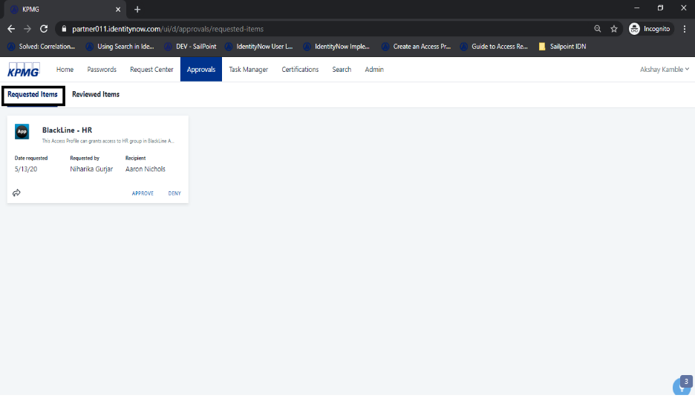

Figure 65: Approvals

1. Click **Requested Items**, then select a **request card.**

Details about the request will appear on the right side of screen.

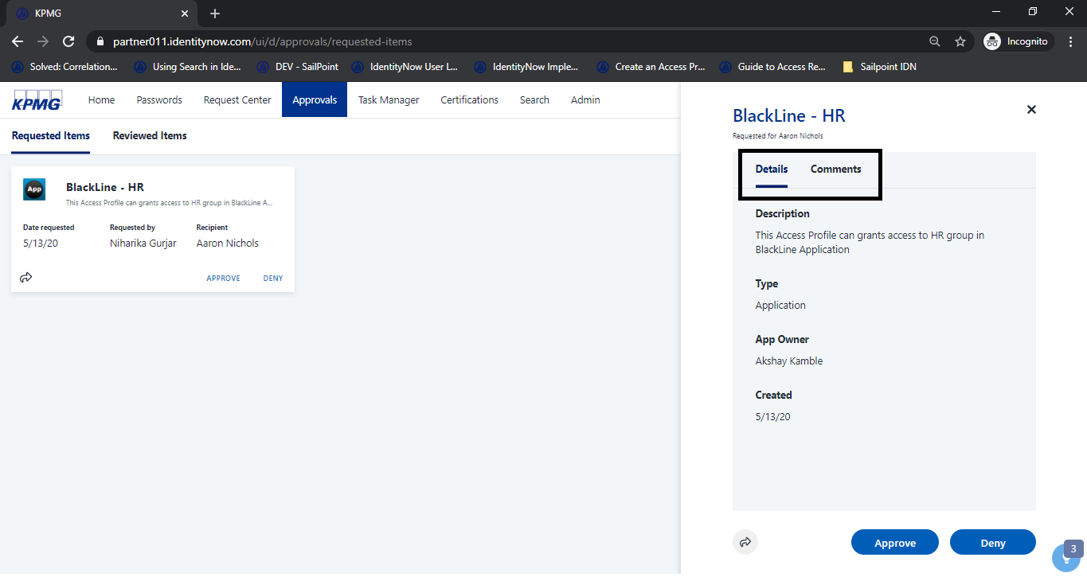

Figure 66: Request Details

1. Review the following information to determine if the user needs access:
   * **Details**: This tab contains the item's Description, Type, Role Owner, and Created date.
   * **Comments:** When applicable, this tab contains any comments associated with the access request.
2. Click the **Approve** or **Deny** button.

The configuration is saved.

1. Click the **Reviewed Items** tab.

Access requests recently approved or denied display.

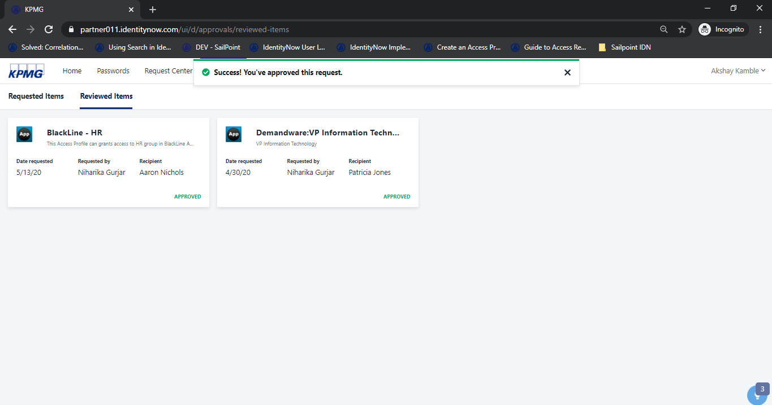

Figure 67: Approved Request Message

1. To finalize the process, the application owner logs into IDN to manually fulfill the request. Sign into IDN using an Admin Account. Click **Dashboards** then click the **My Tasks** card.

The **Task Manager** page displays.

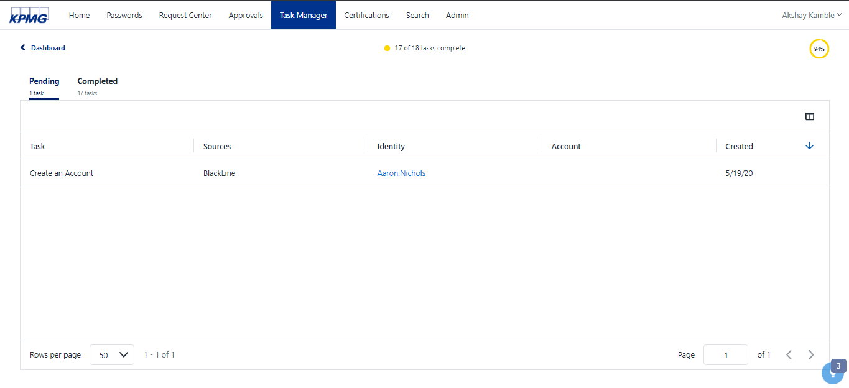

Figure 68: Work Item generated

1. Click the xxx to open the Create an Account screen for the work item.

The Create an Account screen displays.

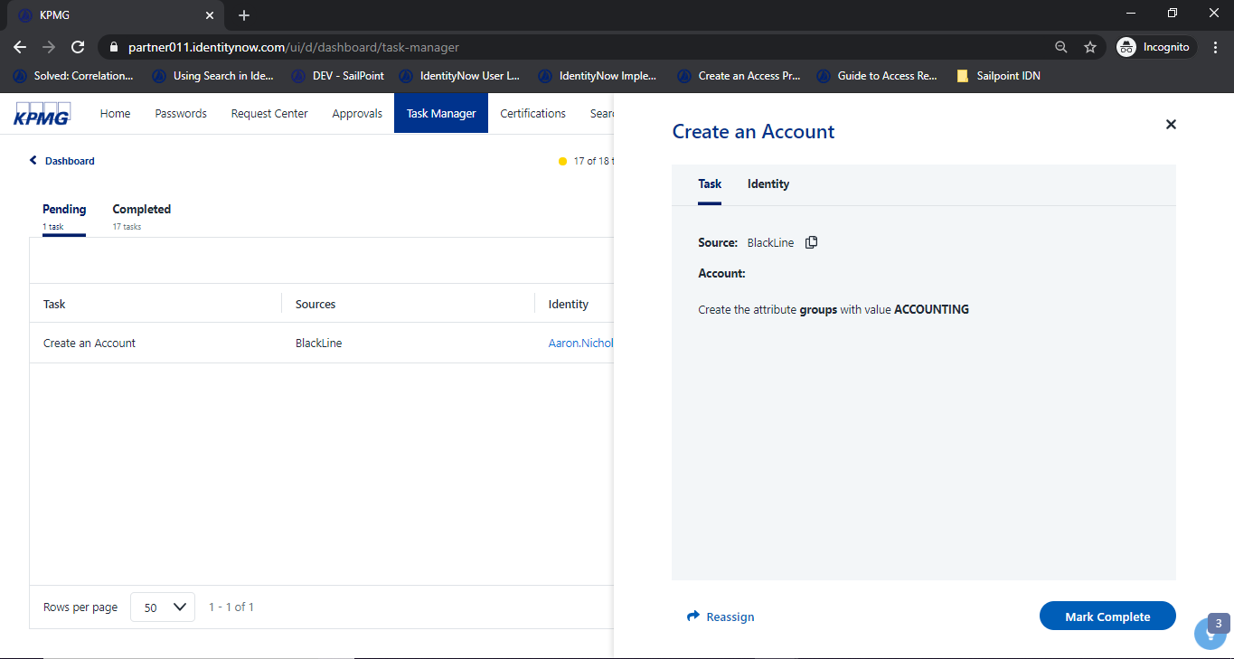

Figure 69: Create an Account

1. Approve the manual work item generated by click the **Mark Complete** button
2. Add the details in the application account feed file and aggregate the source.

**Note**: In a real time environment, this step should not be required and should be seamless. However, because we are working with a test application in this workflow, we need to perform this step to close the access request.

Consider this use case: End user access is requested, it is approved by a manager, and the application owner granted the requested access in target system. The application account feed file represents the data in target system. In this step, assuming request is granted, we are manually adding a record to aggregate it back into IdentityNow.

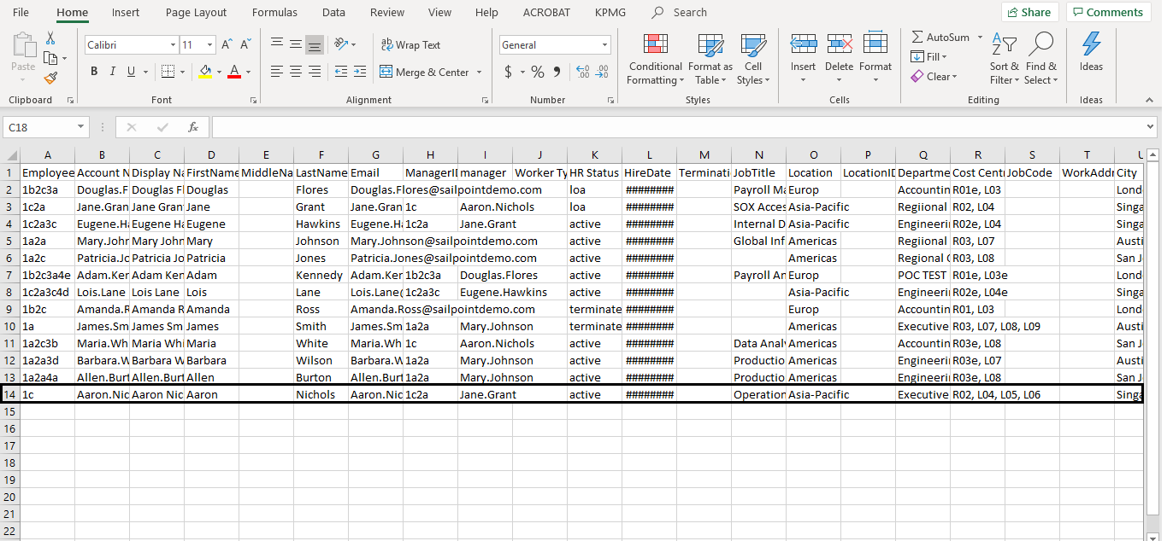

Figure 70: HR Source Data

1. **Reviewing Connected Applications**
2. From the IDN home screen, click the **Approvals** tab.

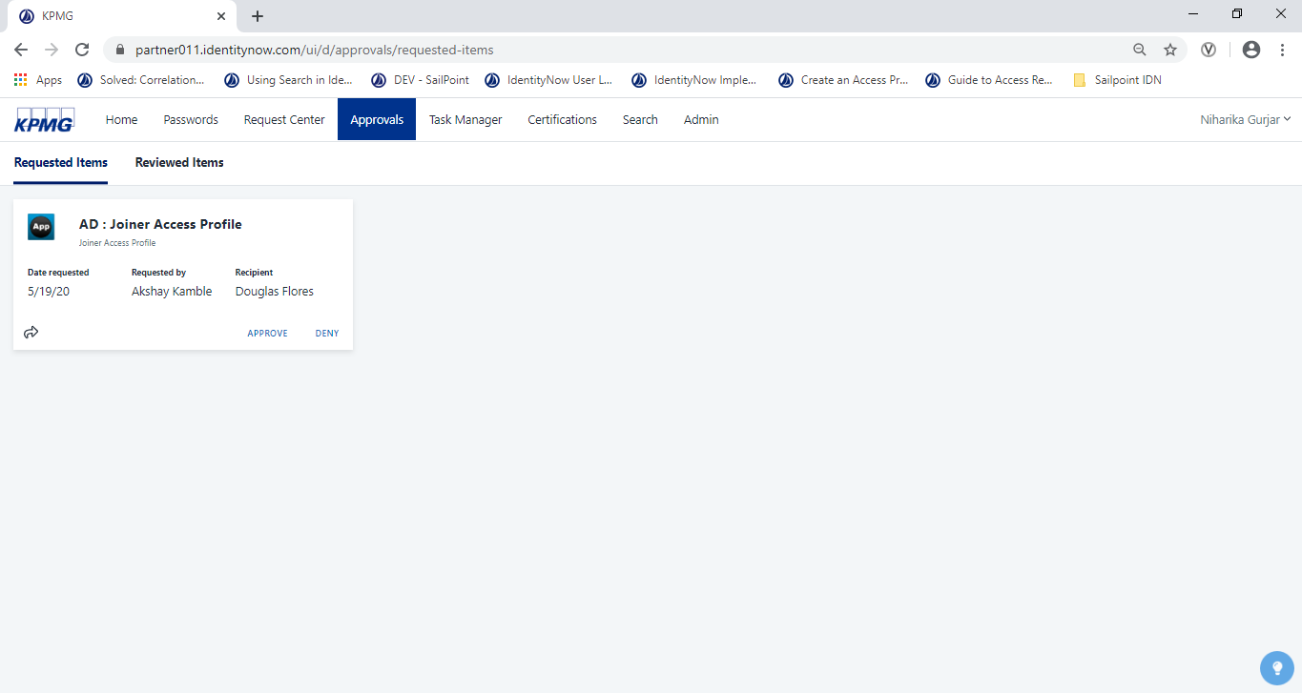

Figure 71: Request for Connected Application

1. Click the Requested Items link then select a request card.

Details about the request display on the right side of the screen.

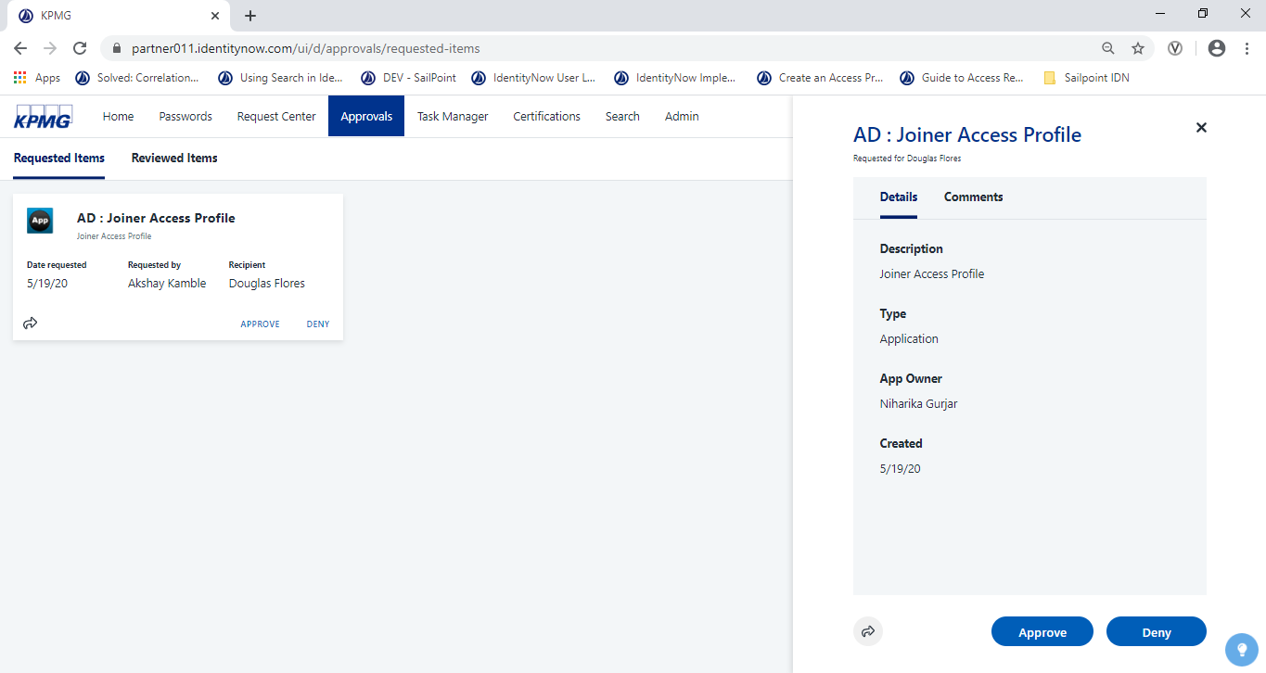

Figure 72: Request Approvals

1. Review the following information as required and determine whether the user needs access then click the Approve or Deny button.

The **Success** message displays.

1. Click the **Reviewed Items** tab to view recent access requests.

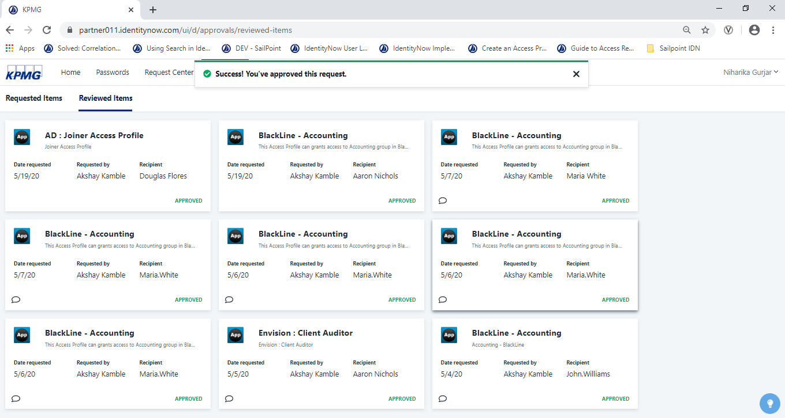

Figure 73: Request Reviewed Items Tab

The validate the request:

1. Point to **Identities** then click **Identity List.**
2. Click the Identity whose request has been Approved/Revoked
3. In Accounts Tab verify that Application has been granted for Approved or not (Revoked)

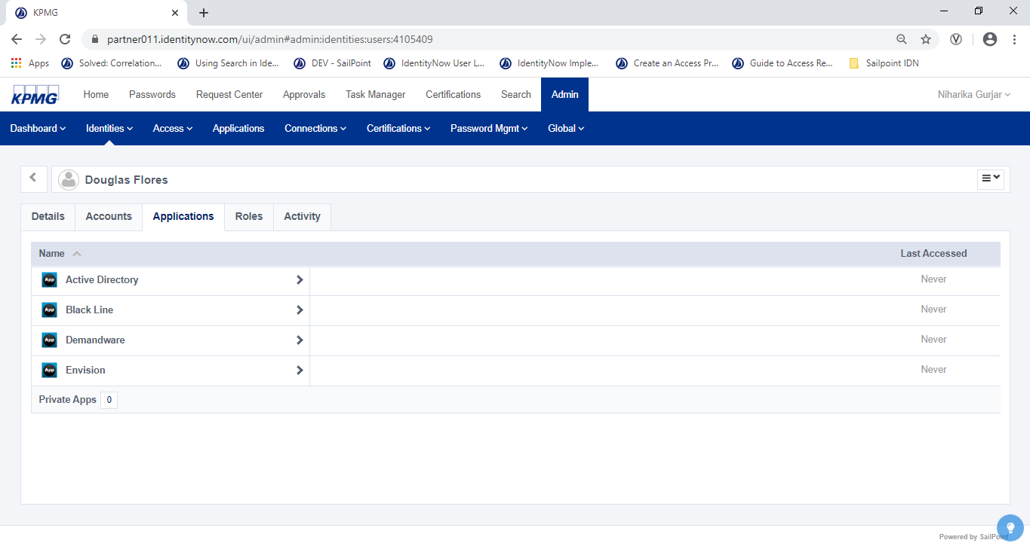

Figure 74: User Applications

Powered 5.0

Password Management

### Password Management

This section details the password management including password reset and password changes.

#### Perform Password Reset

**Powered 5.1**

Out of the box IDN provides ‘Problems signing in?’ on a login screen. Users with access to the link can get their username, unlock their account, and reset a password.

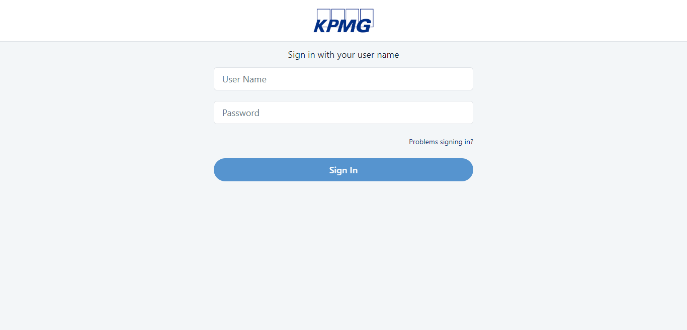

Figure 75: IDN Login Screen

1. The following options display when the ‘Problem signing in?’ link is clicked:

* Forget User Name
* Reset Password
* Unlock Account

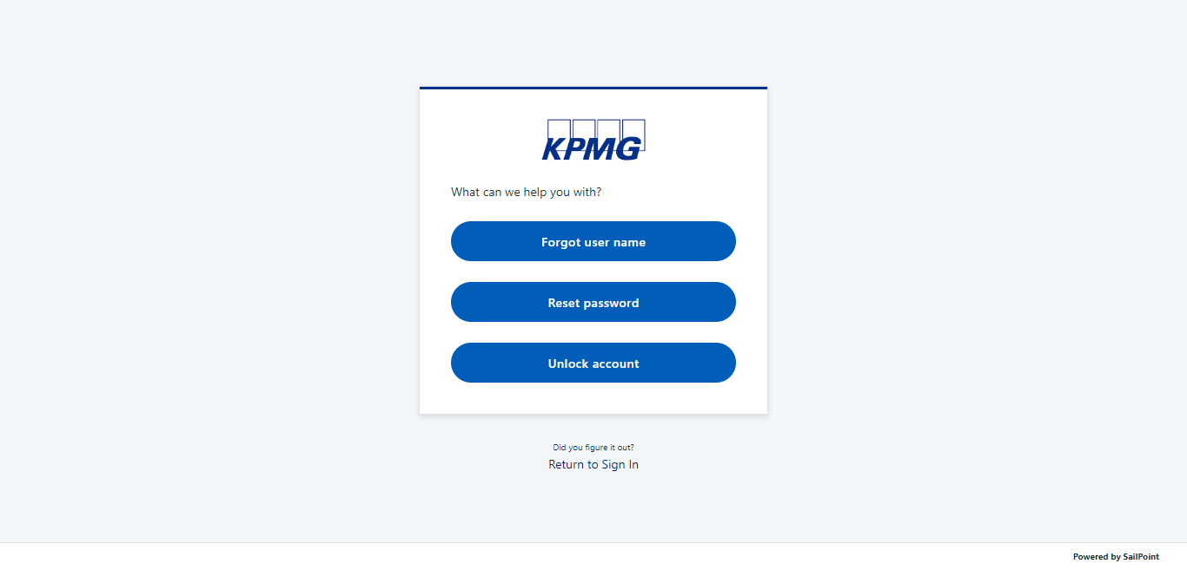

Figure 76: User Reset Password

1. Click on the **Rest Password** option and enter the user name of user to rest the password.

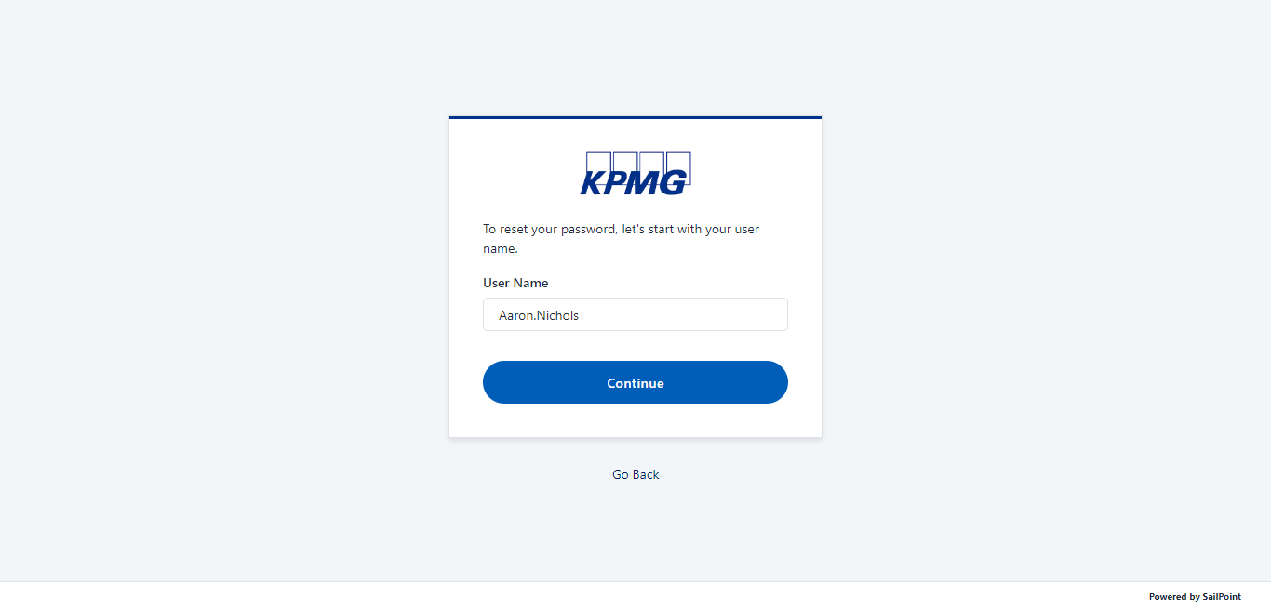

Figure 77: Reset Password for User

1. Click the **Continue** button.

The Authentication Method screen displays

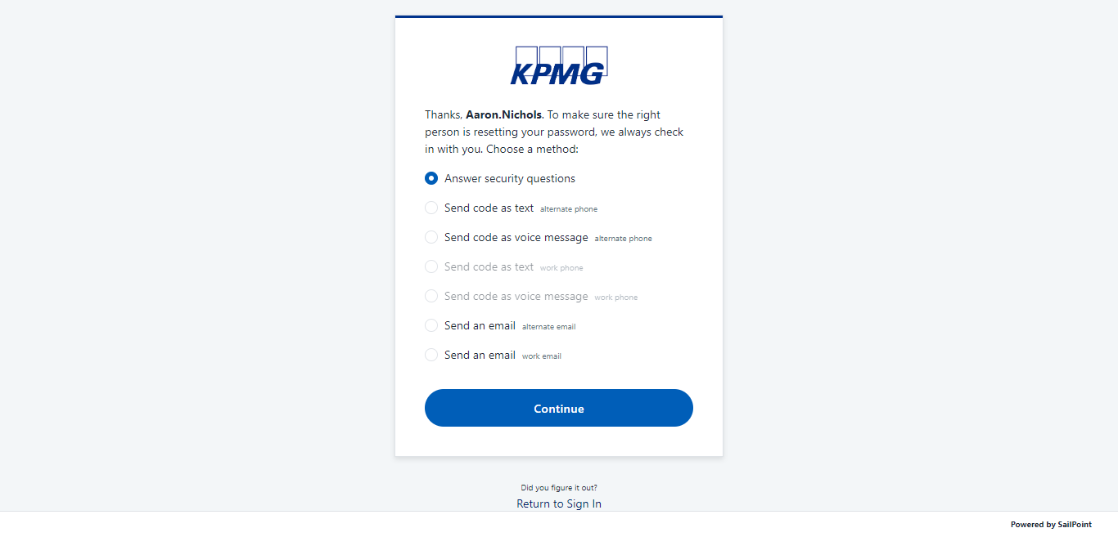

Figure 78: User Authentication Method

1. To make sure the correct user is resetting the password,, select an authentication method and click the **Continue** Button.

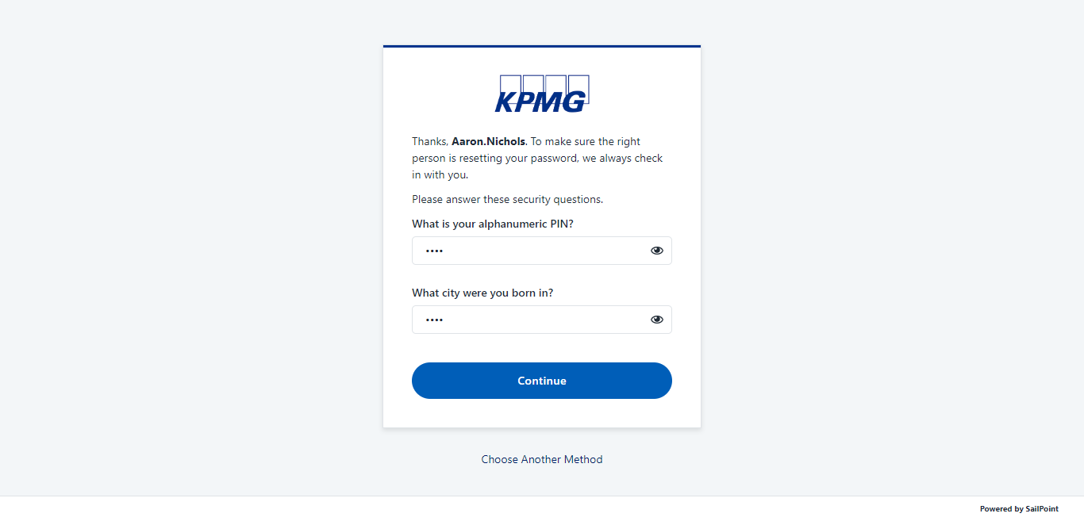

Figure 79: Answer of Security Questions

1. Enter the valid answer for the security questions and click the **Continue** button

The **New Password** screen displays.

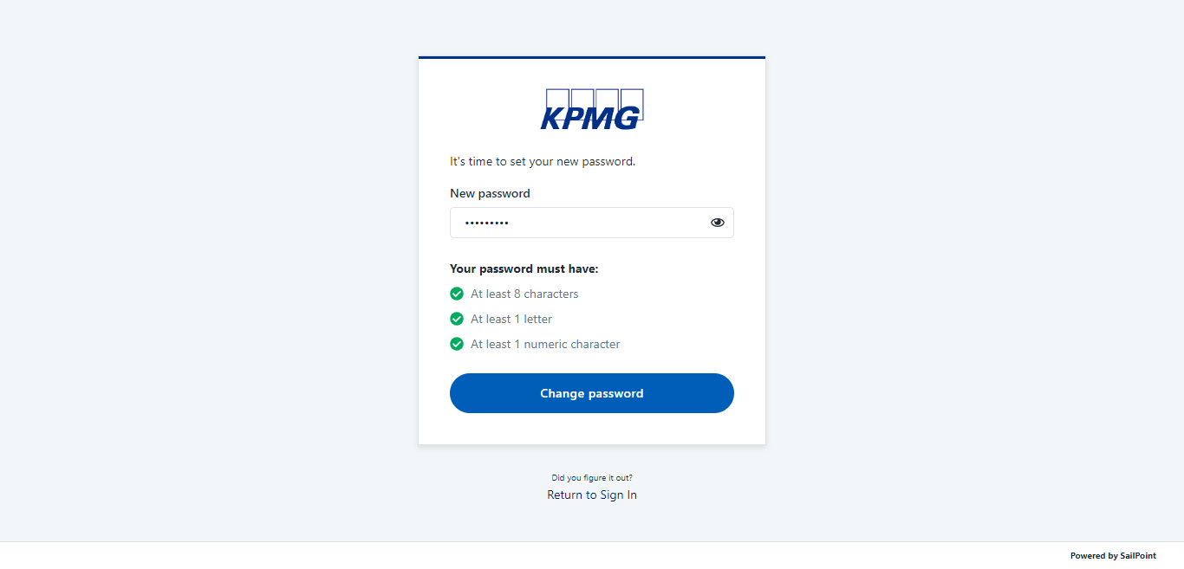

Figure 80: Enter New Password

1. Enter the new password of user and click the **Change Password** button.

The Password successfully changed massage displays

.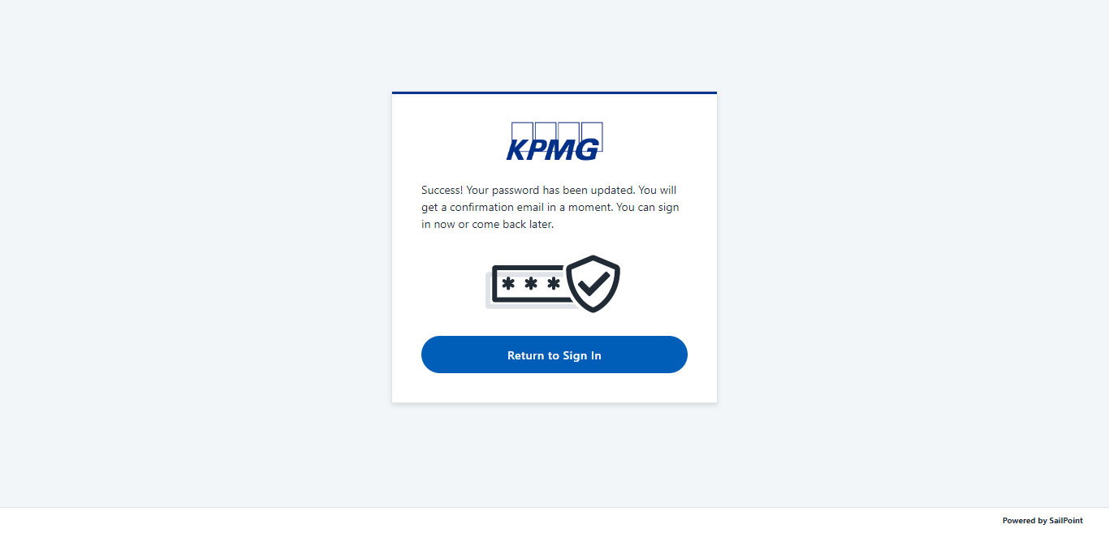

Figure 81: Password Reset Success

1. Sign into IDN with new password.

#### Self Service Password Change

**Powered 5.2**

User sgns in to IDN to reset password. E.g : Aaron.Nichols

1. From the IDN Home screen, click the **My Passwords** tab.

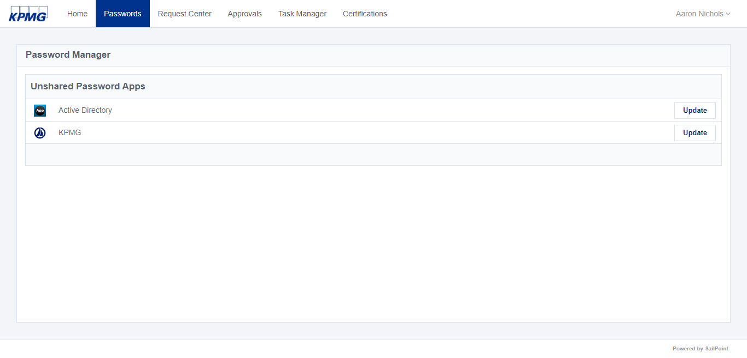

Figure 105: Password Manager Screen

1. Select any user account from the account list and click on **Update** button.

The **Update Active Directory Password** screen displays.

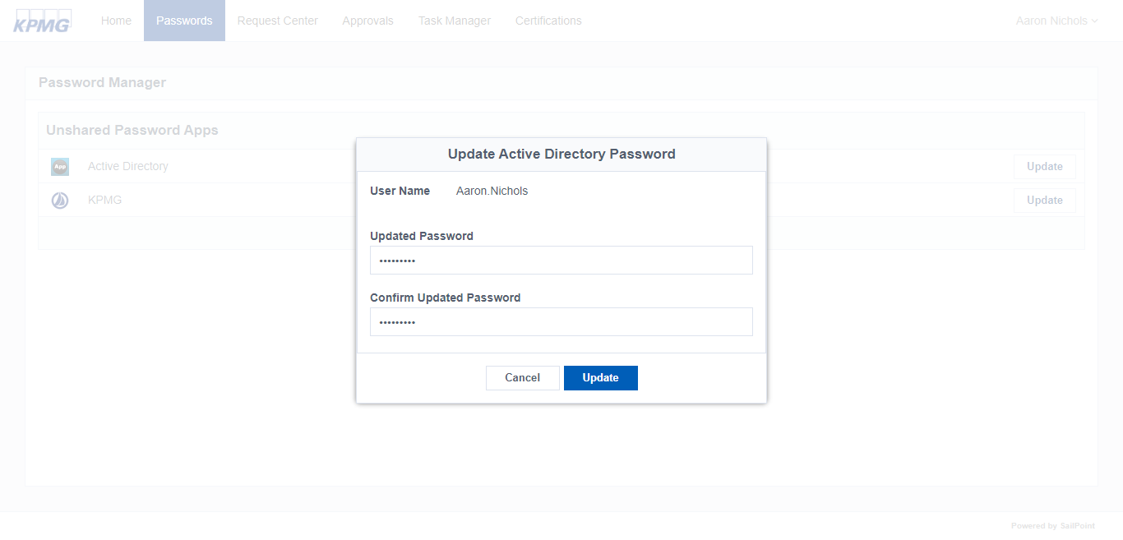

Figure 82: Update AD Password

1. Enter the new password for the application and click the **Update** button.

The **Pending Password Change** message display.

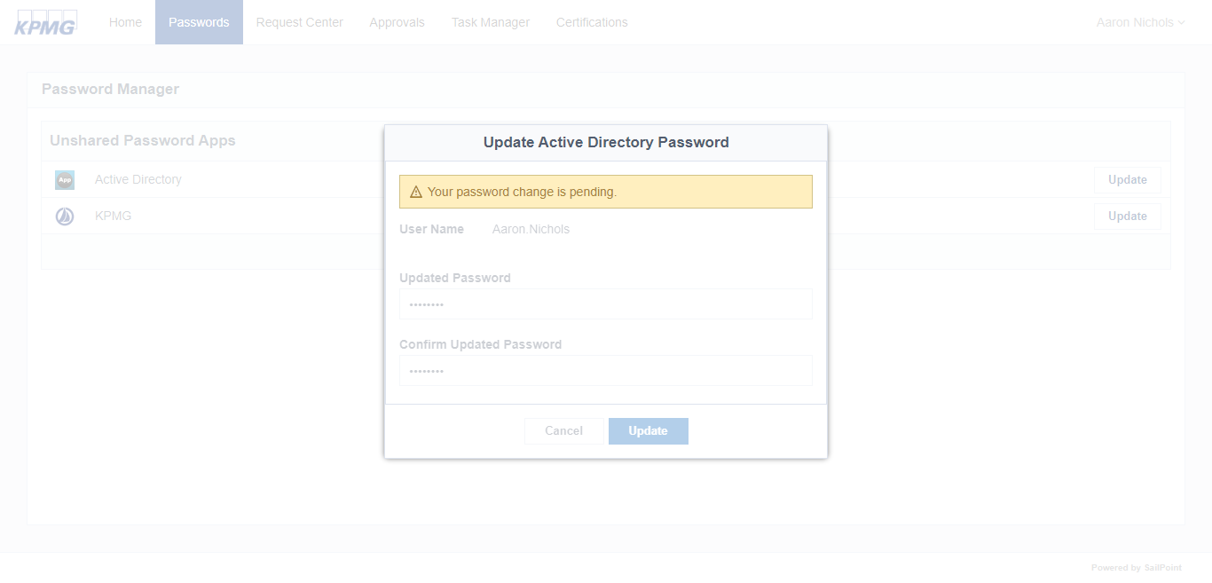

Figure 83: Account Password Change in Progress

1. Wait for a while and the following massage displays:

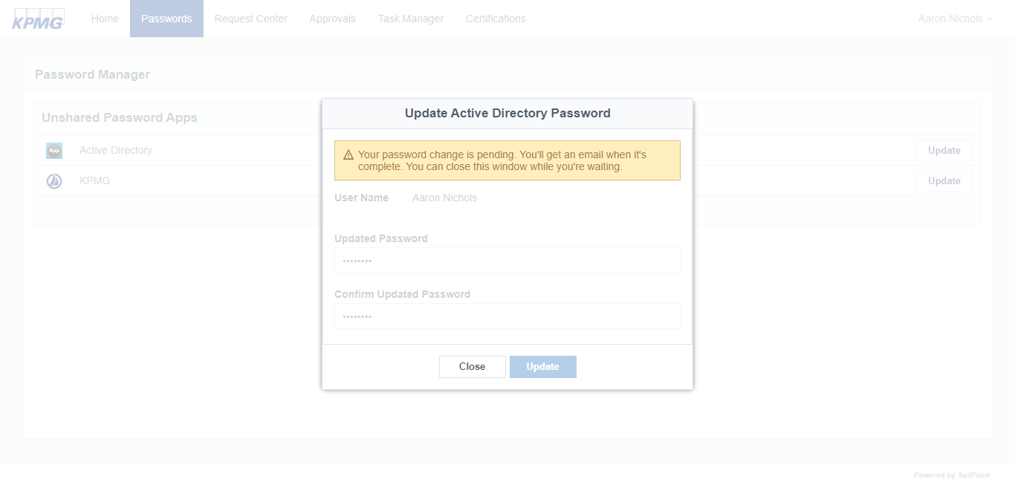

Figure 84: Account Password Change Notification Message

1. Once the password is reset, the system will send an email notification to the user.

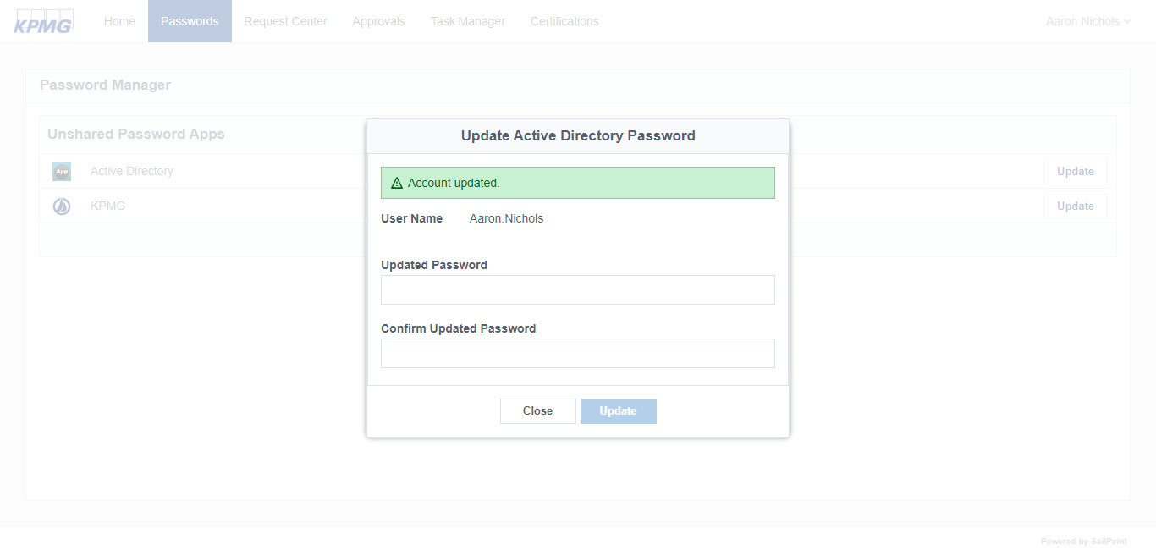

Figure 85: Account Password Change Successfully

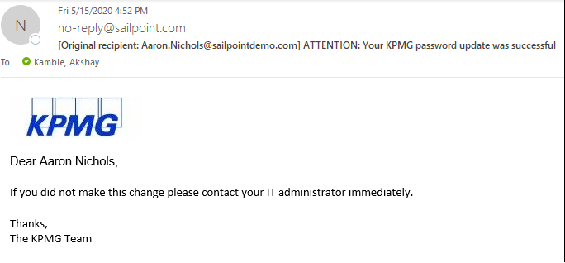

Figure 86: Account Password Change Email Notification

**Powered 5.3**

#### Monitor Password Changes

Administrators can monitor Password Changes in IDN. To monitor password changes for last 7 days:

1. Point to the **Admin** menu and click **Dashboard.**
2. Click the **View All** button next in Password Resets section. 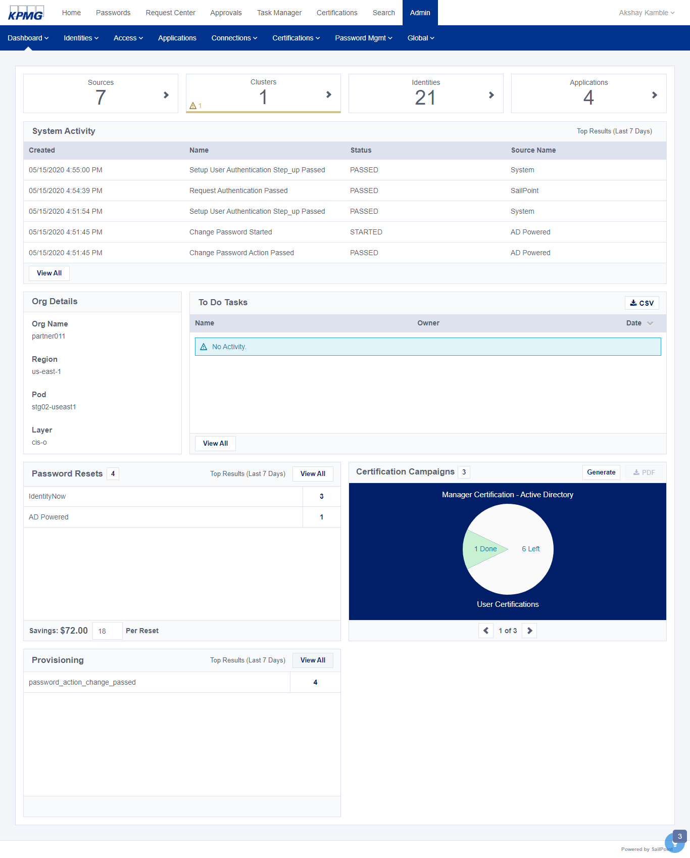

Figure 87: Admin Dashboard

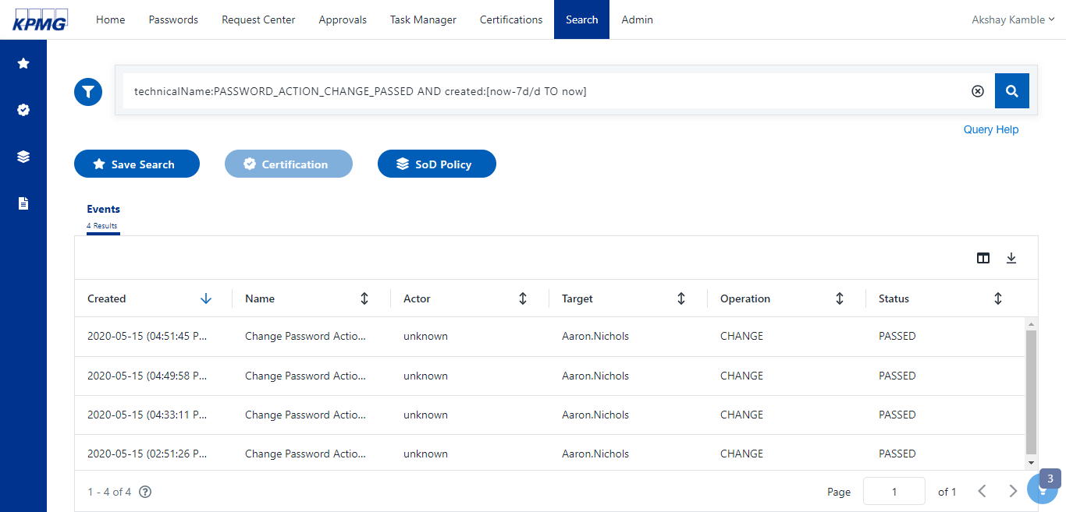

Figure 88: User Password Action Report

Check all password updates including apps, sources, and IdentityNow:

1. On **Admin** menu, point to **Search** and select **Reports**.
2. Select **Password Changes**.

A report containing password updates for application sources and Identities is generated. 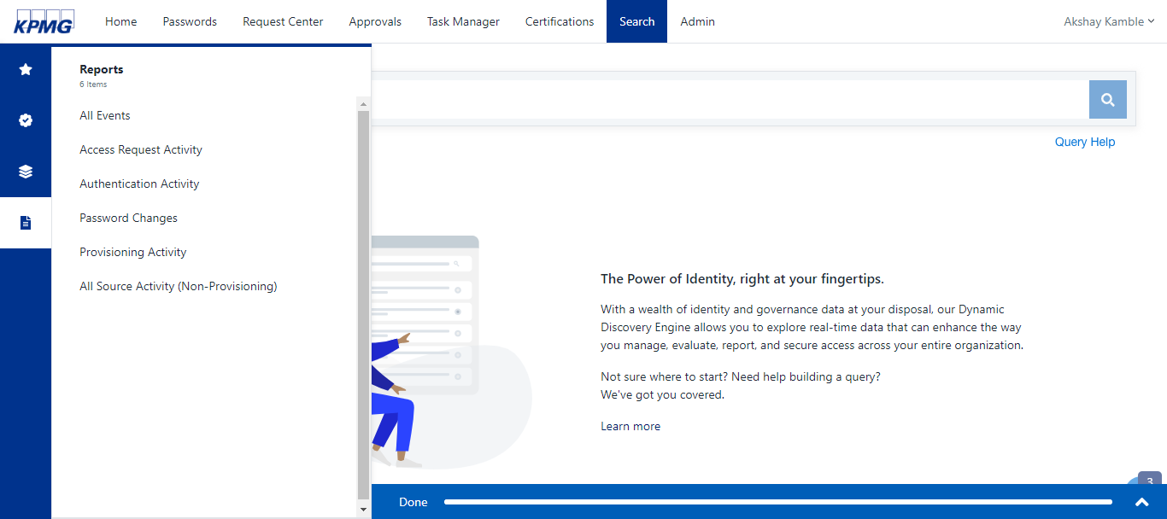

Figure 89: Create Password Change Report

1. Click the **download** icon to download the report. Review the report to validate the user status for each password change operation 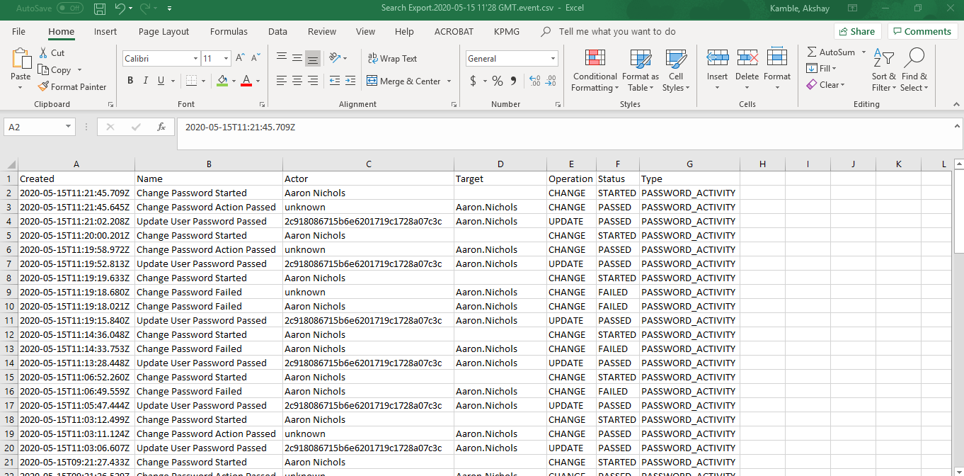

Figure 90: Password Change Report

## Account Management

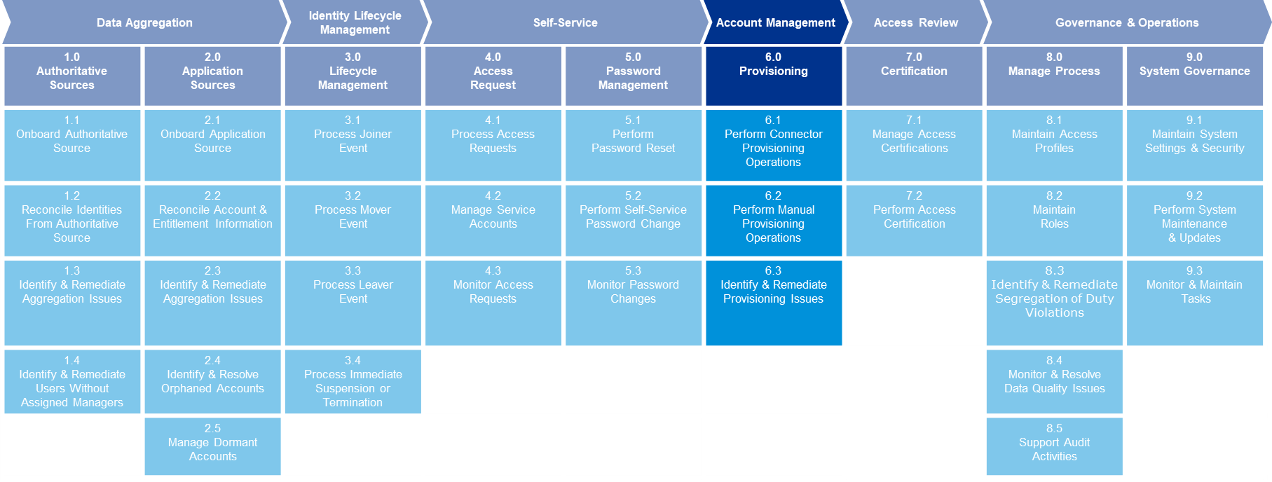

Powered 6.0

### Provisioning

This section describes provisioning users manually or via a connector and how to identify and remediate provisioning issues.

#### Perform Connector Provisioning Operations

**Powered 6.1**

See Adding and Requesting Applications

**Powered 6.2**

#### Manual Provisioning

See Reviewing Request for Connected and Disconnected Applications .

#### Identify & Remediate Provisioning Issues

**Powered 6.3**

See Monitor Tasks

## Access Review/Certifications

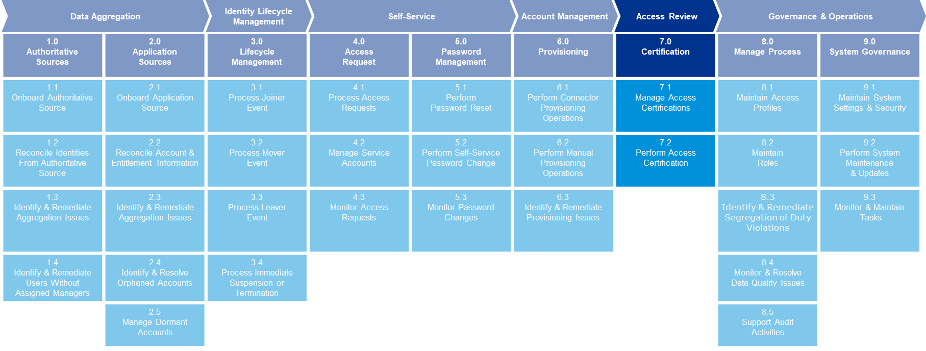

### Certifications

Powered 7.0

This section describes how to configure, manage, and perform access certifications that give or revoke user access.

**Powered 7.1**

#### Manage Access Certifications

The certification process is for reviewing existing user access by a manager or app owner. If access is not required it can be revoked . If it is required, it can be approved

##### Source Owner Certification

###### Create a Source Owner Campaign

Create a Source Owner Campaign so that an application owner can certify user access.

1. Sign into IDN as an Admin.
2. Point to the **Admin** menu, click **Certifications**, and select **Campaigns**.

The **Certification Campaign** screen displays.

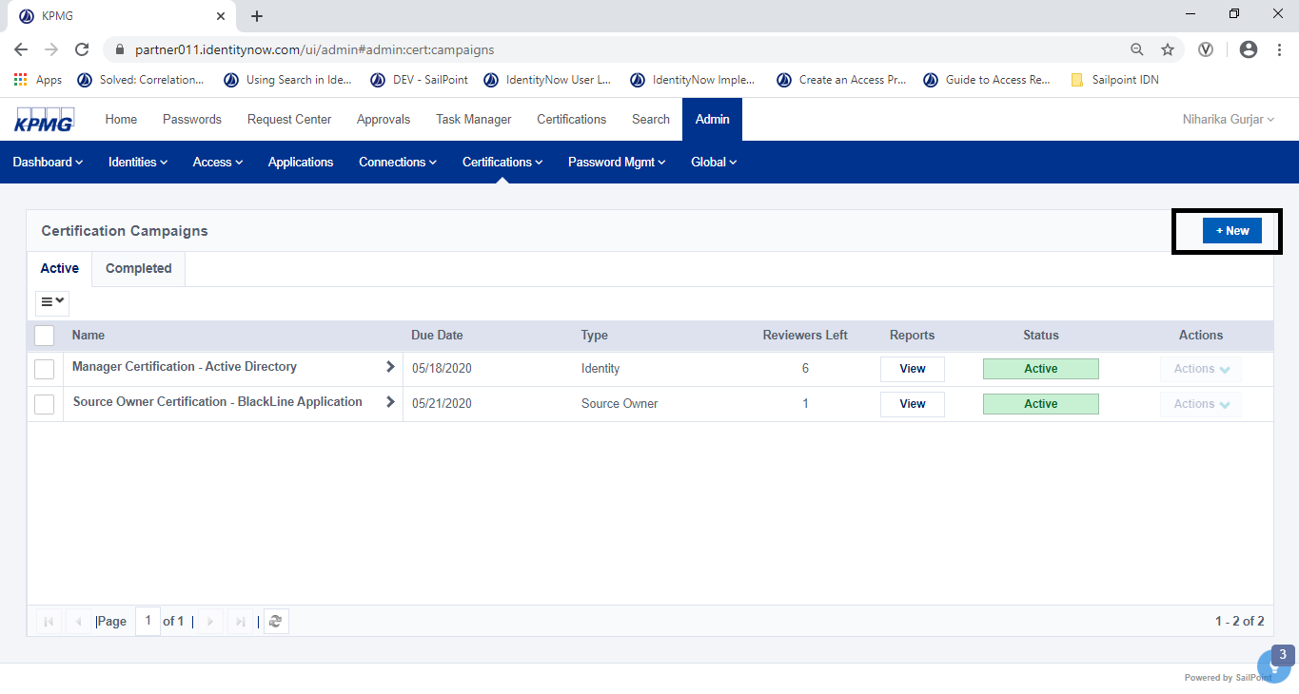

Figure 91: Certification Campaign UI

1. From the **Certification Campaigns** page, click the **+New** button.

The **New Certification Campaign** page displays.

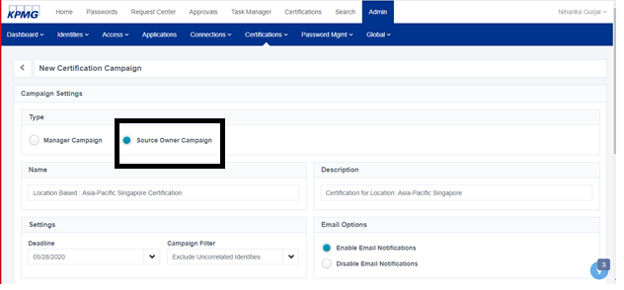

Figure 92: Campaigns Setting

1. On the **New Certification Campaign** page,

* In the **Type** section, select **Source Owner Campaign**.
* Type a **Name** and **Description** in the text boxes
* In the **Deadline** field in the Settings section, select a certification review completion date.

1. In the **Select Source(s)** section, use the **Search Sources** field to add a source(s).
2. Click the **Preview Campaign** button.

A preview campaign displays.

###### Preview a Campaign

Follow the steps below to preview a Source Owner Campaign to ensure that the certification campaign we have created is accurate.

1. Sign into IDN as an Admin
2. Point to the **Admin** menu, select **Certifications**, then click **Campaigns.**

The **Certification Campaigns** screen displays.

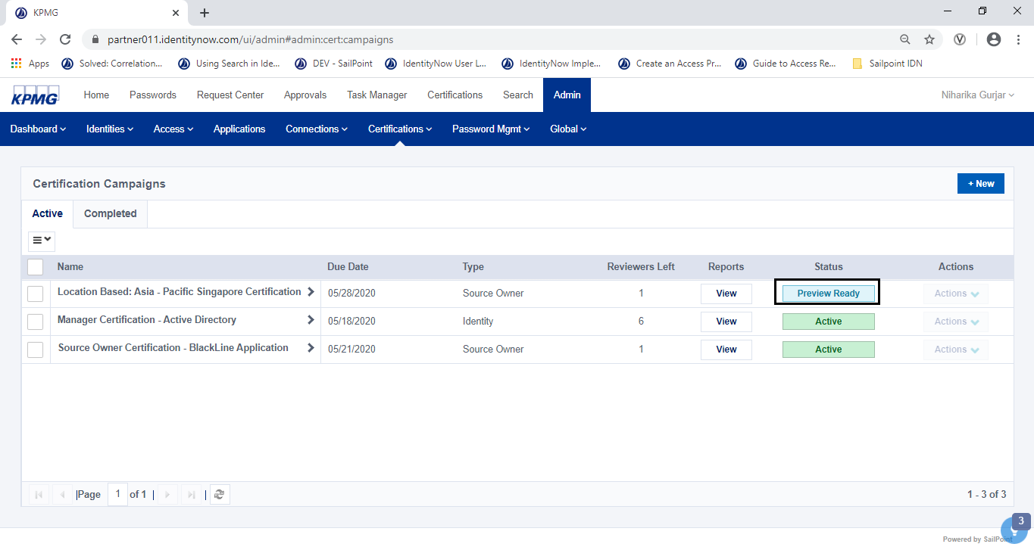

Figure 93: Preview Status

1. Select a certification in the list that has a status of **Preview/Preview Ready**
2. Click the **View** button in the Reports column to preview the reports.

The **Campaign Reports** screen displays.

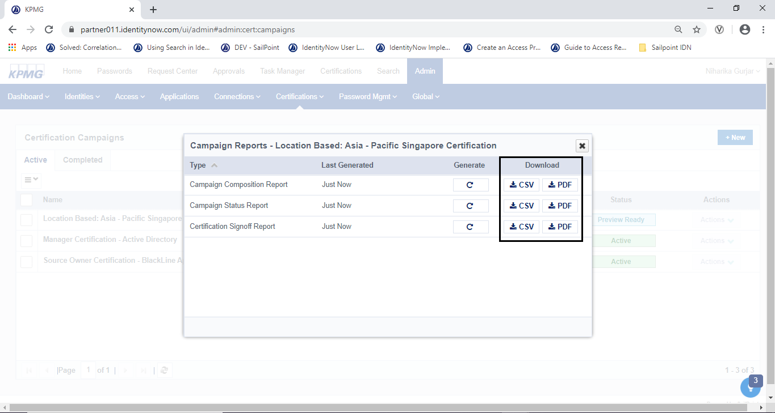

Figure 94: Reports

1. Download each report to preview the campaign contents in the reports.
2. When the campaign preview is finished generating the reports and the download is complete, close the window.

###### Start a Campaign

Follow the steps below to start a Source Owner Campaign.

1. Sign into IDN as an Admin.
2. Point to the **Admin** menu, select **Certifications**, then click **Campaigns.**

The **Certification Campaigns** screen displays.



Figure 95: Certifications Campaigns List

1. Click the **View** button to open a certification with a status of **Preview/Preview Ready.**

A preview of the campaign displays.

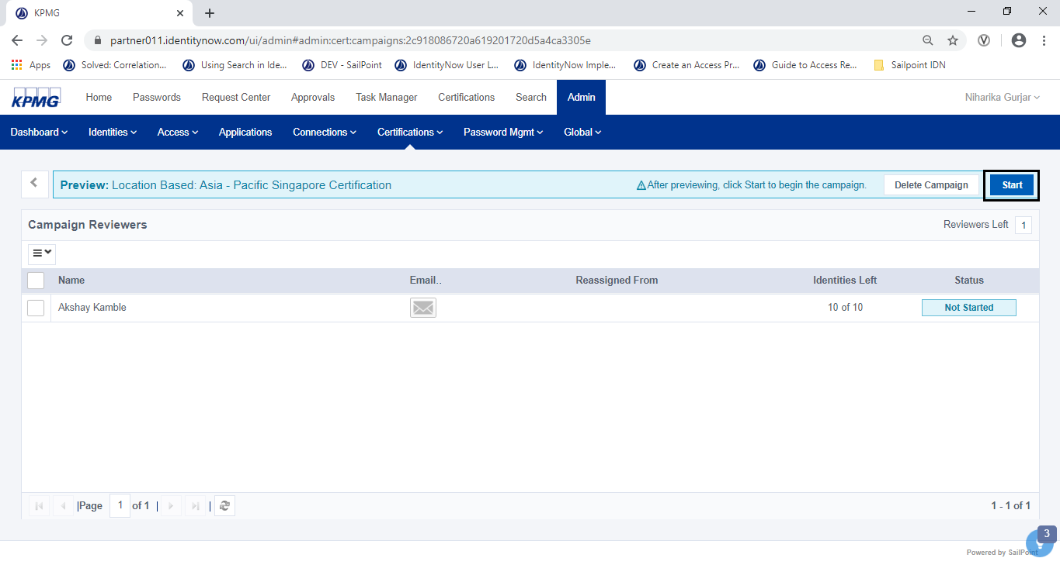

Figure 96: Start Certification Campaign

1. Click the **Start** button to start the Certification Campaign.

The system sends notifications to the reviewers included in the campaign.

##### Manager Certification

###### Create a Certification

Follow the steps below to create a Search based Manager Campaign

1. Sign into IDN as an Admin.

The home screen displays.

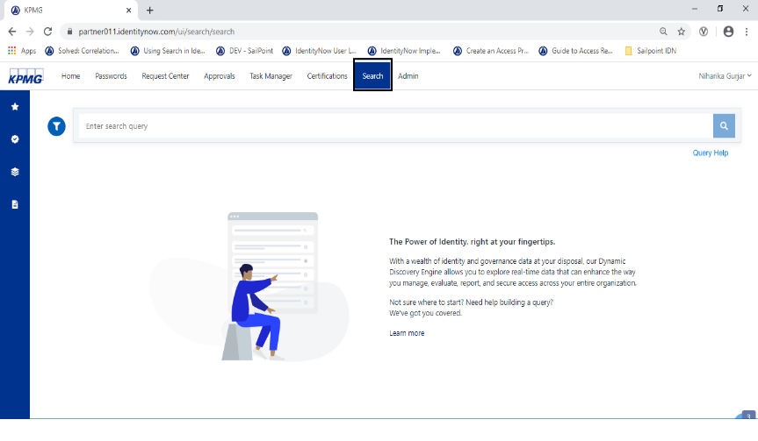

Figure 97 Search UI

1. Click the **Search** link and type a query to return the identities in the following format: @accounts(source.name:"<SOURCE_NAME>") then press **Enter**.

Search results display.

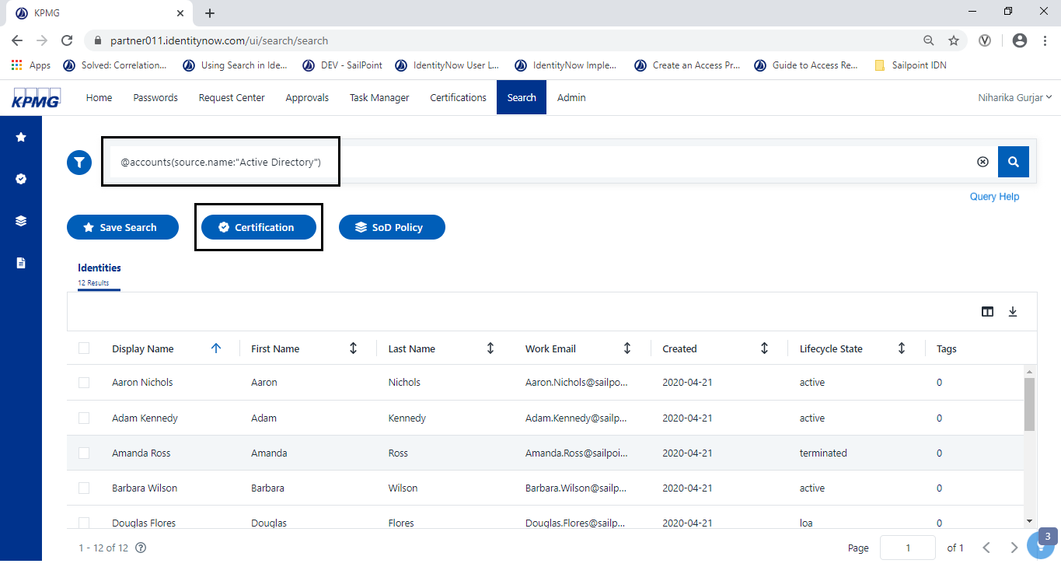

Figure 98 Search Query

1. Click the **Certification** button.

The **Certification Campaign** screen displays

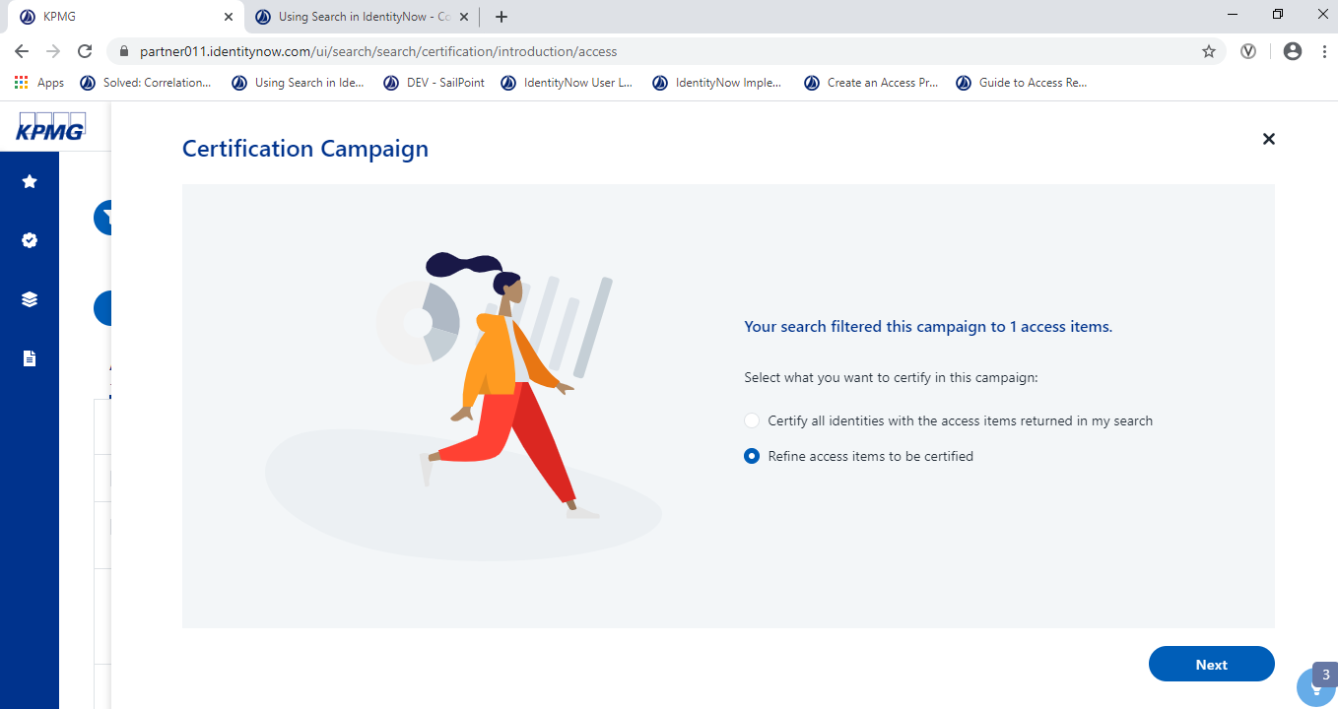

1. Figure 99: Create Certification
2. Select **Refine Access items to be certified** for the Identities returned in the Search and click the **Next** button.

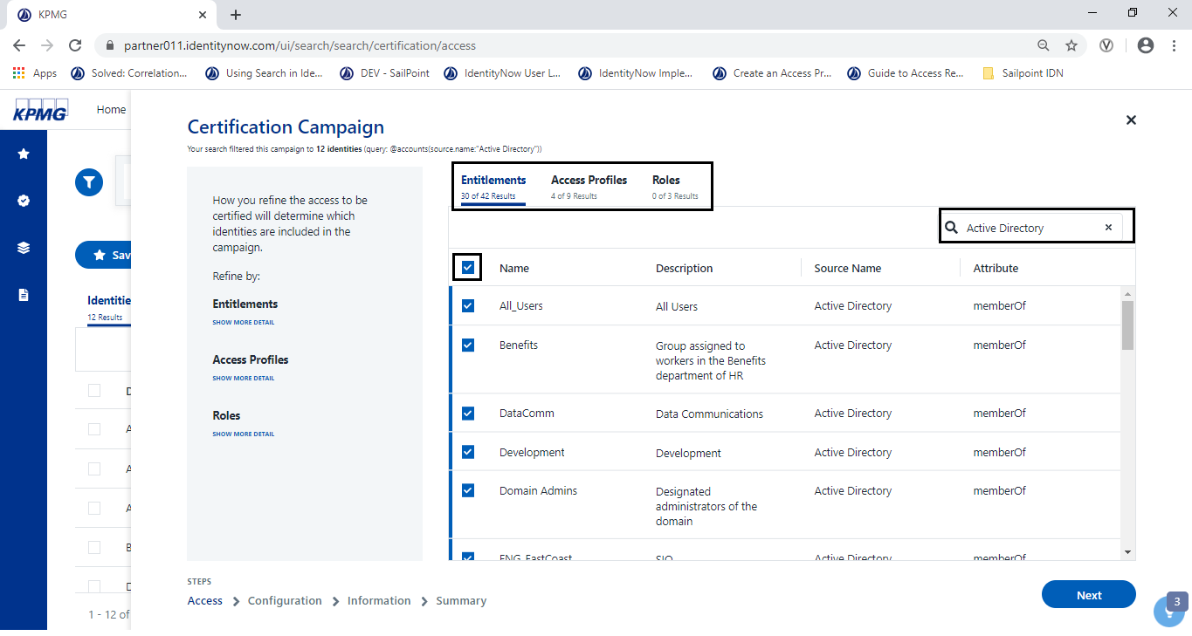

Figure 100: Refining entitlements w.r.t source

1. Use the Search Box to filter the entitlements by source and Select (put a checkmark) the entitlement. Click **Next**.

The **Certification Campaign review** screen displays.

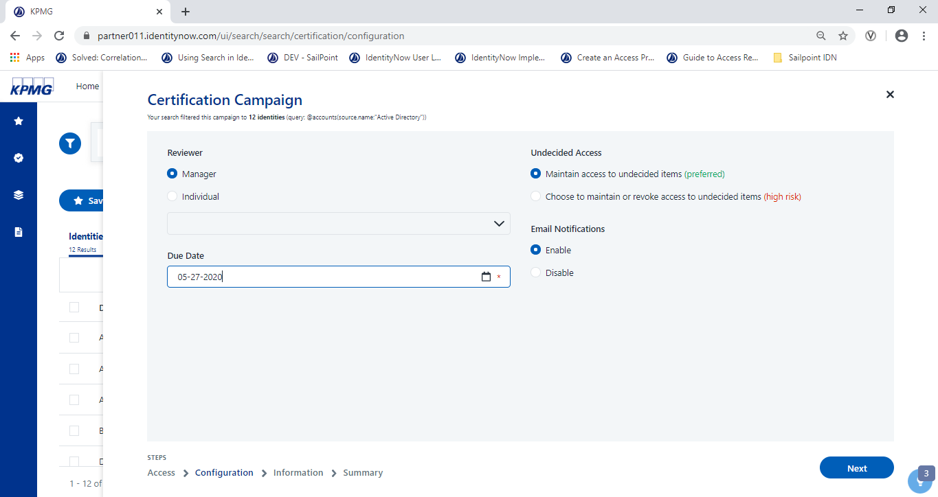

Figure 101: Set Certification Due Date

1. Complete the following information on the Configuration page then click the **Next** button.
2. **Reviewer** - Select a Manager to have their access reviewed for each identity.
3. **Due Date** - The deadline for reviewers to complete their certification reviews.

The **Certification Campaign Information** page displays.

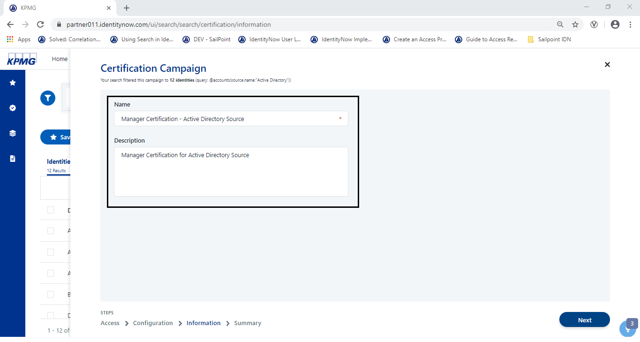

Figure 102: Configure Name and Description

1. On the Information page, type a **Name** and a **Description** for the certification campaign, and click the **Next** button.

The **Certification Campaign Summary** page displays.

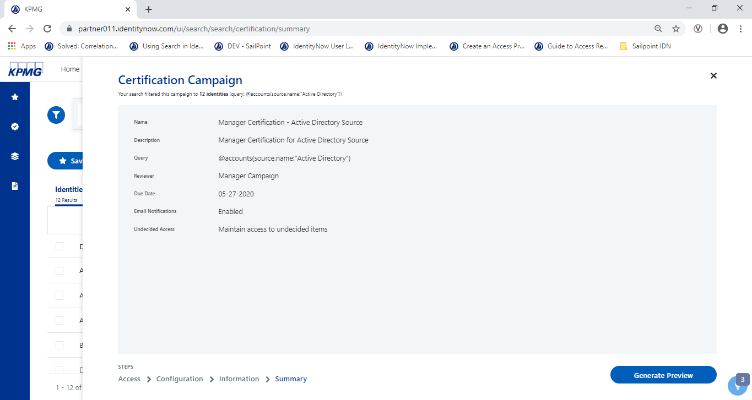

Figure 103: Summary

1. Review the campaign details on the Summary page and click the **Generate Preview** button**.**

A preview of the campaign displays. The wizard closes and a green success banner displays at the top of the Search page.

##### Certification Campaign Tracking

Follow the steps below to track the certification Campaign.

1. Sign into IDN as an Admin. Point to the **Admin** menu, click **Certifications**, and select **Campaigns**.

A list of campaigns display.

1. Click the **view** button in the reports column to view a campaign.

The **Campaign Report**s dialog box displays available reports.

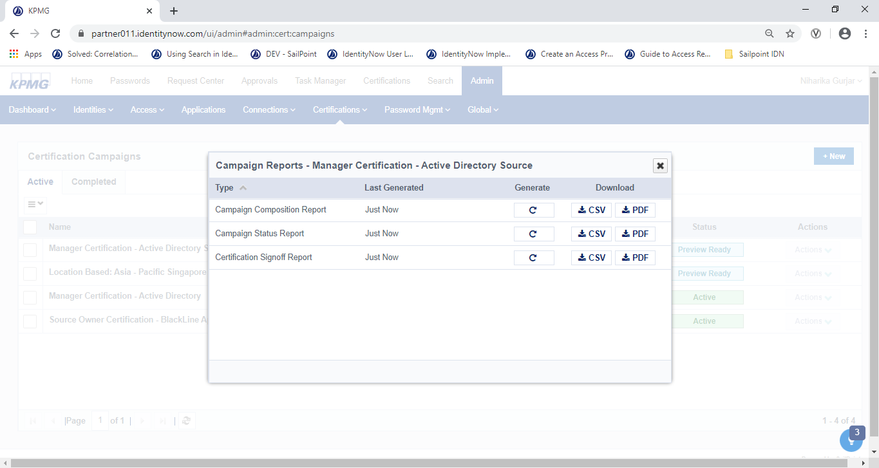

Figure 104: Campaign Reports

1. Click the **Generate** button to create a report that reflects the most recent status of the campaign.
2. To Download the report, click one of the following:

* **CSV** - Opens the report as a spreadsheet
* **PDF** - Opens the report as a PDF

##### Certification Reminders

IDN is configured to send reminder emails on a predetermined schedule. Reviewers receive a reminder email when the campaign is activated, one week after a certification campaign begins, and every seven days after that. Reviewers will continue to receive reminders until they sign off, the certification expires, or an administrator completes the campaign for them by choosing to maintain or revoke remaining decisions.

**NOTE**: If a certification campaign is less than seven days long, reviewers do not receive reminder emails by default. This schedule can’t be edited.

##### Reassign a certification campaign

Follow the steps below to reassign a certification in a campaign to another reviewer.

1. Sign into IDN as an Admin.
2. Point to the **Admin** menu, select **Certifications**, then click **Campaigns.**

The **Certification Campaigns** screen displays.

1. Click the name of the campaign from the list.

A list of reviewers in the campaign displays.

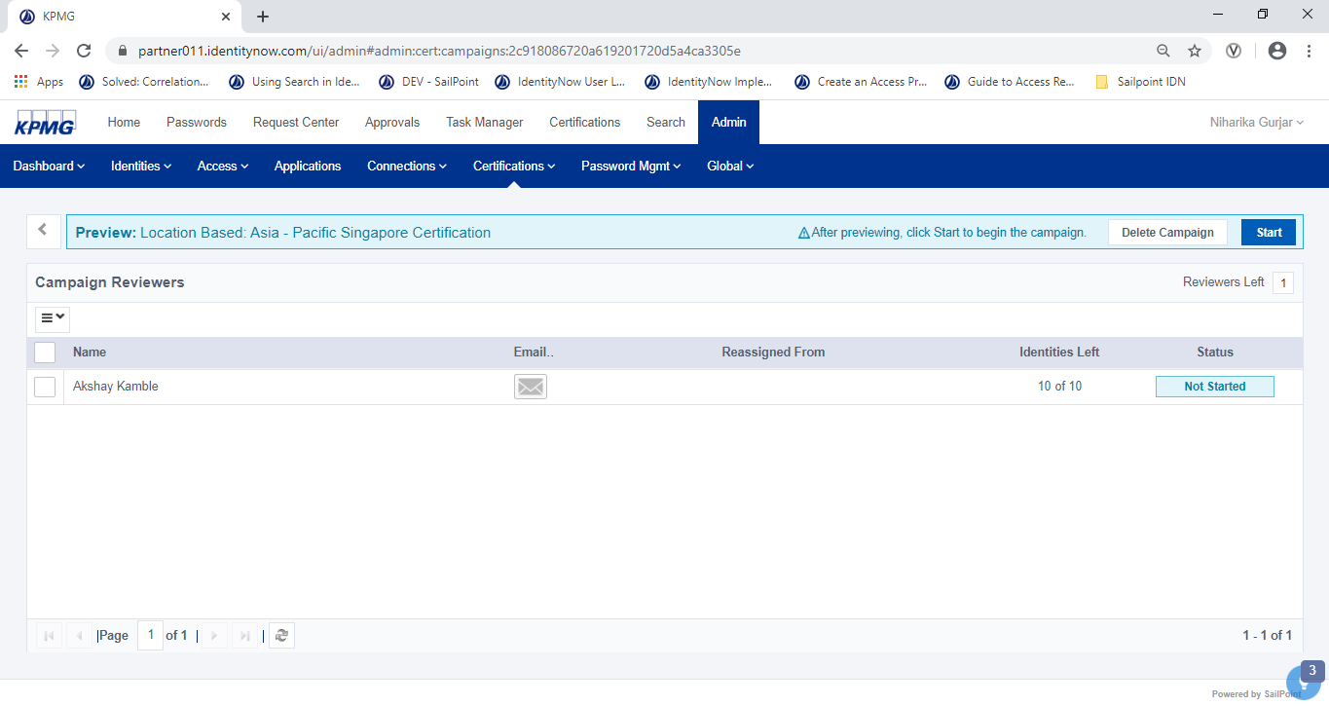

Figure 105: Name of Campaign to Edit

1. Select (put a checkmark) the name of each user whose certifications will be reassign to a specific reviewer.

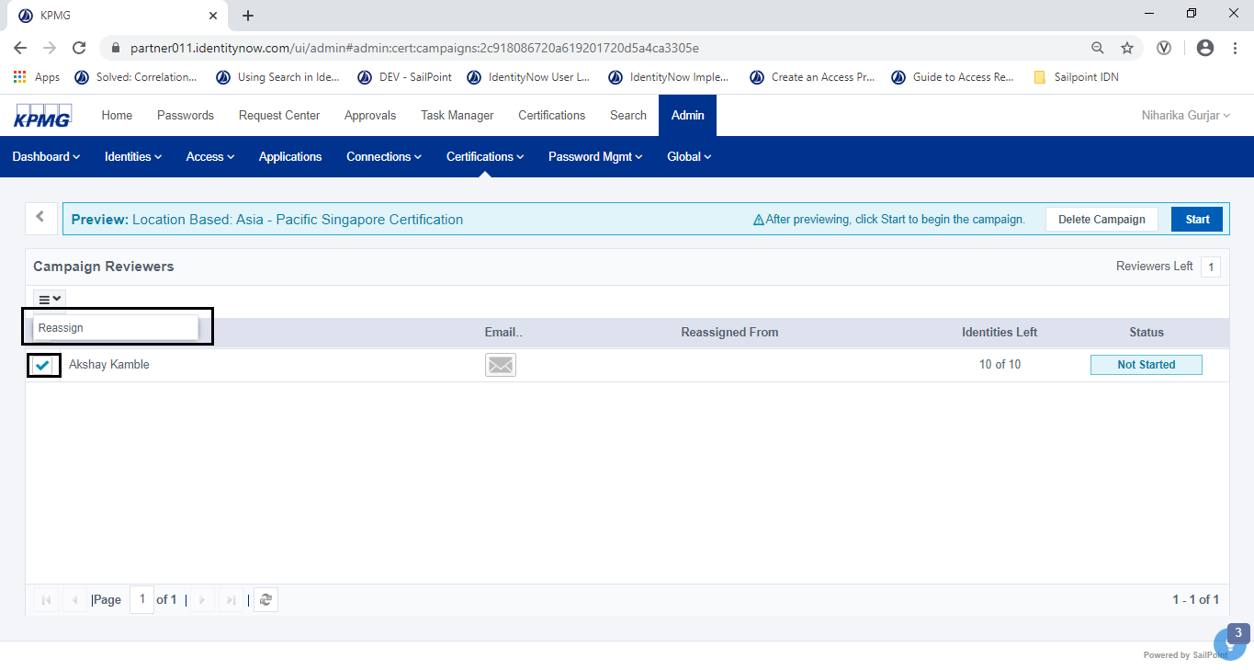

Figure 106: Reassign Certification

1. Click the **Hamburger**  drop down and select **Reassign**.

The **Certification Reassignment** screen displays.

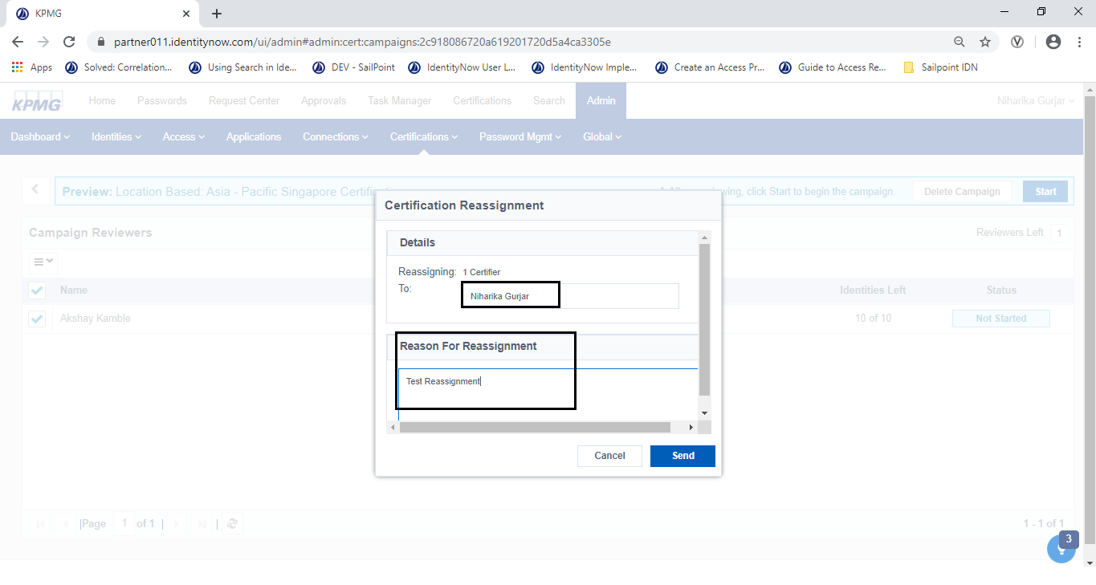

Figure 107: Certification Reassignment

1. In the **To** box, enter the name of the user who will be reassigned to the campaign.
2. In the **Reason for Reassignment** box, enter a reassignment reason and click **Send**.

A status message displays in a green box at the top of the screen.



#### Perform Access Certification

**Powered 7.2**

##### Approve/Revoke access

Follow the steps below to review a certification and approve access.

1. Sign into IDN as an Access Certifier and click **Certifications.**

The certifications screen displays.

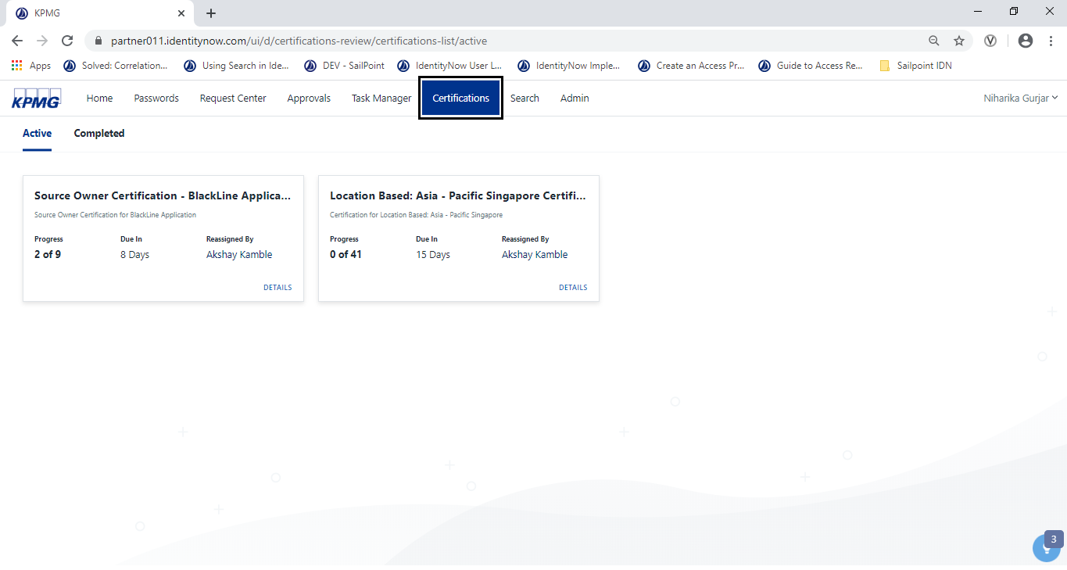

Figure 108: Certifications UI

1. Click the **Active** tab to view active certifications. Each certification displays the following information on a card.

* **Progress** - The progress of the campaign in numbers.
* **Due In** - The campaign due date.
* **Reassigned by -** The name of the person who reassigned the campaign, if it was reassigned.

**NOTE**: If a campaign is overdue, it will reflect display on the card. Days Overdue is shown during the certification process next to the calendar icon.

1. Click a certification campaign card to view details.

The certification review or start screen displays.

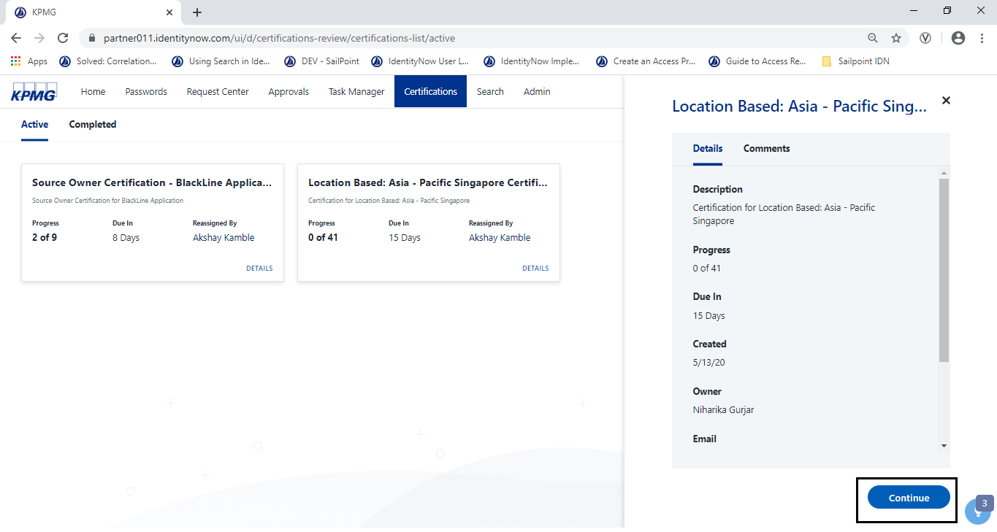

Figure 109: Certification Campaign to Start or Continue

1. Click the **Continue** button.

The **View as Access** screen displays.

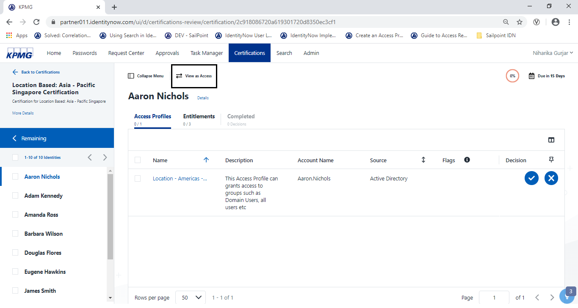

Figure 110: View as Access

1. From the list of identities on the left, select an identity to certify.
2. Click **View as Access** to review and complete the campaign based on access items instead of identities.

The categories display in the list.

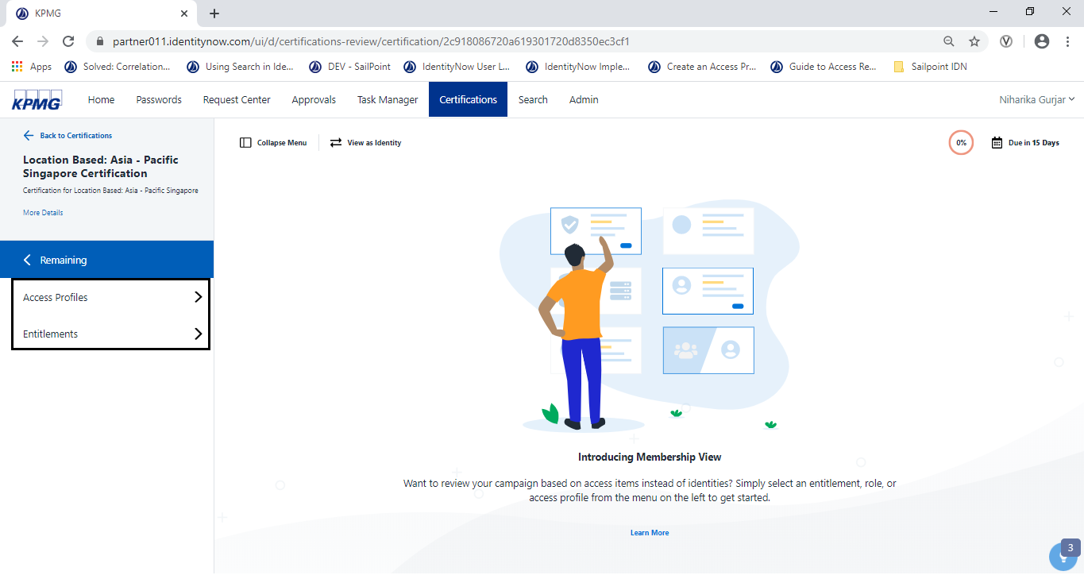

Figure 149: View as Access

1. From the categories on the left, choose either **Roles**, **Access Profiles**, or **Entitlements**.

The pending access items display for that category.

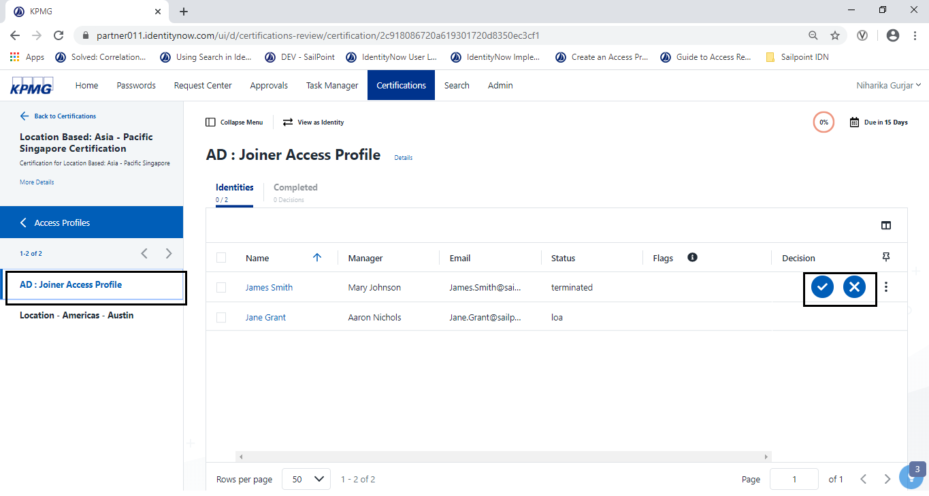

Figure 150: Joiner Access Profile

1. Select an access item from the list.

The identities related to that access item display.

1. In each section (Roles, Entitlements, Access profiles), select (put a checkmark) each access item to Approve or Revoke accessor. Click  to approve or  to deny.

##### Delegate a certification

Follow the steps below to delegate a certification to another reviewer.

1. Sign into IDN as an Access Certifier and click **Certifications**.

The certifications screen display.

1. Select an active certification campaign box.

A list of users display.

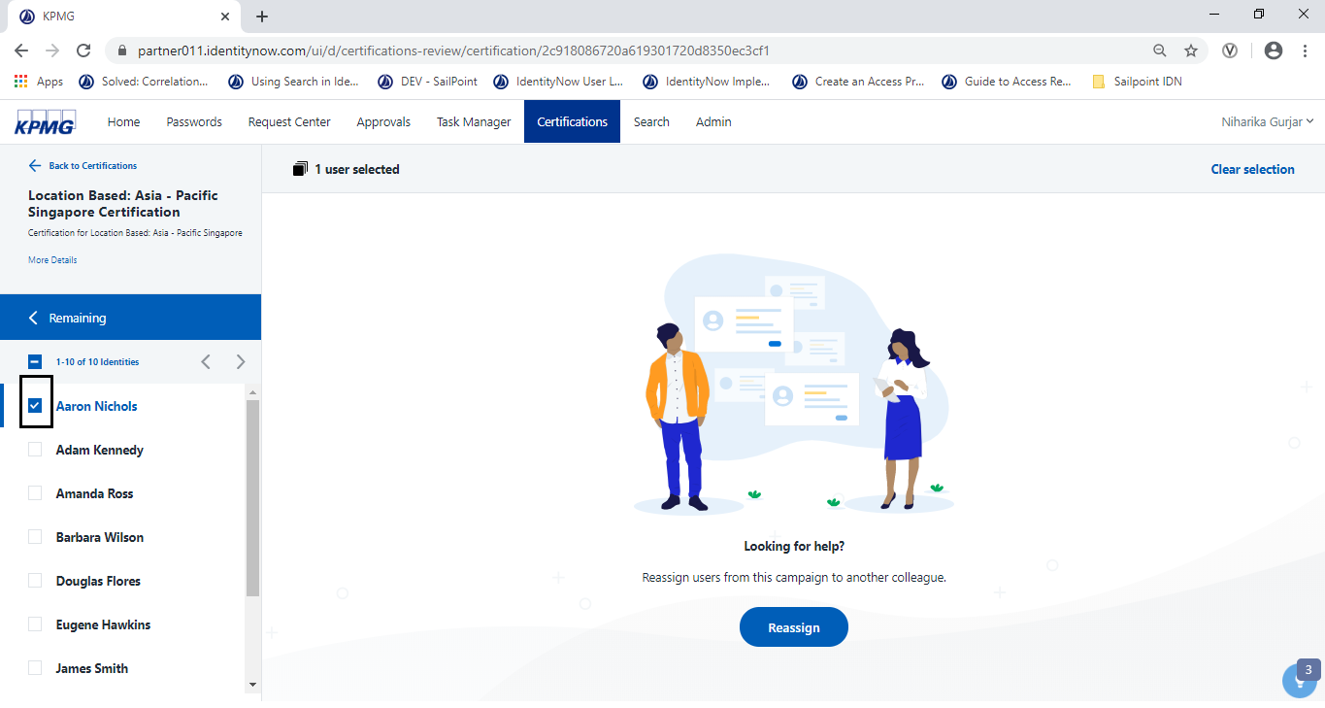

Figure 111: Reassign Certification UI

1. Select the person (add a checkmark) from the list of users. To reassign multiple people at once, select multiple checkboxes. Click the **Reassign** button.

The **Reassign** menu displays

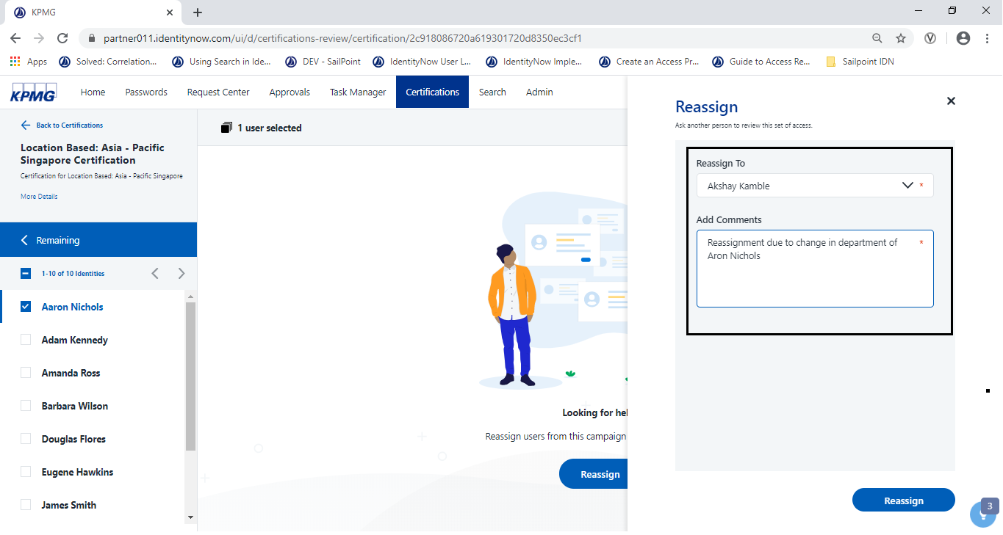

Figure 112: Reassign Menu

1. Type or select the name of the reviewer who the certification will be reassigned.
2. In the **Add Comments** box, enter any comments about the reassignment and click **Reassign**.

The certification is reassigned.

##### Complete a Campaign as Reviewer

Follow the steps below to review a certification

1. Sign into IDN as Access Reviewer and click **Certifications**.

The certifications screen display.

1. Click an active certification campaign box.

The certification campaign displays on the screen.

1. Click **View as Access** to review and complete the campaign based on access items instead of identities.



Figure 113: Access to Review and Complete the Campaign

1. Select (put a checkmark) each access item to Revoke/Approve accessor. Click  to approve or  to revoke.
2. Once the campaign is ready for signoff, click the **signoff** button.

The **just one more step** message displays.

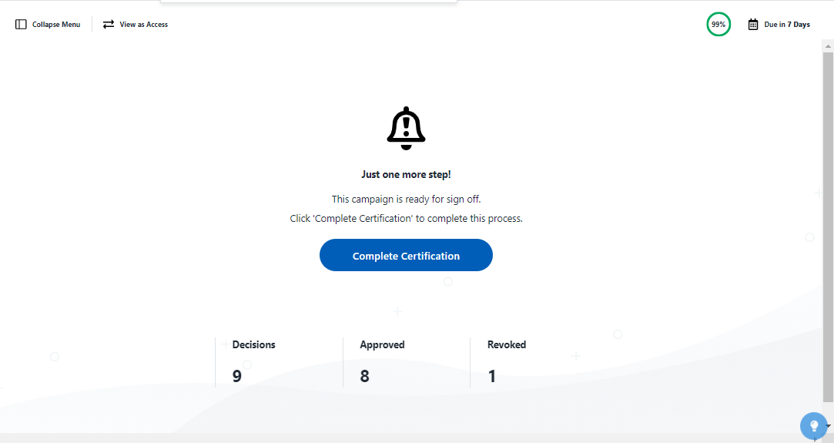

Figure 114: Complete Certification message

1. Click the **Complete Certification** button to mark the certification as complete.

##### View Completed campaign

Follow the steps to view a completed campaign as a Reviewer.

1. Sign into IDN as an Access Certifier.

The **Certifications** screen display

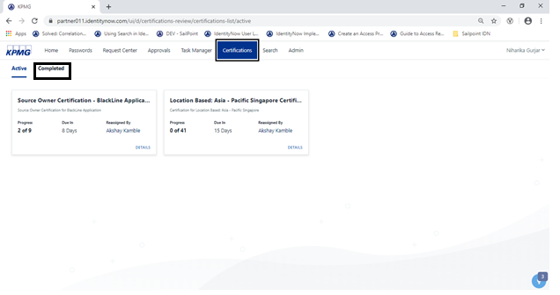

Figure 115: Certification UI

1. Click the **Completed** link and select a completed certification campaign box.

Completed certification campaigns displays on the screen.

1. Click a certification campaign box to open, then click the **Review** to look at the contents of the certification in detail.

The certification campaign detail displays.

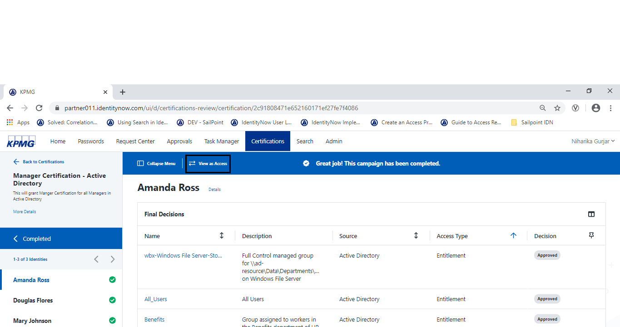

Figure 116: Campaign by Identity

1. Click the **View as Access** link to view the completed campaign based on access items instead of identities.
2. Click the **View as Identity** link to switch back to reviewing the campaign by identity at any time.

## Governance and Operations

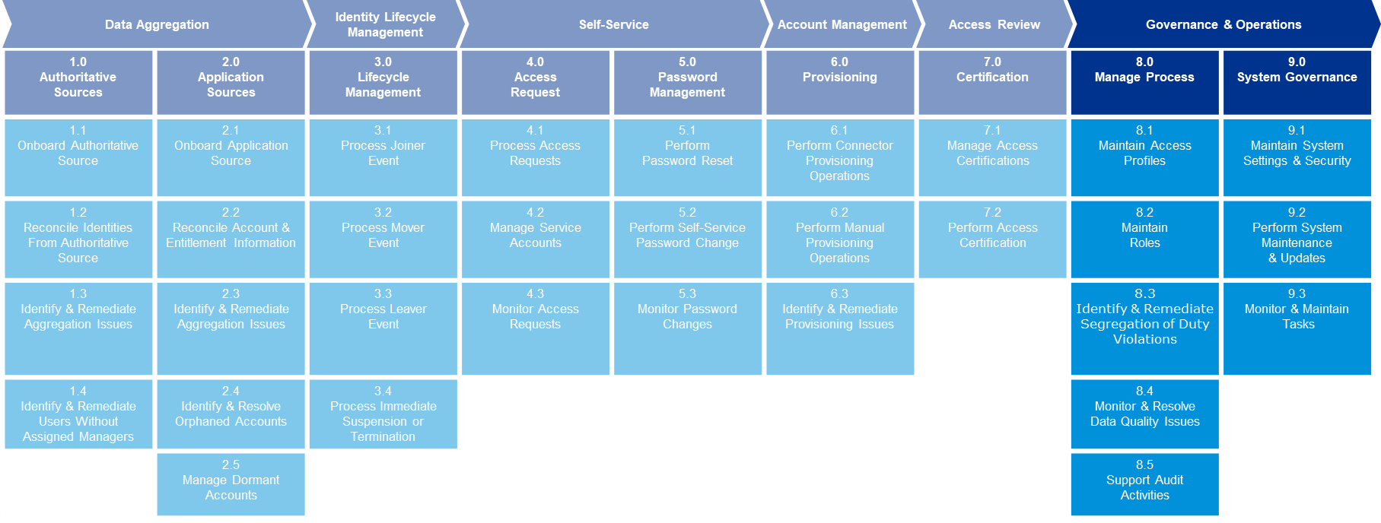

Powered 8.0

Manage Process

### Manage Process

This section describes configuring access profiles and roles. It also describes identifying and remediating SOD policies, managing uncorrelated accounts and identity exceptions, and downloading reports for various tasks.

#### Maintain Access Profile

**Powered 8.1**

#### Maintain Roles

**Powered 8.2**

##### Creating Roles

1. From the Admin interface, point to **Admin**, click **Access**, then select **Roles**.

The **roles** screen displays.

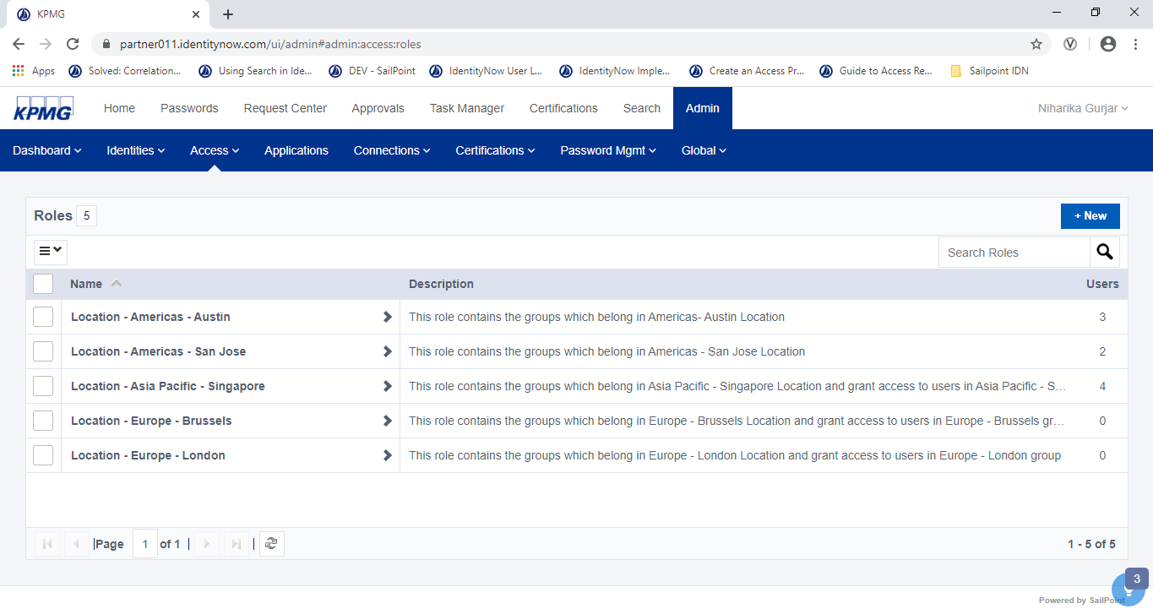

Figure 117: Role Dashboard

1. Click the **New** button.

The **Create New Role** screen displays.

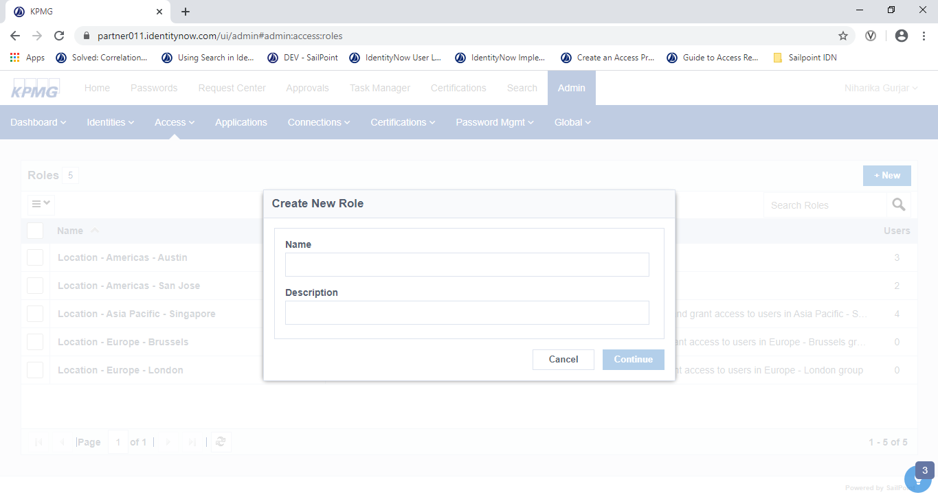

Figure 118: Create New Role

1. Type a name for role and a description and click **Continue**.

The **Role** details screen displays.

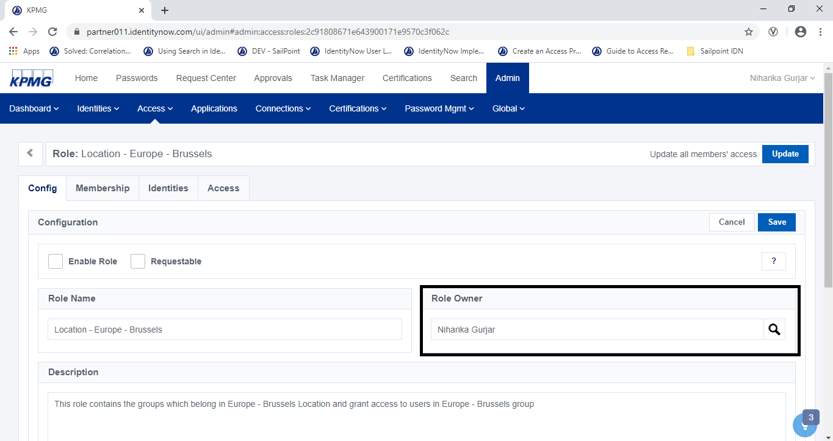

Figure 119: Set Role Owner

1. Select an identity in the **Role Owner** drop-down list.
2. Click the **Membership** tab.

The **Define Membership Criteria** panel displays.

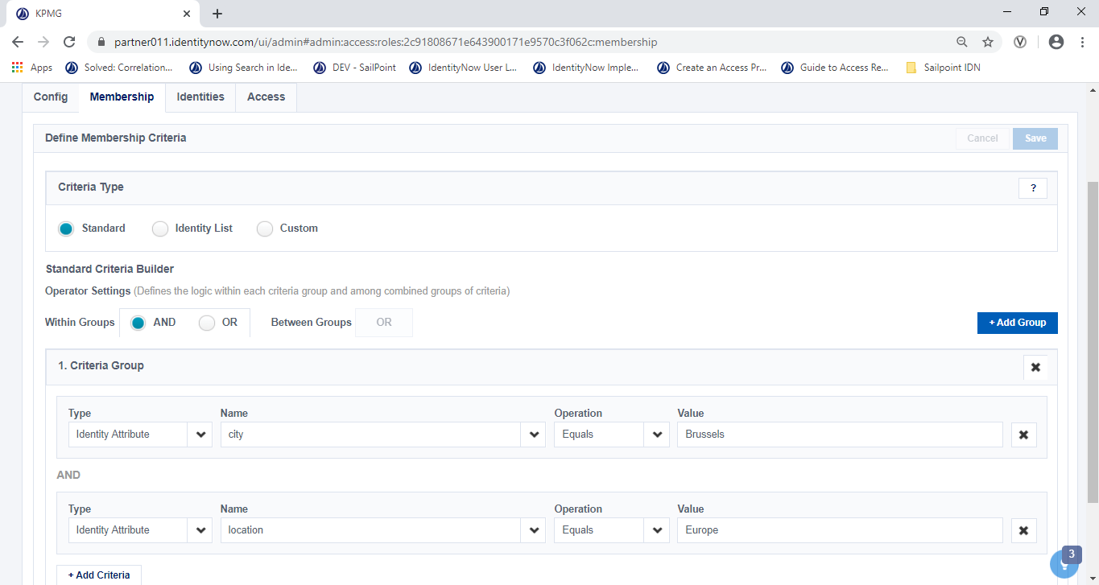

Figure 120: Role Membership Tab

1. Click the **Access** tab.

The **Configure access** screen displays.

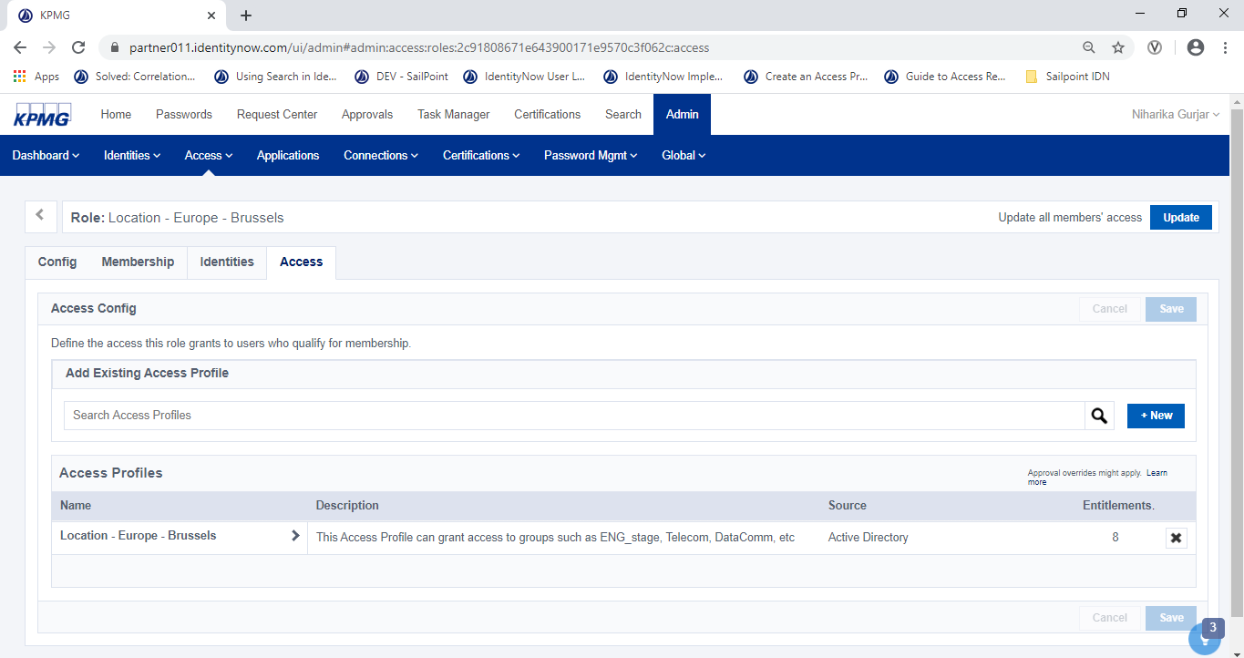

Figure 121: Configure Access Profile

1. In the **Access Config** panel, add access profile(s) to by searching and adding access profiles in the **Add Existing Access Profile** section. Click **Save**.
2. Click the **Config** tab, select (add a checkmark) the **Enable Role** checkbox. Click **Save**.

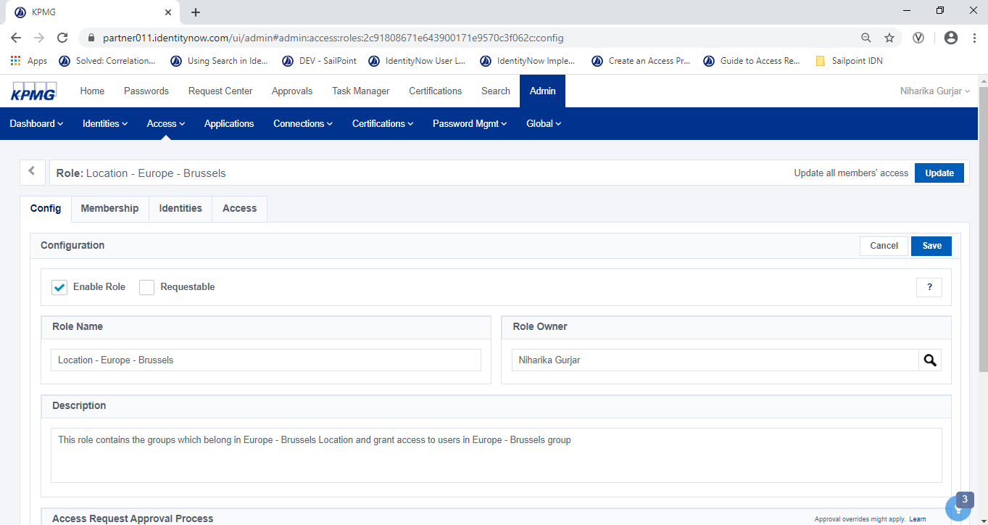

Figure 122: Role Configuration Tab

1. Click the **Update** button at the top of the screen.

Access is provisioned accordingly to the users belonging to this role.

#### Identify and Remediate Segregation of Duty Violations

**Powered 8.3**

##### Creating SoD

1. Sign into IDN as an Admin.
2. Click **Search**. Use internal SoD policy to create a search query. If results are returned, there are violators of this policy. If not, policy is violation free.
3. Click a **SoD Policy.**

The **Separation of Duties Policy** screen displays.

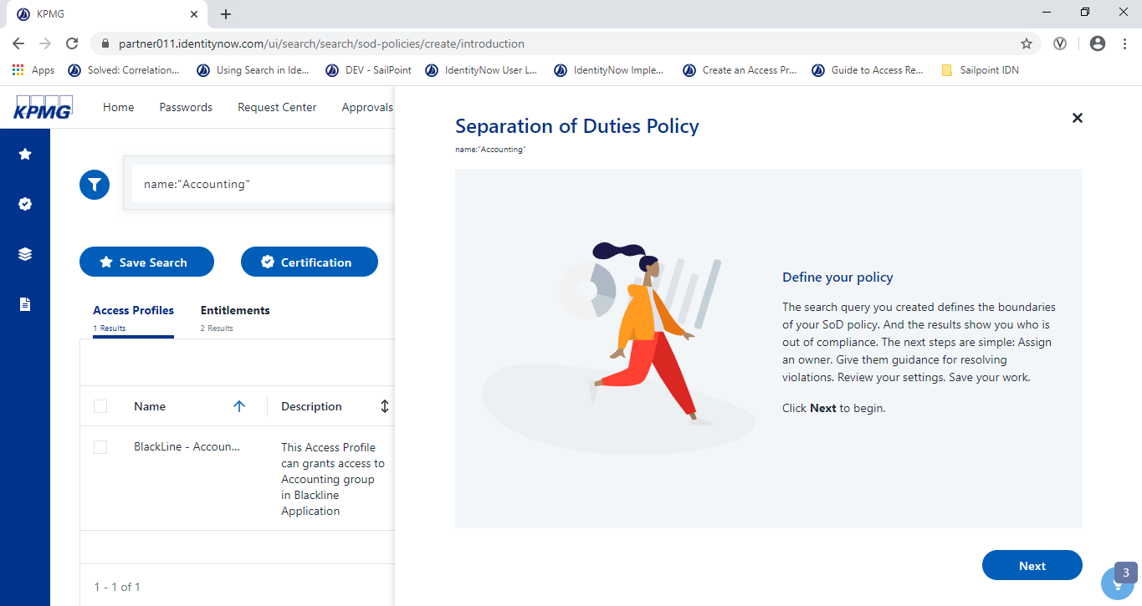

Figure 123: SOD Tab

1. Click the **Next** button.
2. To use a governance group or an individual as the violation owner, enter the name of that entity in the field.

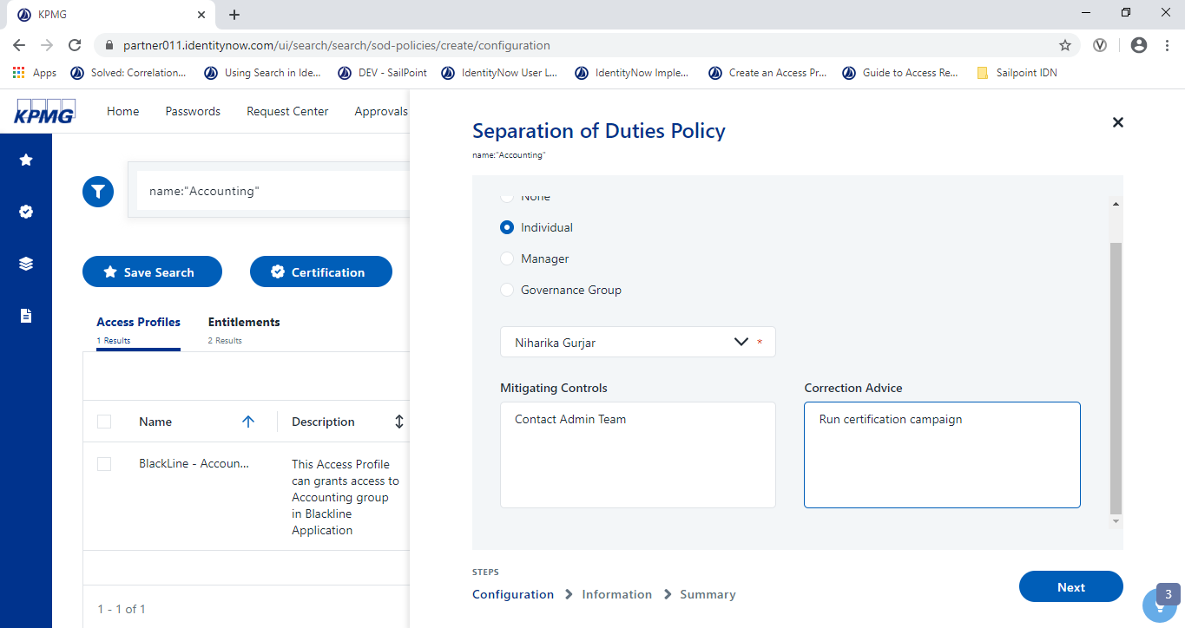

Figure 124: Configure SOD

1. Enter the following optional information and click the **Next** button.

* **Violation Owner** - The user or governance group:
  + Will be notified when there are violations to this policy and will be automatically included in any subscriptions to this policy.
* **Mitigating Controls** - Instructions on what to do if a violation is unavoidable.
* **Correction Advice** - How to correct violations.

.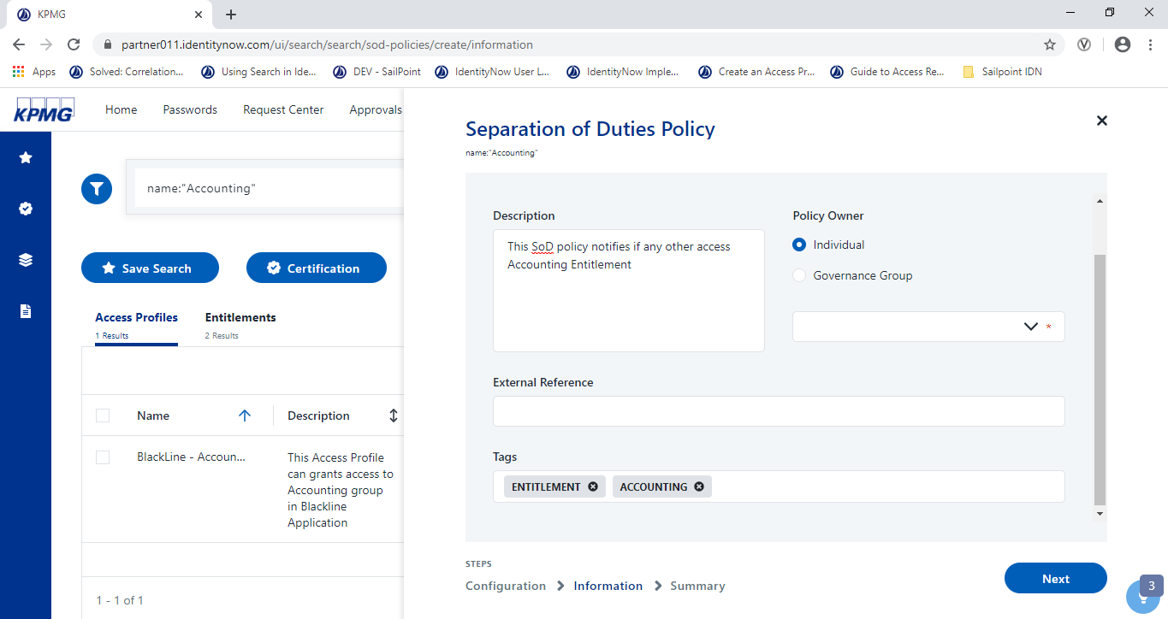

Figure 125: Save Configuration

1. Enter the following information then click the **Next** button.

The summary screen displays

* **Business Name** - The name of SoD (per the organization). This field is required.
* **Description** - A description of the policy and why it's important.
* **Policy Owner** - This user or governance group is the subject matter expert and point of contact for the policy. This field is required.
* **External Reference** - A link to reference site, such as an internal policy or a standards body, that describes this policy and the connections to stakeholders. Click the link to navigate to the site to make sure the link is valid.
* **Tags** - Enter any labels for the policy to associate it to governance processes.

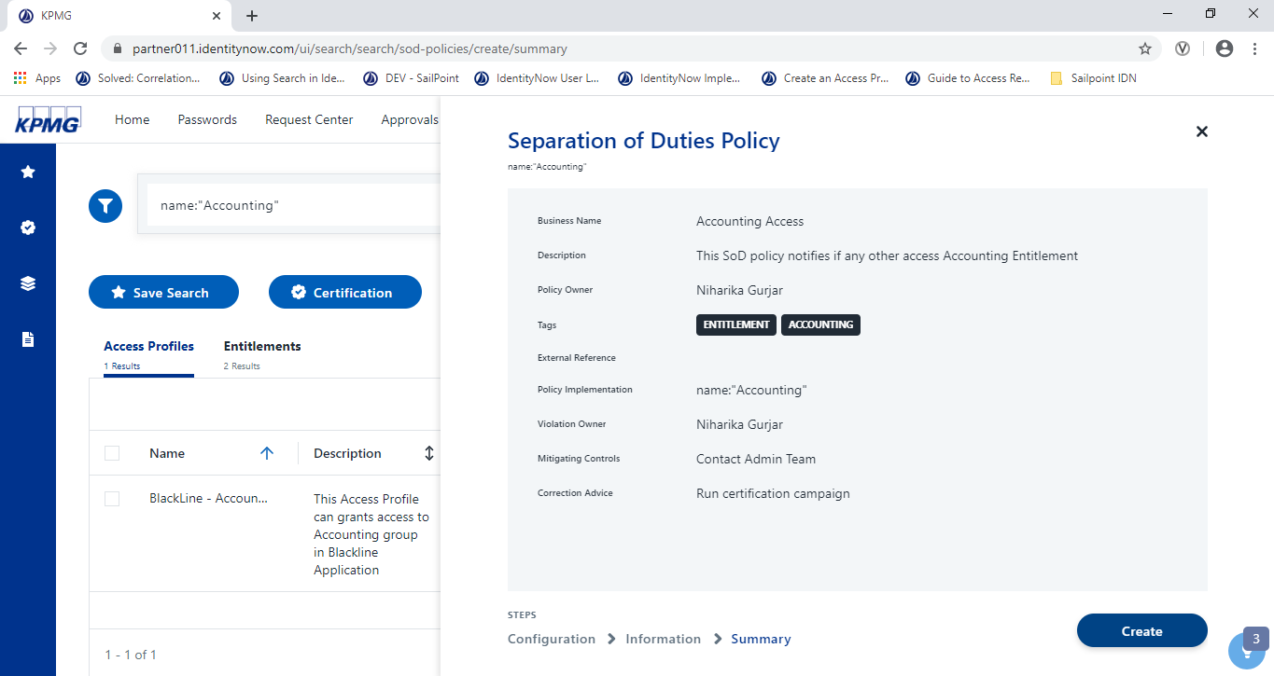

Figure 126: Create SOD

1. Review the policy and click **Create**.

The policy is created.

##### View SoD Policy

1. Sign into IDN as an Admin and click **Search**
2. Click the **SOD**  icon

The **SoD policies** display.

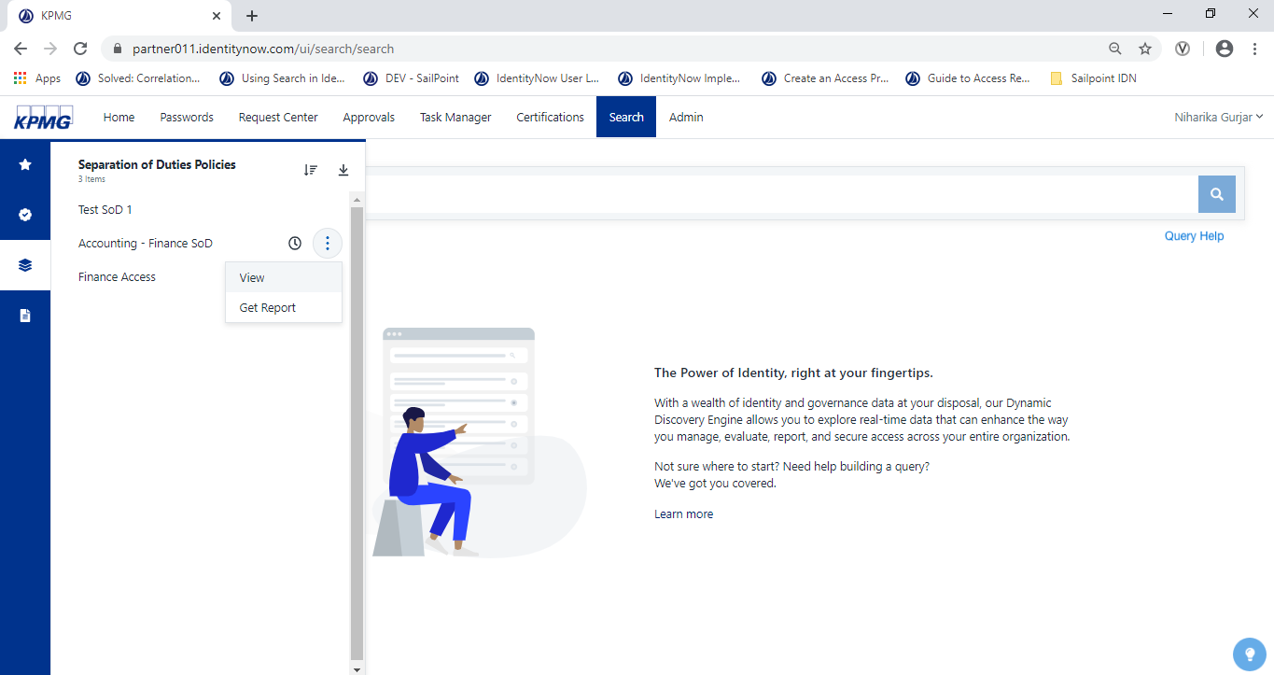

Figure 127: Open SoD Policies

1. Click the ellipsis  for a policy and click **View**.

The **SoD Policy** detail displays.

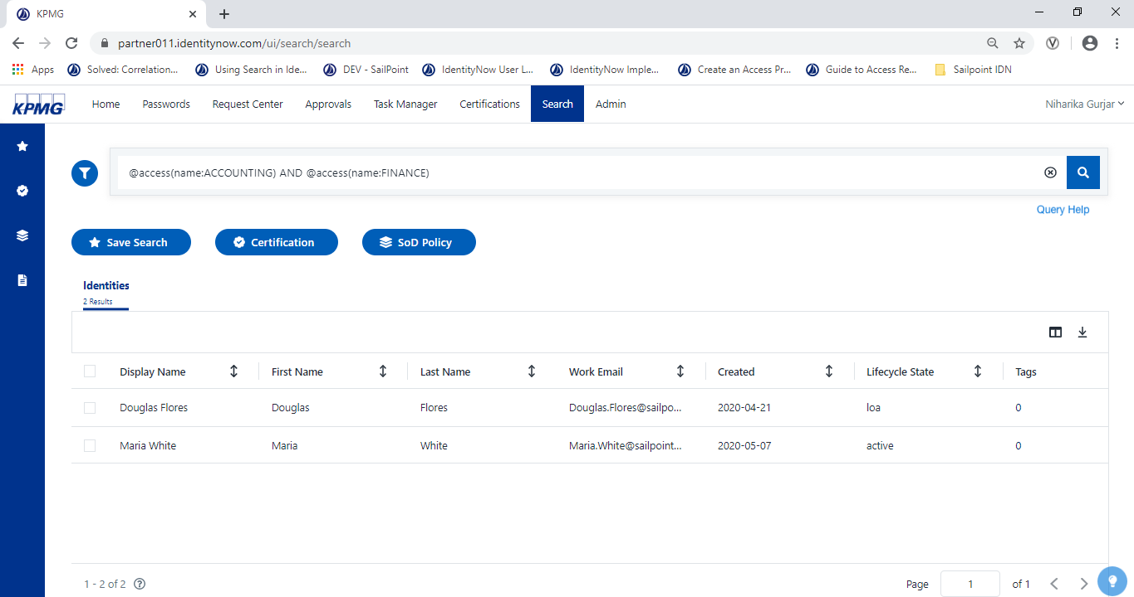

Figure 128: List of SOD

##### Download Report

1. Sign in to IDN as an Admin and click Search.
2. Click the **SOD**  icon.

The SOD policies display.

1. Click the ellipsis  for a policy and click **Get Report**.

The **reports** display.

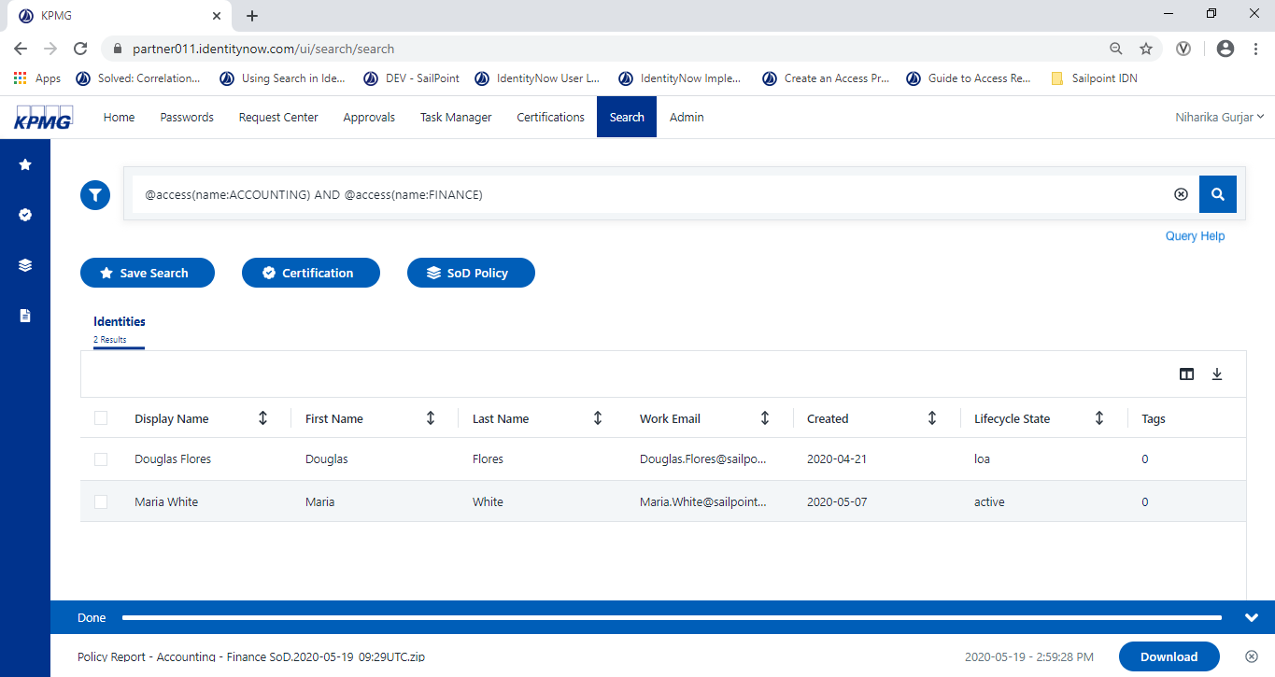

Figure 129: Get Report

1. Click **Download** to download the report.

#### Monitor & Resolve Data Quality Issues

**Powered 8.4**

##### Manage Uncorrelated Accounts

1. Sign into IDN as an Admin.
2. Point to **Admin** menu, click **connections,** then click **Sources.**

The **Sources** display on the screen.

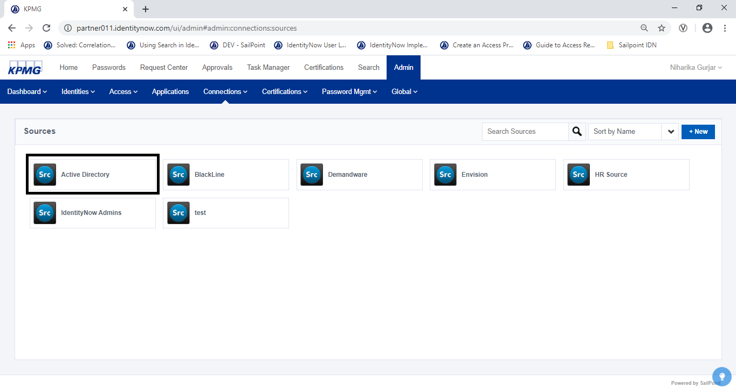

Figure 130: Sources List

1. Click a source to open it.
2. Click **Import Data** and select User Accounts.

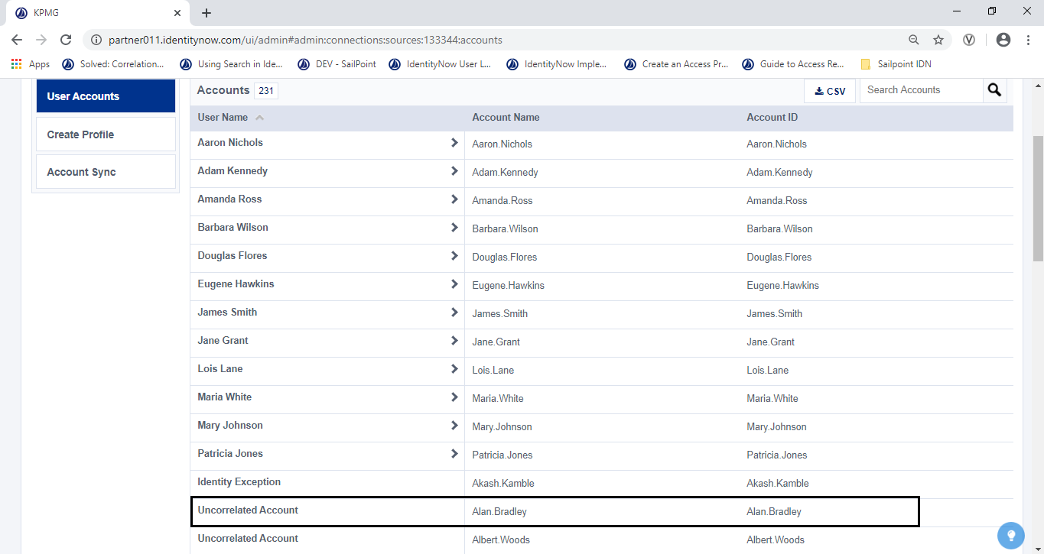

Figure 131: AD User Account

1. Click the **Uncorrelated Accounts** link.

The number of uncorrelated accounts display to the right of the Export panel.

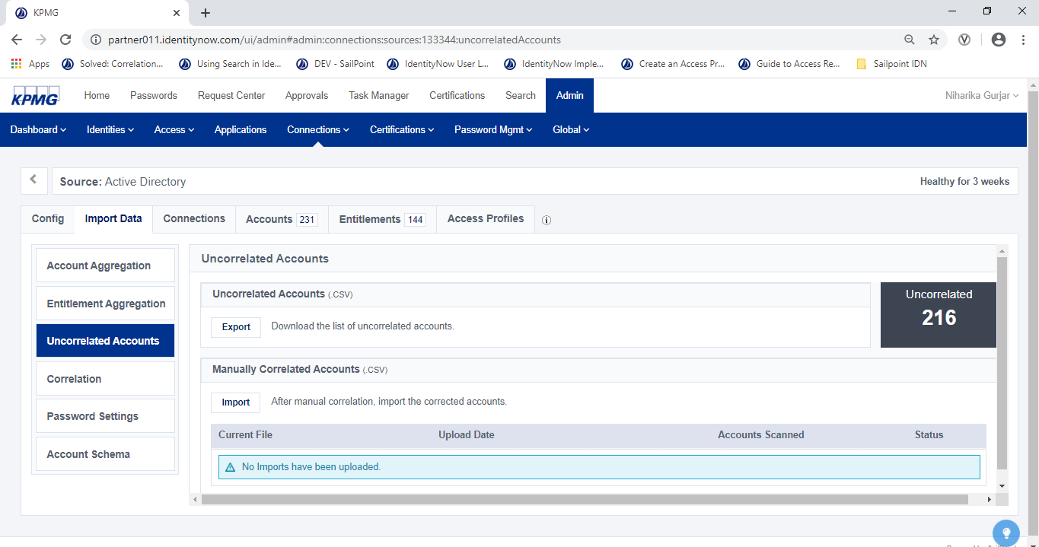

Figure 132: Select Uncorrelated Accounts Tab

1. Click **Export** to download the list of uncorrelated accounts.

The accounts download to a .CSV file.

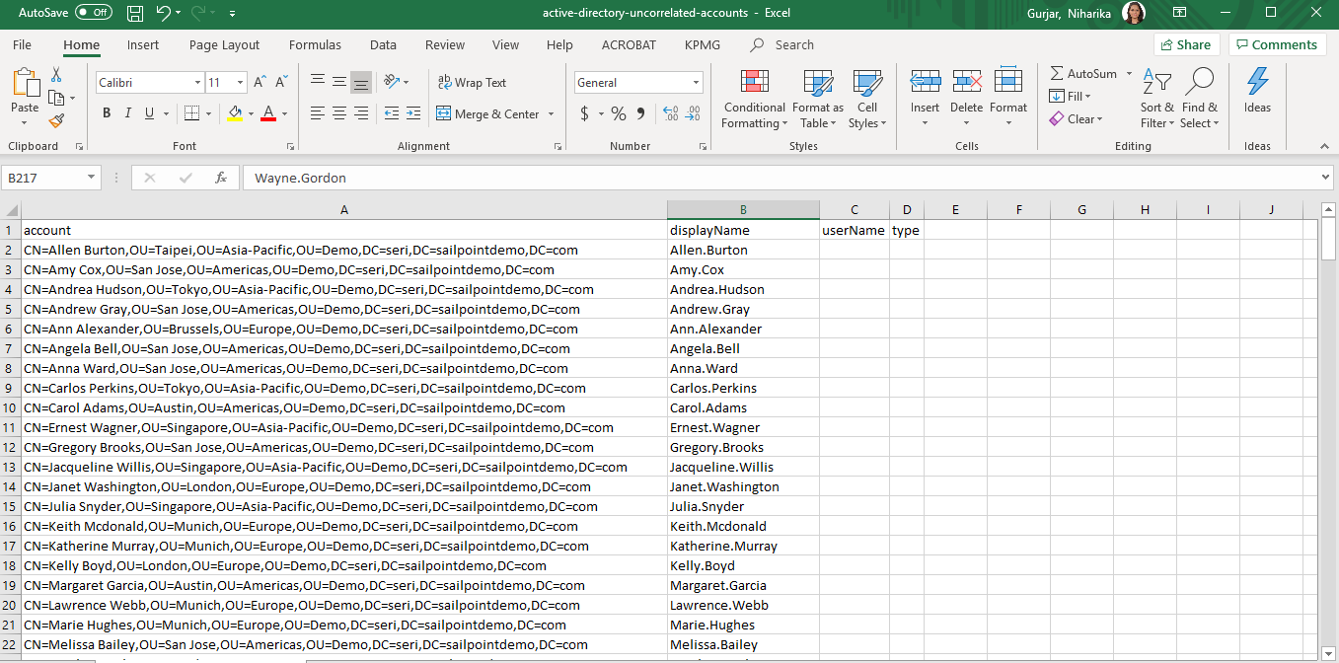

Figure 133: Export Uncorrelated Accounts

1. Edit the .CSV file to resolve the uncorrelated accounts by adding an Account ID of the associated identity. The find the Account ID:
2. From the **Admin** menu, click **Identities** and select **Identity** **List**.
3. Find the identity to correlate to an account.
4. Click the name of that identity.

The Identity details display for the selected account.

1. On the **Details** tab, scroll down to the **Attributes list.**
2. Find the value of the Account ID for the identity.
3. Copy the Account ID value into the uncorrelated accounts in the .CSV file.
4. Save the CSV file.
5. Click **Import** to load the corrected accounts into IDN.

The adjusted number of uncorrelated accounts displays.

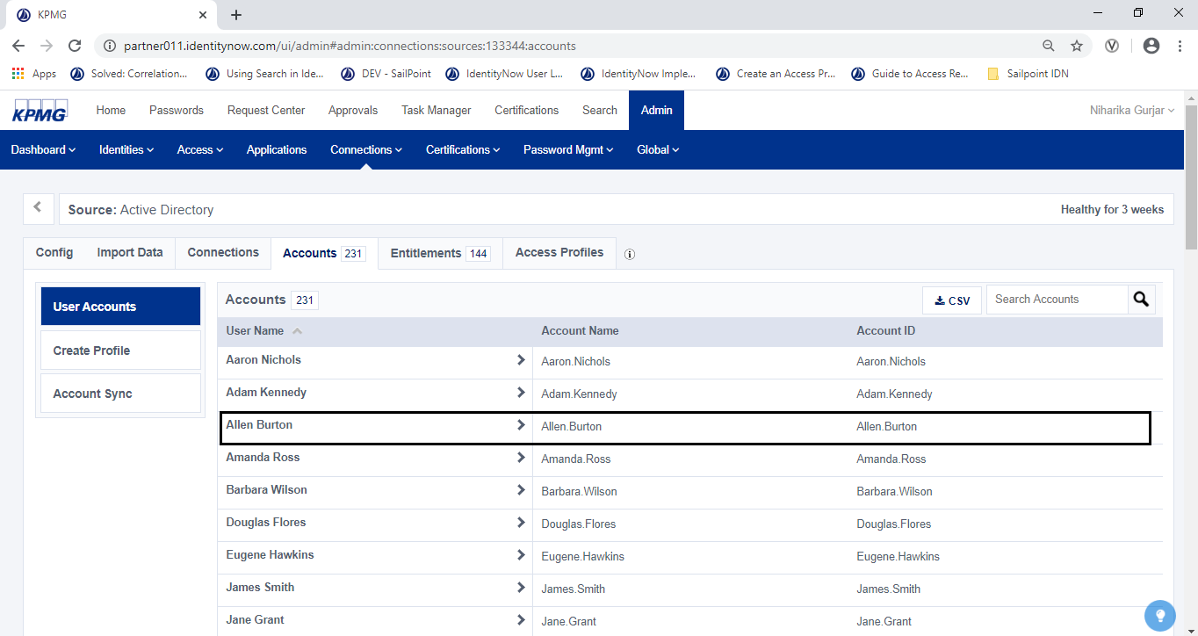

Figure 134: AD User Account List

##### Manage Identity Exception

IDN generates a new source and then creates an identity profile from that source. If an account on that source is missing values for one or more attributes that an identity requires, IDN generates an identity exception(s).

Required attributes include:

* uid
* email
* lastname

1. Sign into IDN as an Admin.
2. Point to **Admin**, click **connections**, click **Source,**  then click **HR Source.**

The HR Sources screen displays.

1. Click **Identities**, then click **Identity Profiles.**

The **Identity Profiles list** display.

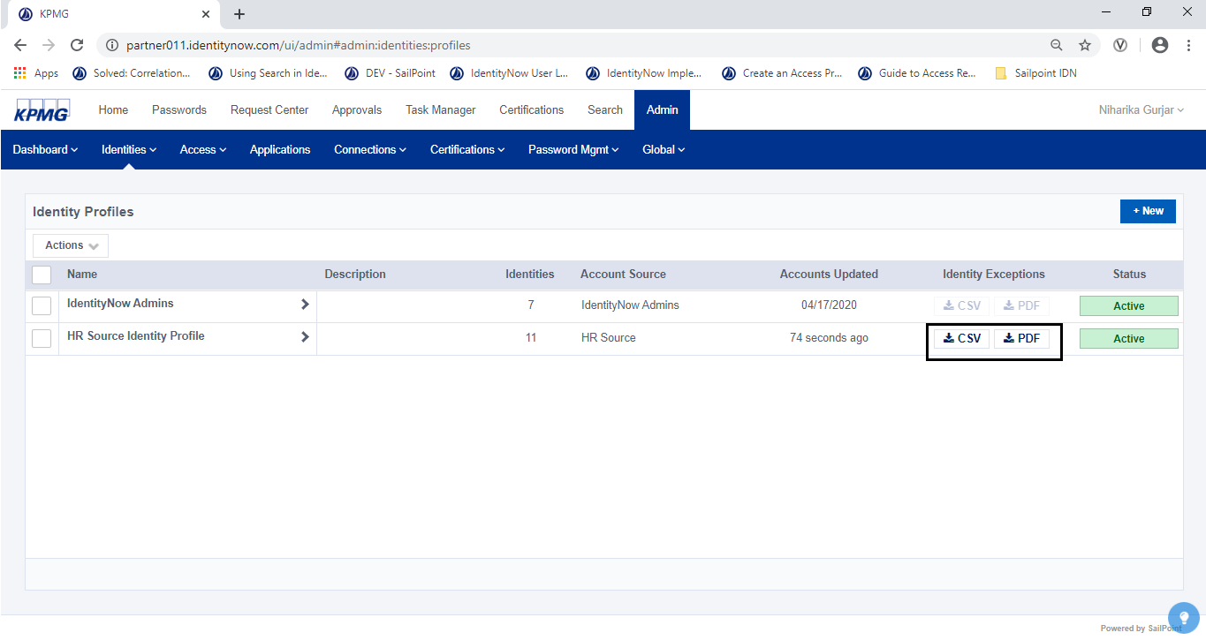

Figure 135: Identity Profiles List

1. In the **Identity Exceptions** column, click (put a checkmark) to select an identity and click **CSV** or **PDF** to download the report.

The report builds.

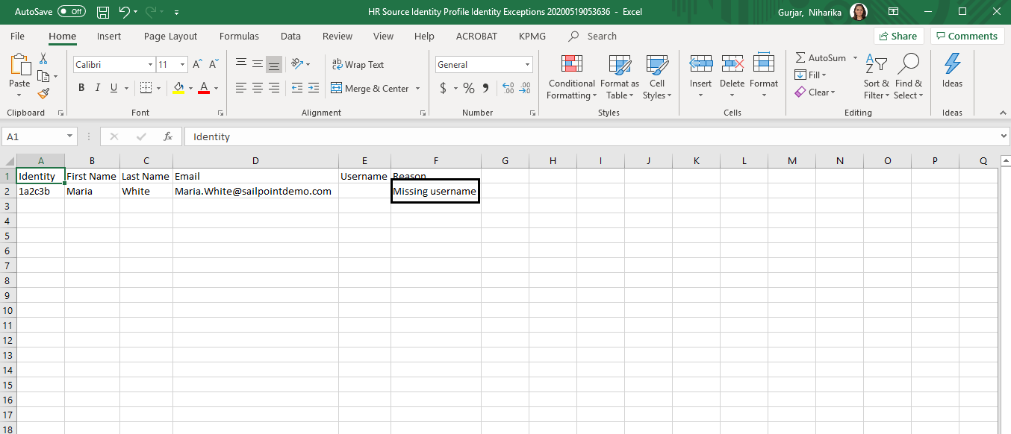

Figure 136: Identity Attribute Export List

1. Determine which attributes are missing associated accounts and update the file. Save changes.

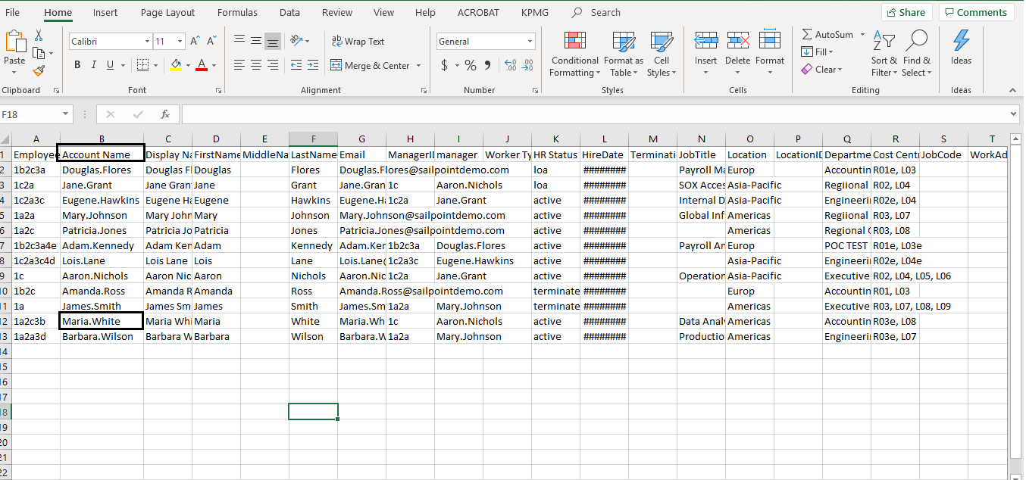

Figure 137: HR Source Feed File

1. Using IDN, manually aggregate the source to incorporate changes.

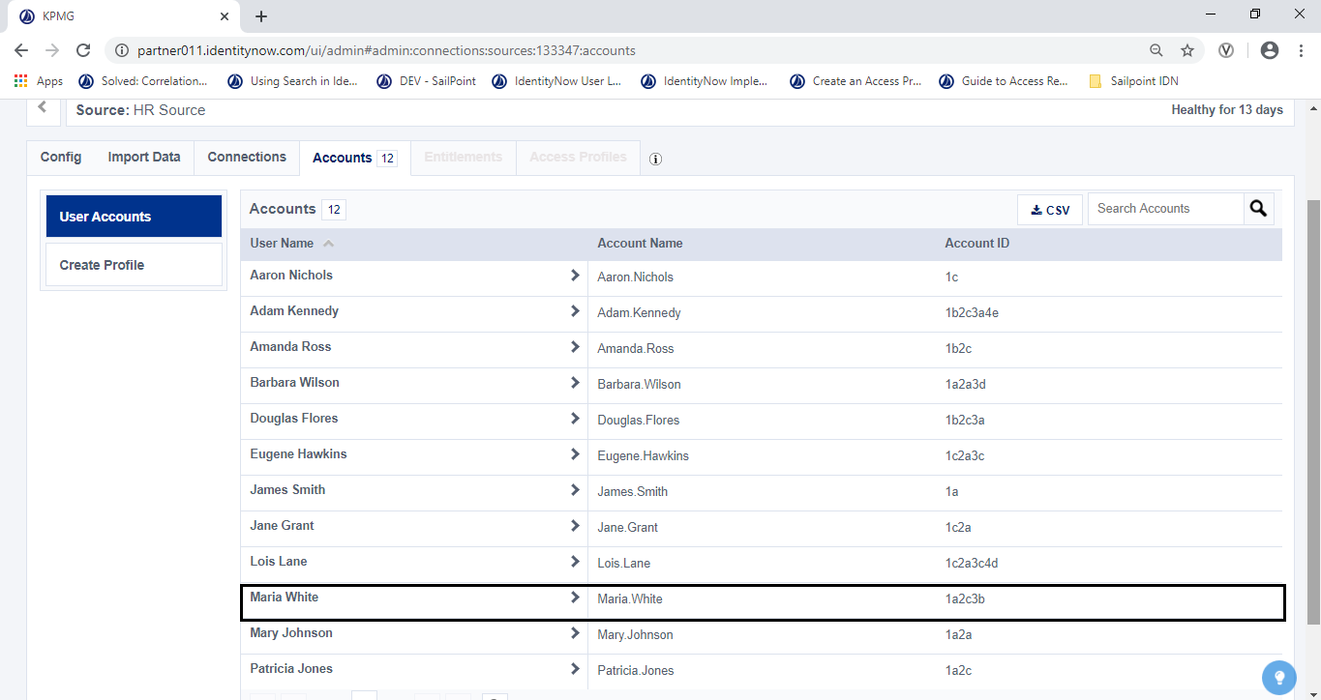

Figure 138: HR Source User Account

#### Support Audit Activities

**Powered 8.5**

All IdentityNow audit activity can be found in Search. Download several readily available audit reports or download a custom report by modifying search query.

1. From the **Search** interface, click the **Reports**  icon in the toolbar.
2. Choose a report to run.

The results display on the **Events** tab.

The table below includes the name of the report, a description of its contents, and the search query IDN uses to retrieve the results.

|  |  |  |
| --- | --- | --- |
| Report Name | Description | Query |
| All Events | *All activity that IdentityNow tracks in audit events.* | *type:\** |
| Access Request Activity | *All activity related to access requests.* | *type:"ACCESS_REQUEST"* |
| Authentication Activity | *Events related to any kind of authentication, including into IdentityNow and into apps.* | *type:AUTH* |
| Password Changes | *All password updates, including for apps, sources, and IdentityNow.* | *type:"PASSWORD_ACTIVITY"* |
| Provisioning Activity | *See a basic audit report of provisioning events.* | *type:PROVISIONING* |
| All Source Activity (Non-Provisioning) | *All activity on all sources, not including provisioning activity.* | *type:"SOURCE_MANAGEMENT"* |
| SSO Activity | *A report of all recent SSO activity.* | *type:SSO* |

Table 25: Audit Report Details

.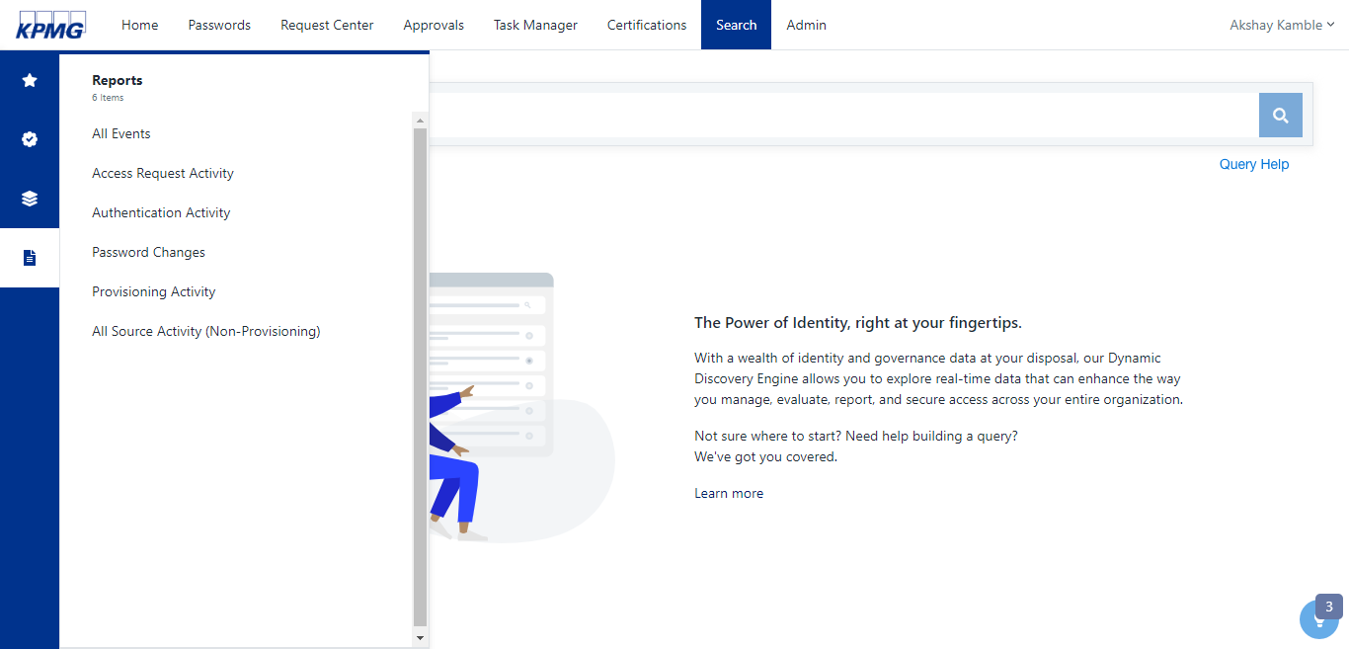

Figure 139: List of Report

1. From the Search interface, enter any **query** and click the **Search** icon.

Available categories from the report display.

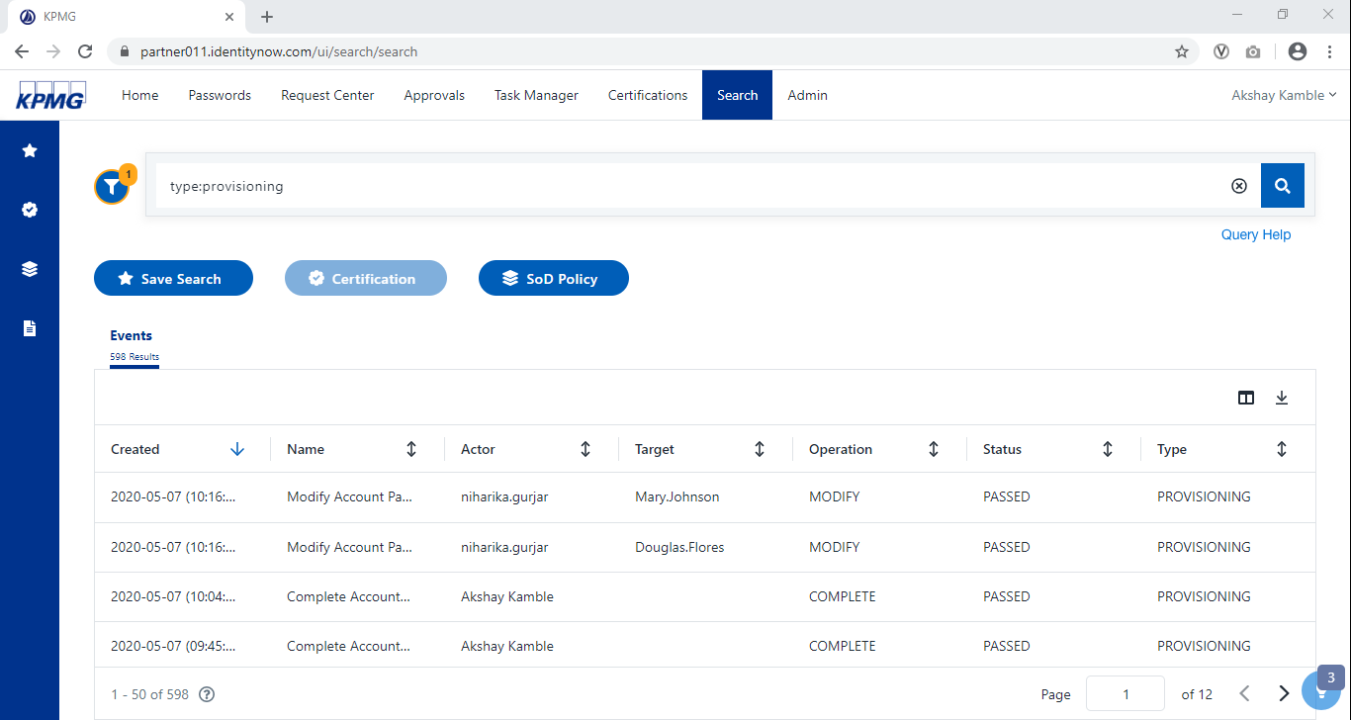

Figure 140: Search Tab

1. Tab to the search category for the report. For example, if you want to download all the entitlements that appeared in search results, go to the Entitlements tab.
2. Click the **Columns icon** and select the columns to include in **CSV report**.

The columns display in the **Search UI**.

1. Click the **Download** icon.
2. If applicable, choose whether to include additional details about the access related to data by moving the slider labeled **Include Access Details**.

**Note**: This option is available for identities, access profiles, and roles. The name of this slider is different for each search category it applies to.

1. If applicable, click **Generate Report**.

The report generates; this might take several minutes.

**Note**: IdentityNow can display up to 10,000 search results in the interface, but the report will always contain the complete list of search results.

1. Click **Download**.

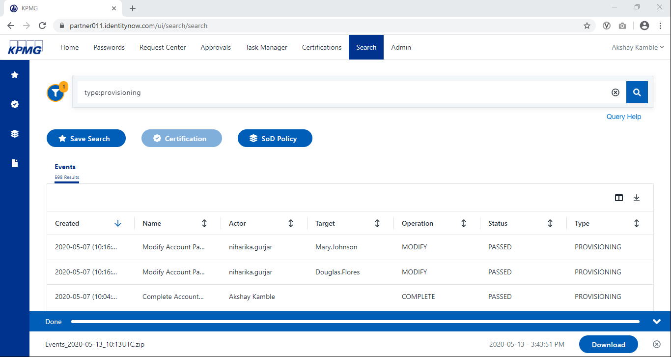

Figure 141: Download Search Report

1. Unzip the file and open it in the editor of choice.

**Note**: IdentityNow stores events for 90 days or 100,000 events, depending on their type. To maintain audit events for longer, we recommend a SIEM solution. Contact SailPoint for help integrating these solutions with IdentityNow.

##### Account Activity

The following information about the account activity that search query returned is available.

|  |  |  |
| --- | --- | --- |
| **Column Name** | **Description** | **Search Query** |
| **Status** | *The overall status of the account action* | *status:<term>* |
| **Action** | *The action performed. This will always match an action in this list.* | *action:<term>* |
| **Requester** | *The display name of the user or system that requested the action* | *requester.name:<term>* |
| **Recipient** | *The display name of the user or system that the action is modifying* | *recipient.name:<term>* |
| **Sources** | *A list of sources that will be modified by the account action* | *sources:<term>* |
| **Last Modified** | *The date and time of the last activity related to the action.* | *modified:<term>* |
| **Stage** | *The progress of the action on the source* | *stage:<term>* |
| **Identity Request ID** | *The technical ID of the request* | *id:<term>* |
| **Tracking Number** | *The shortened tracking ID of the action* | *trackingNumber:<term>* |
| **Created** | *The date and time the account action was created* | *created:<term>* |

Table 26: Account Activity

**Note**: When a report is selected, IdentityNow automatically runs a search query to return the data associated with that report.

##### Roles

The information about roles that search query returned is available:

|  |  |  |
| --- | --- | --- |
| Column Name | Description | Search Query |
| Name | The name of the role | name:<term> |
| Description | The user-entered description of the role | description:<term> |
| Modified | The date the role was last modified | modified:<term> |
| Enabled | A Boolean describing whether the role is enabled | enabled:<term> |
| Access Profile Count | The number of access profiles granted by the role | accessProfileCount:<term> |
| Owner Name | The name of the role | owner.name:<term> |
| Role ID | The technical ID of the role | id:<term> |
| Created | The date the role was created | created:<term> |
| Requestable | A Boolean describing whether the role is marked as requestable | requestable:<term> |
| Owner ID | The technical ID of the owner of the role | owner.id:<term> |

Table 27: Role Details

Access profile role information is also available. If requested, each access profile displays on a separate row of the file. Each role will appear in the list once for each access profile . The following is added to the file when access profiles are requested.

|  |  |  |
| --- | --- | --- |
| Column Name | Description | Search Query |
| Access Profile ID | The technical ID of the access profile in this role | accessProfiles.id:<term> |
| Access Profile Name | The name of the access profile | accessProfiles.name:<term> |

Table 28: Access Profile Details

Powered 9.0

System Governance

### System Governance

This section is an overview of configurations to maintain system settings and security, and monitoring tasks.

#### Maintain System Settings and Security

**Powered 9.1**

##### Branding

1. Sign into IDN as an Admin.
2. Point to **Admin**, click **Global**, click **System Settings**, then select **Product Branding.**

The **Product Branding** screen displays.

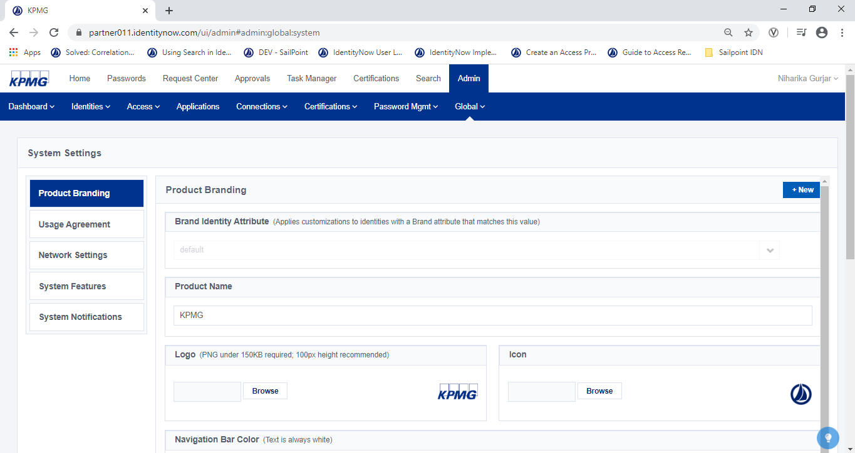

Figure 142: System Settings

1. In **Product Name**, type the name of the product.
2. Click **Save**.

The changes dsplay.

##### Logo

1. Sign into IDN as an Admin.
2. Point to **Admin**, click **Global**, click **System Settings,** then select **Product Branding**

The **Product Branding** screen displays.

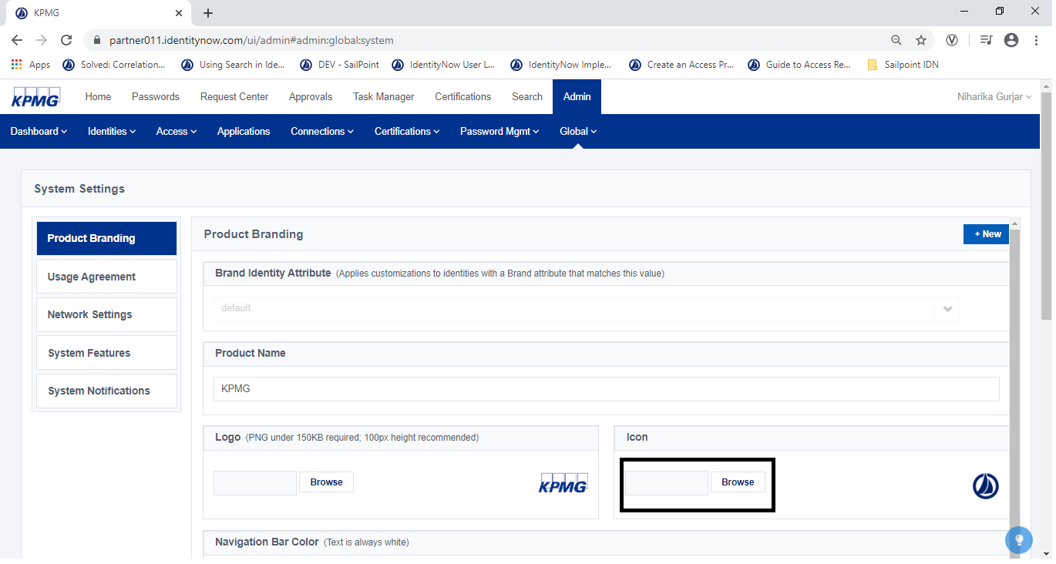

Figure 143: Product Branding Configuration

1. In the Logo section, click the **Browse** button. Select the image and click **Open**.

A preview of the image appears to the right of the field.

1. In the Logo Under section, click Browse. Select the image and click **Open**.

A preview displays.

1. Click Save.

The new image displays at the top of the page.

##### Blacklist/ White List Countries

1. Sign into IDN as an Admin.
2. Point to **Admin** and click **System Settings**

The **System Settings** screen displays.

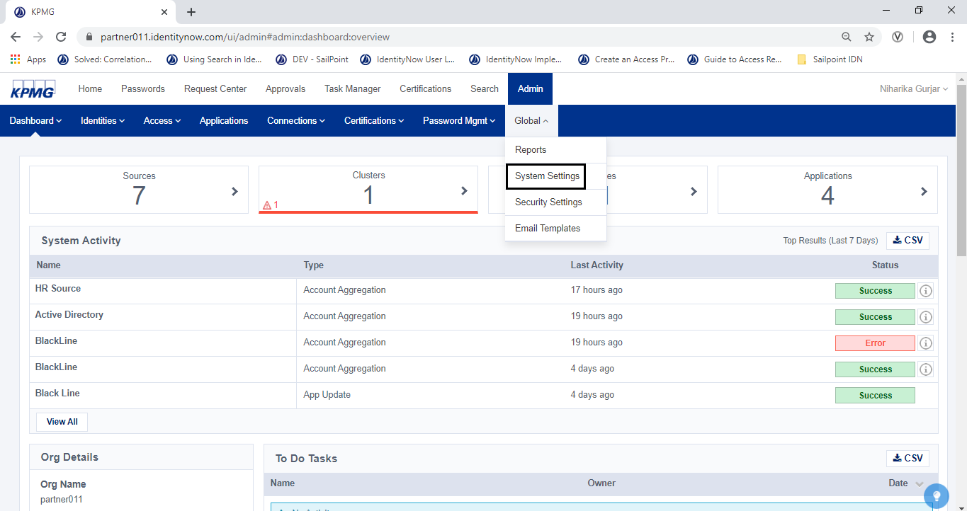

Figure 144: Navigate to System Settings

1. Select **Network Definition**, then select **Trusted Countries.**

The **Network Settings** screen displays.

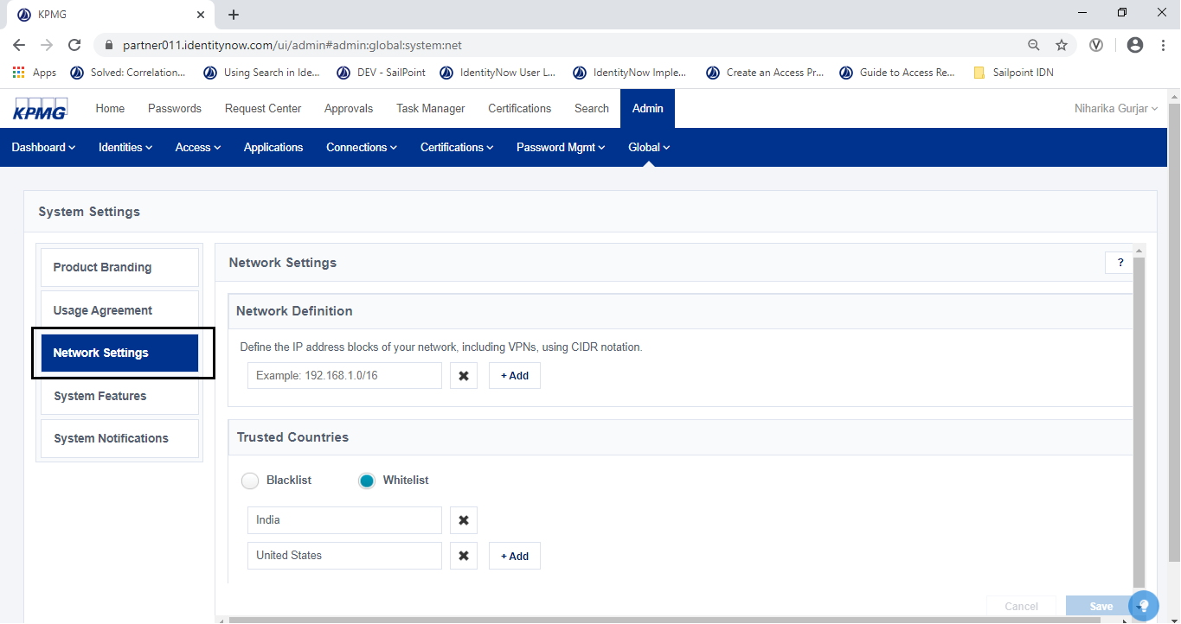

Figure 145: Network Settings

1. In the Trusted Countries box, select **Blacklist** or **WhiteList**

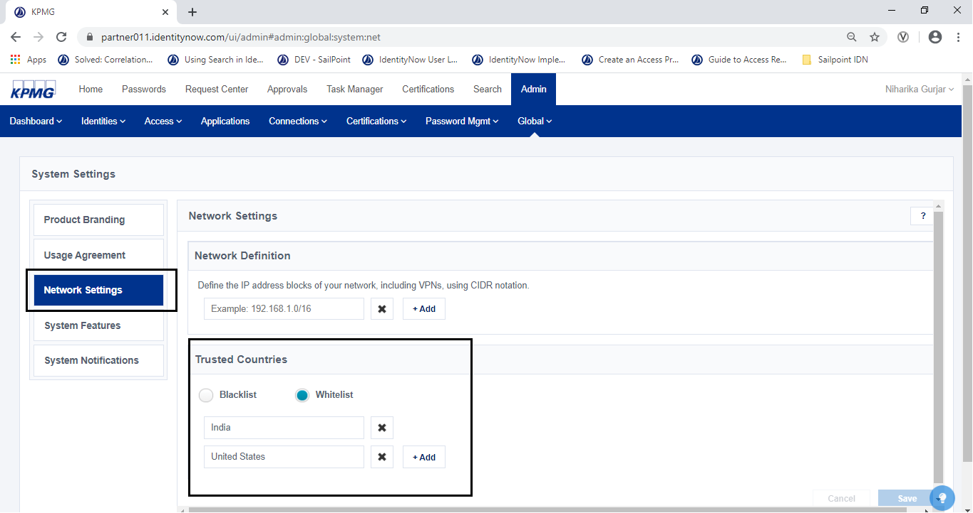

Figure 146: Add Trusted Countries

1. Type the name of a country in the field and click **+Add.**

The country is added to either the blacklist or whitelist.

1. Repeat until all the countries have been added. Click the **Save** button.

The configuration is saved.

##### Configure System Notifications

1. Sign into IDN as an Admin.
2. Point to **Admin** menu, click **Global**, then click **System Settings,**

The **System Settings** screen displays.

1. Click the **System Notifications** tab.

The **System Notifications** tab displays.

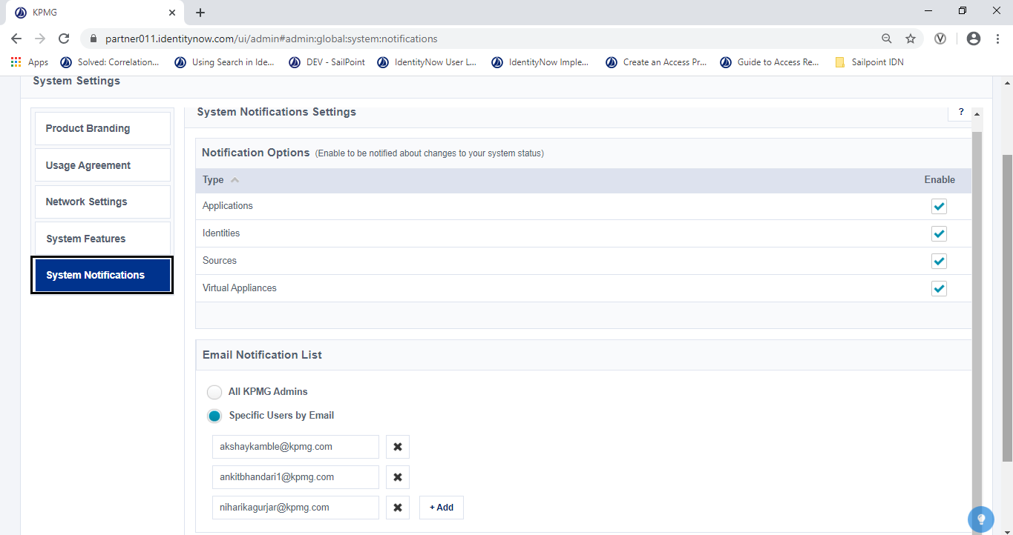

Figure 147: System Notification Tab

1. In **Notification Options**, Enable one or more notifications by select the **Enable** check box
2. In the **Email Notification List**, select who you want to send notifications.

* **All SailPoint Admins** - The notification is sent to the work email address of all users in the system with access to the Admin interface.
* **Specific Users by Ema**il - The notification is sent to the specified email addresses

1. Click the ​**Save**​ button

##### Configure security questions

1. Sign in to IDN as an admin.
2. Point to **Admin**, click **Global**, then click **Security Questions**.

The **Security Questions** screen displays.

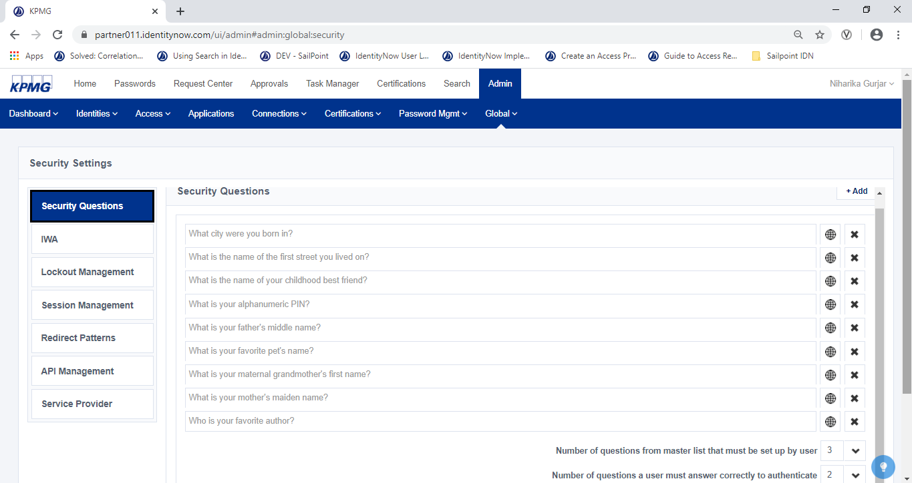

Figure 148: Security Questions Tab

1. Click **+Add** to add a new security question.
2. Type the question and then click **Add** button.

The new security question is added to the list.

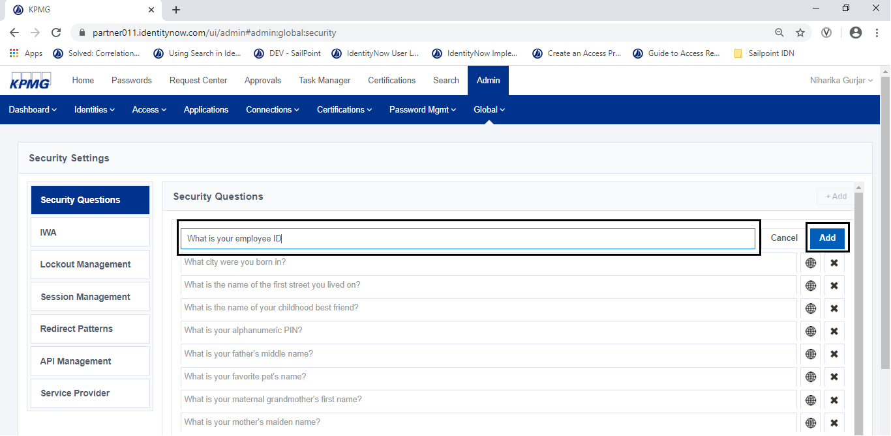

Figure 149: Configure Security Questions

1. Configure the minimum required questions for users by selecting values for each of the following:

* **Number of questions from master list that must be set up by use**r - This is the number of questions a user must set up in SailPoint.
* **Number of questions a user must answer correctly to authenticate** - This is the number of questions a user must answer correctly to reset their SailPoint password.

1. Click the **Save** button.

##### Configure Pass through

1. Sign in to IDN as an Admin.
2. Point to **Admin**, click **Identities**, then click **Identity Profiles**

The **Identity Profiles** screen displays.

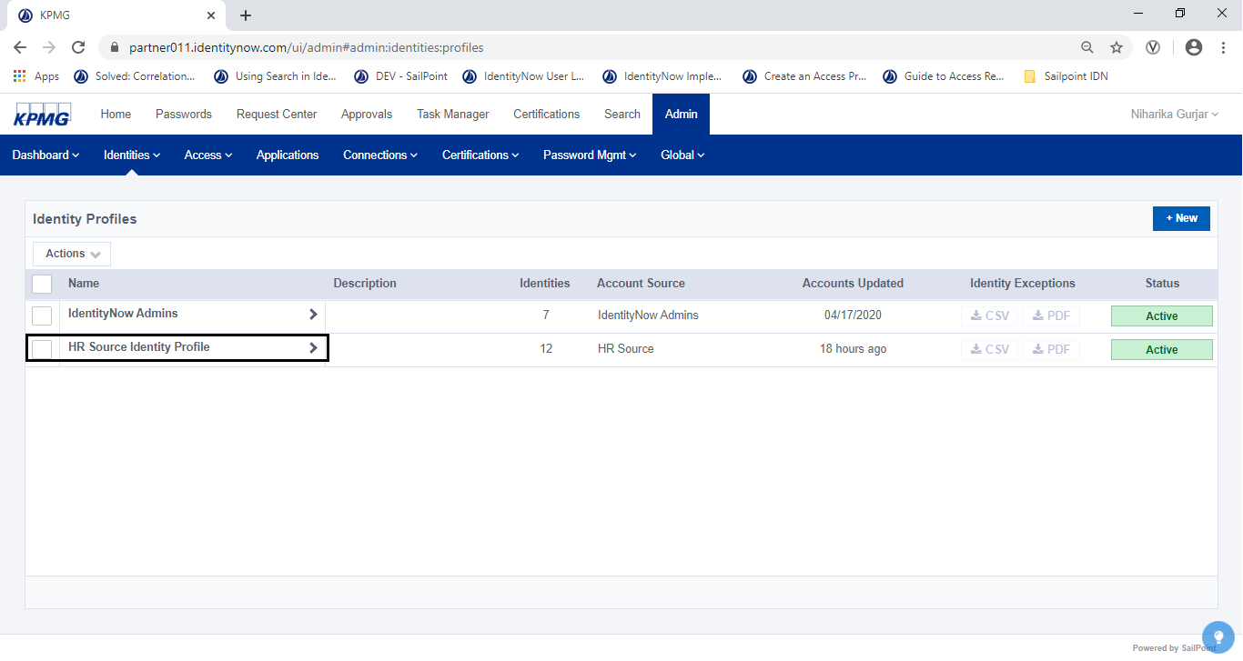

Figure 150: List of Identity Profile

1. Open the **HR Source Identity Profile**

The **Identity Profile** screen, **Settings** tab opens.

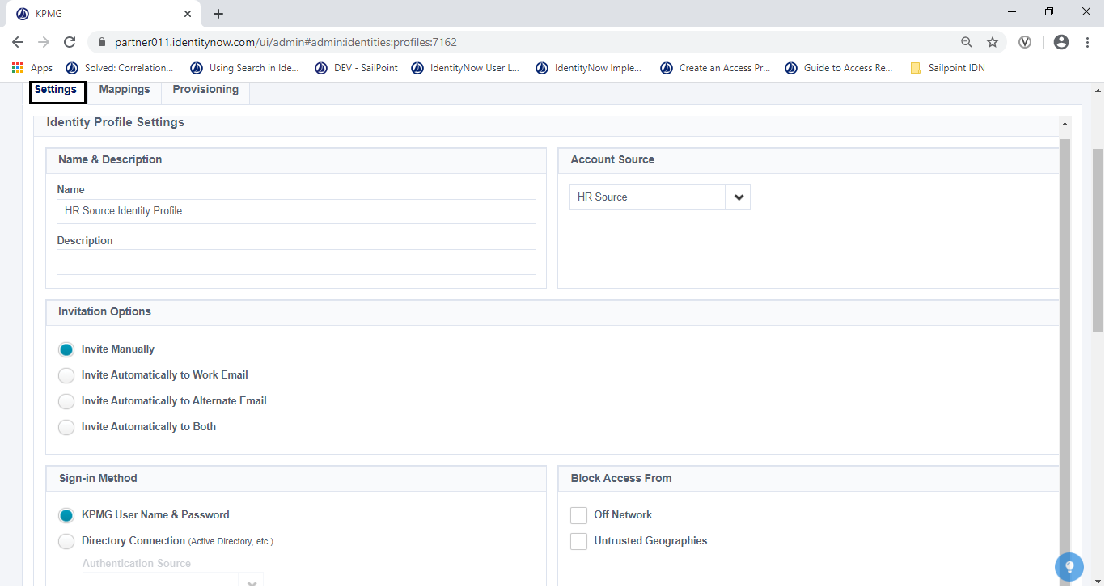

Figure 151: Identity Profile Setting Tab

1. In the **Sign-In Method** tab, select the **Directory Connection** option
2. In the **Authentication Source** drop-down list box, select **AD source.**
3. Click the **Save** button.

The profile is saved.

##### Configure IWA

1. In Active Directory, right-click **Computers** and select **New**.

The **New Object – Computer** screen displays.

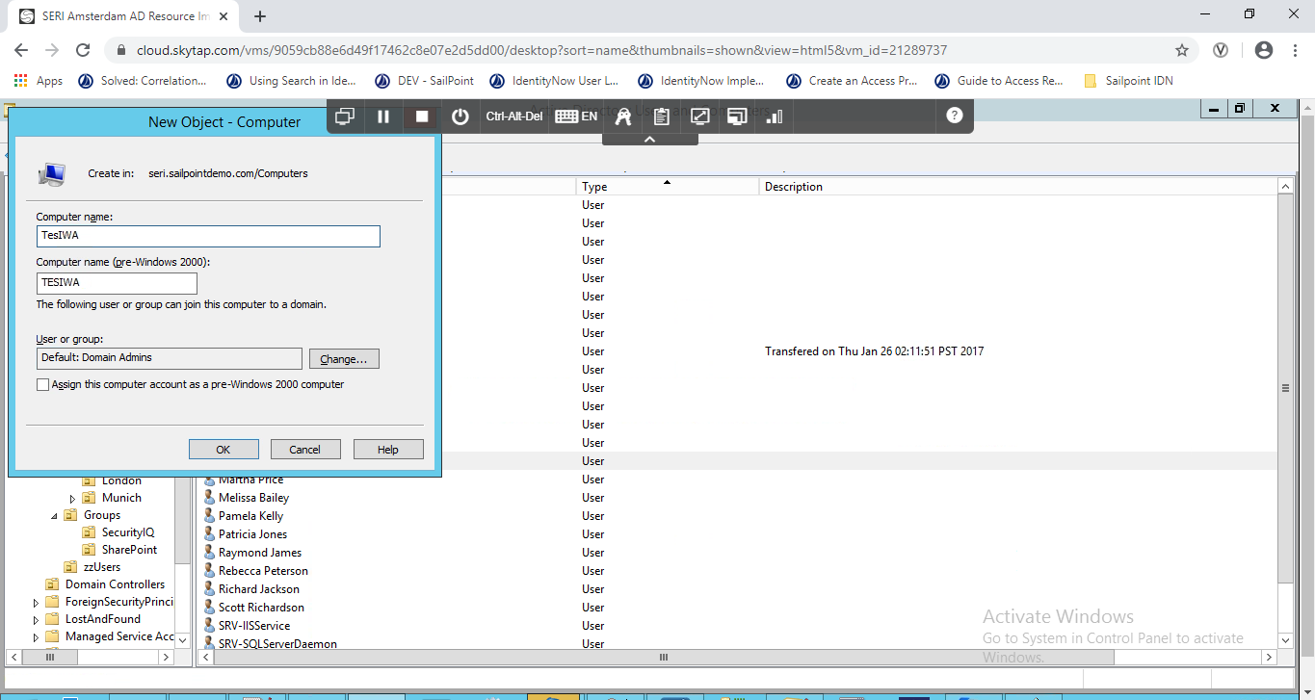

Figure 152: New Object – Computer Screen

1. In the **New Object – Computer** window, define a name for the new computer that will represent the SailPoint server.
2. Sign in to SailPoint as an Admin.
3. Point to **Admin**, click **Global**, click **Security Settings**, then select **IWA**.

The **IWA** screen displays.

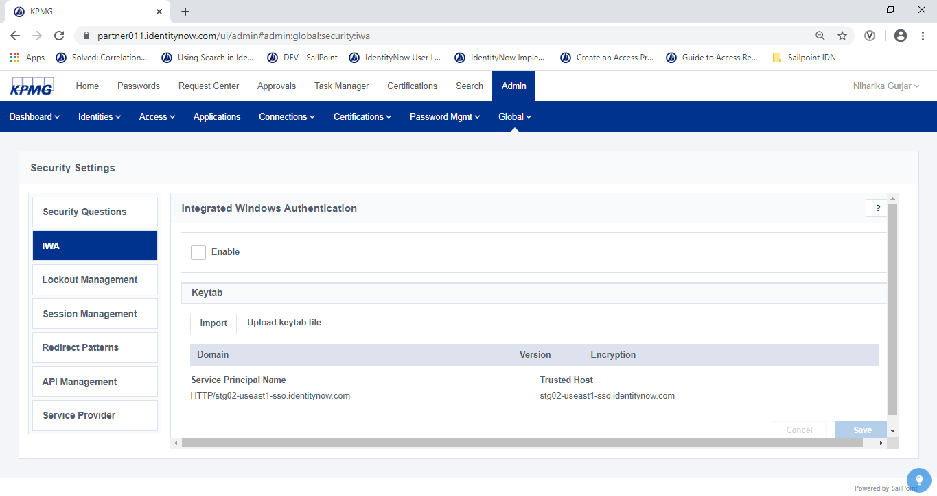

Figure 153: IWA Configuration Tab

1. Under Integrated Windows Authentication, make note of the **Service Principle Name**.
2. Open a command prompt on the Active Directory server.
3. Change the new computer name created in step 2 to the Service Principle Name from step 5 by running the **setspn** command as follows:

*setspn -A <svc_principle_name> <computer_name>$*

For example:

setspn -A HTTP/organization-sso.identitynow.com computer-sso$

1. Generate a keytab file by running the **ktpass** command as follows:

*ktpass /princ <svc_principle_name>@<AD_domain> /mapuser <AD_domain>\<computer_name>$ /crypto ALL /out <filename>.keytab +rndpass*

A success message is displayed when the file is generated.

1. In SailPoint, Point to Admin, click Global, click Security Settings, then select IWA.

The **IWA** screen displays.

1. In the Integrated Windows Authentication section, click **Browse** and browse to the location of the keytab file generated in step 8.

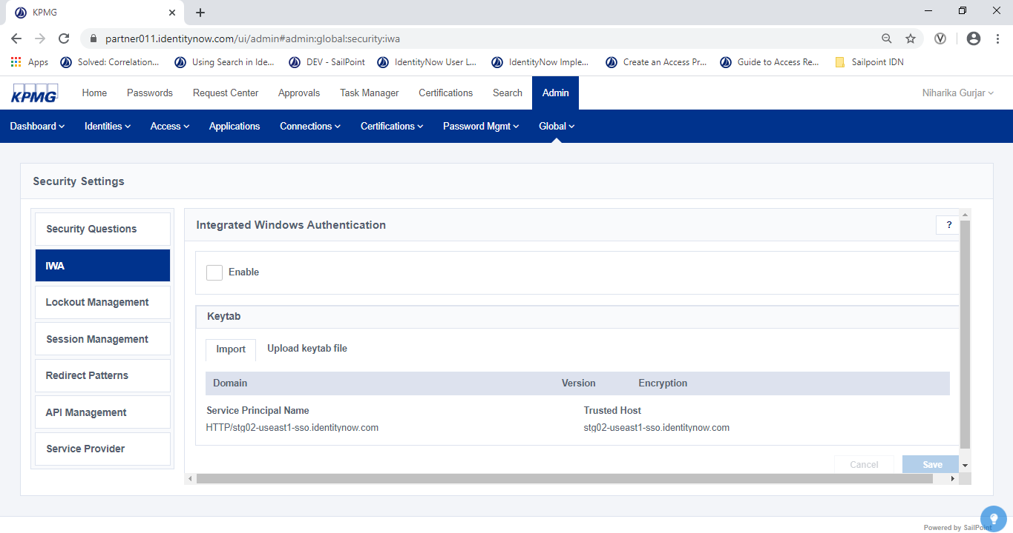

Figure 154: IWA Configuration

1. Click the **Enable** button

##### Session Management

1. Sign in to IDN as an Admin.
2. Point to **Admin**, click **Global**, then click **Security Settings**,

The **Security Settings** screen displays.

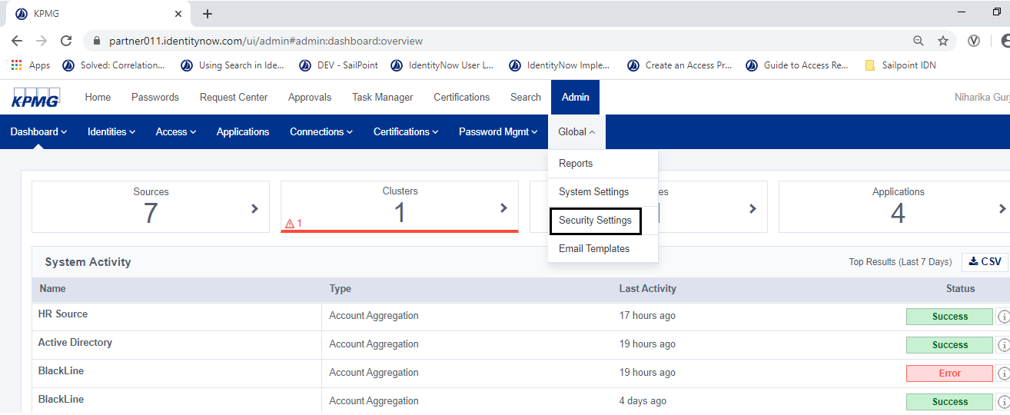

Figure 155: Navigate to System Settings

1. Click **Session Management**.

The **Session Management** screen displays.

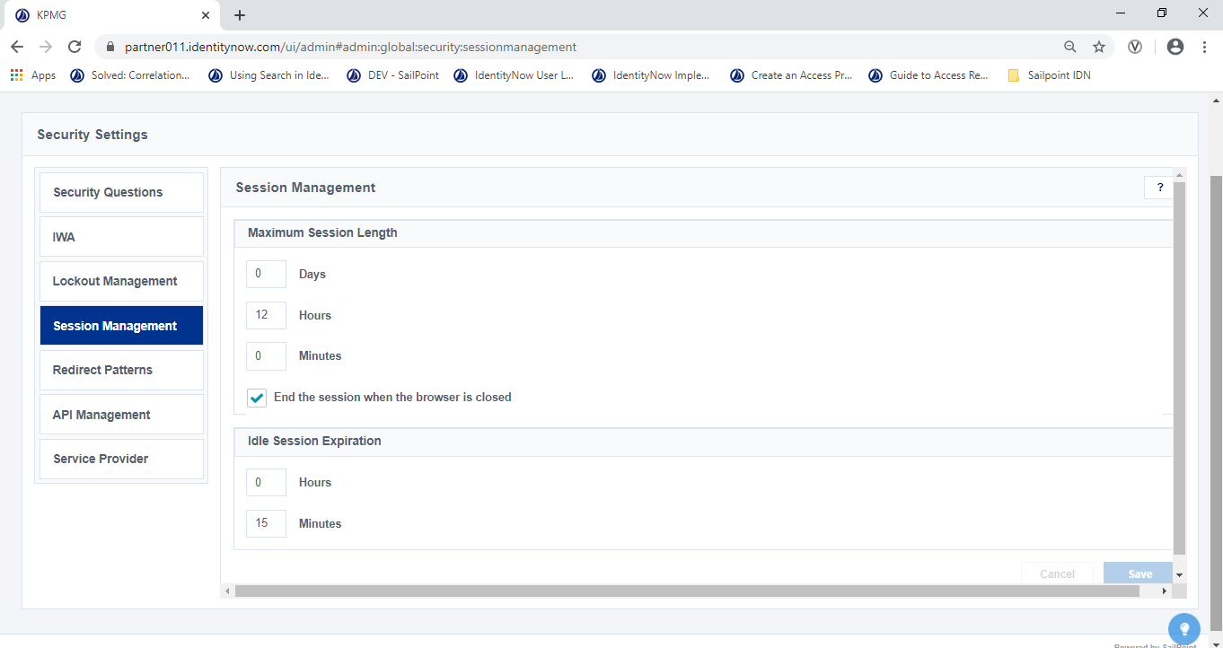

Figure 156: Configure Session Management

1. In the **Maximum Session Length** box, select a short session length that is appropriate to users' environment.
2. Select (add a checkmark) to **End the session when the browser is closed.** This signs the user out when they close the browser so that subsequent users cannot access their IDN information.

**NOTE**: This also hides the **Remember Me** check box on the Sign In page so that users always must provide their username when they navigate to IdentityNow or an app on their Launchpads.

1. In the I**dle Session Expiration** box, set a short period of time that the browser can remain idle before the user is signed out. This ensures that if a user is either not actively using IDN or failed to close the browser or sign out, their account information is still protected from other users.

#### Perform System Maintenance and Updates

**Powered 9.2**

For IDN system maintenance and updates contact SailPoint Service Expert Team. You can create a new ticket by sending an email to: [**support@sailpoint.com**](mailto:support@sailpoint.com)

#### Monitor Tasks

**Powered 9.3**

##### View Source Activity

1. Sign into IDN as an Admin and click **Search**.

The **Search** screen displays

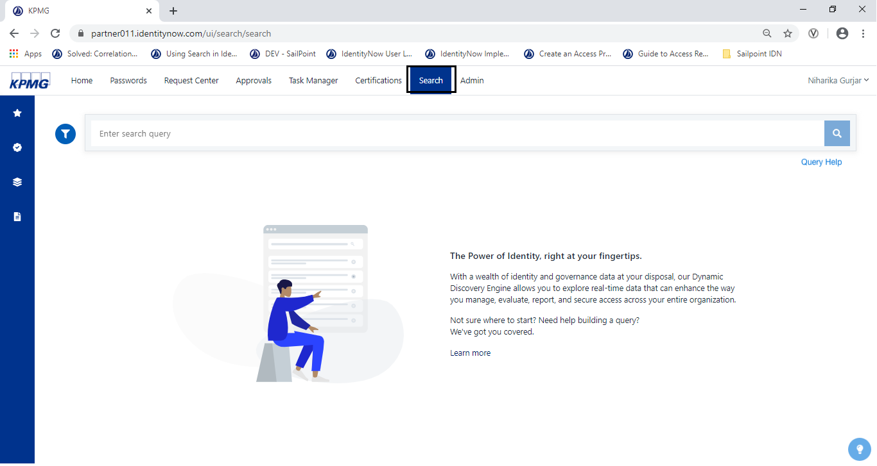

Figure 157: Search Tab

1. In the search tab, enter the following query then click the **Search** icon.

***attributes.sourceName:* AND created:[now-7d/d TO now]***

**Note**: You may choose to replace * with a Source name to view activity for that Source. For example:

**attributes.sourceName: “Active Directory” AND created:[now-7d/d TO now]**

A report showing all activity for the source displays.

1. Click the activity to view more details about the activity in the sidebar.

##### Recent Source Activity

1. Sign into IDN as an Admin and click Search.

The Search screen displays.

1. In the search tab, enter the following query: ***created:[now-1d TO now]***

A report showing recent activity in IdentityNow is generated.

1. From the **Events** tab, click the activity to view more details about the activity .

The details display.

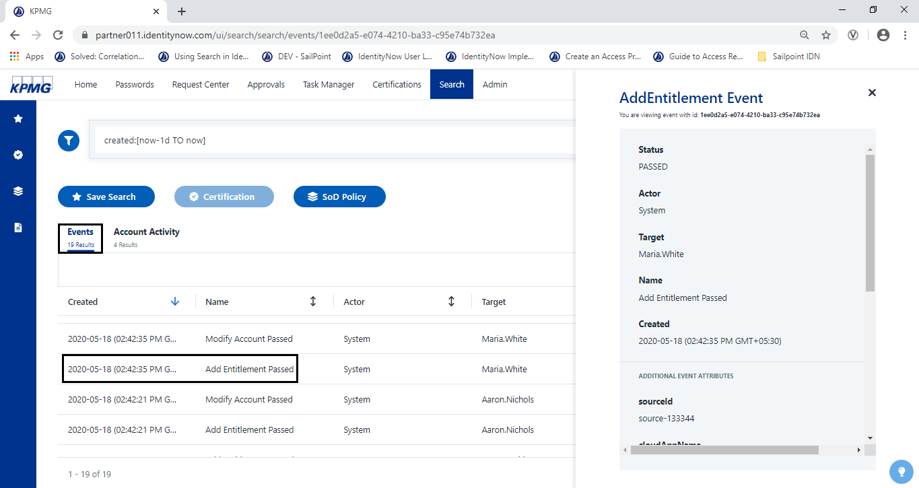

Figure 158: Detail Report Activity

1. Click the **Account Activity** Tab

The type of action taken on an Identity and Sources displays in the Identity Refresh screen

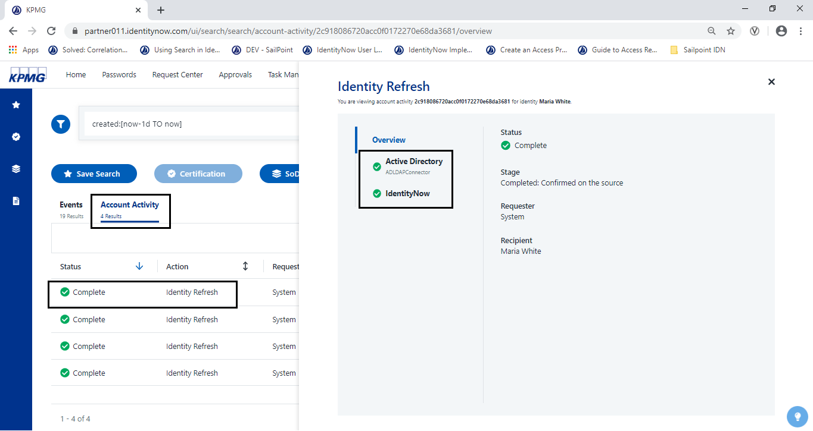

Figure 159: Account Activity

1. Click on any activity to view more details about the activity in the sidebar.

## Email Notification

In IDN, email templates are used in various parts of the application to notify users of certain milestones or other events. These templates provide a way to describe the intended content (subject, body) of the email. Each template mainly consists of name, description, subject, body, and a set of variables that can be used in the subject or body. At runtime, IDN will replace those variables with proper values.

Below are some out of the box available email templates in IDN.

|  |  |
| --- | --- |
| Template | Description |
| Access Request Decision | When IdentityNow is configured for the Access Request service, this email is sent to a user who requests access to an app. It notifies the user whether their request was approved or denied. |
| Access Request Decision for Other | When IdentityNow is configured for the Access Request service, this email is sent to a user when access was requested for them by another user, and the reviewer of that request has made a decision. |
| Access Request for Other | When IdentityNow is configured for the Access Request service, this email is sent to a user when another user has requested access for them. |
| Access Request for Self | When IdentityNow is configured for the Access Request service, this email is sent to a user to confirm that they've successfully submitted an access request for another person. |
| Access Request Reassignment | When IdentityNow is configured for the Access Request service, this email notifies a reviewer when they have had access requests reassigned to them. |
| Access Request Reviewer | When IdentityNow is configured for the Access Request​ service, this email is sent to each access reviewer who needs to review the access request. |
| App Password Changed | If IdentityNow is configured for passthrough authentication, a user receives this email when they change their password for IdentityNow or any app or direct connect source connected to the source used for passthrough authentication. |
| Application Health | A System Notification sent when an application changes status. |
| Certification | Whenever a certification campaign is created, reviewers will get this email. |
| Certification Due | Reviewers of certifications will receive this email one week after a certification campaign starts and every seven days after that, until they sign off or the campaign ends. |
| Certification Reassignment | Notifies a reviewer when they have been reassigned identities from an existing certification. |
| Forgot User Name | Sent when a user clicks **Forgot User Name** on the Sign In page and then supplies an email address that is valid for their account. |
| Helpdesk Password Reset | Sent when a user requests a password reset via email. |
| Identity Errors | A System Notification sent when an identity refresh causes 5% or more of identities to be in an error state. |
| Lifecycle State Change | Notifies select users when an identity's lifecycle state changes. |
| New Account Provisioned | Sent to a user when an account is created on a source for them. |
| Preference Update | Whenever any authentication settings (phone number or answers to security questions) change for a user, IdentityNow notifies them with this email. |
| Password Expiration | When a user's password is about to expire or has expired, IdentityNow notifies the user with this email. |
| Password Reset Code | Sent when a user requests a password reset code via email. |
| Search Subscription Notification | Sent to administrators when a scheduled search is run. |
| SoD Policy Subscription Notification | Sent to remediators or notification recipients for SoD Policies. |
| Source Health | A System Notification sent when a source changes status |
| Strong Authentication | Sent when a user wants to use strong authentication when using an email. |
| Task Manager Subscription | If enabled, this email is sent to users daily when they have incomplete tasks in their Task Manager. |
| Unlock User Code | Sent when a user clicks Unlock on the Sign In page; this includes a code that the user enters in IdentityNow to unlock the account. |
| User Invitations | Sent to invite a user to use IdentityNow. |
| User Locked Out | Notifies a user that their account has been locked out due to too many failed sign in attempts. |
| User Password Changed | When a user from any app or source that does not use passthrough authentication changes their IdentityNow password, they receive this email. |
| User Unlocked | Sent after the Unlock User Code​ email to confirm that the account was unlocked successfully. |
| User Verification Token | When an administrator or Helpdesk admin resets a user's SailPoint password or their password for a source, the user receives this email. |
| Virtual Appliance Health | A System Notification sent when a virtual appliance changes status. |

Table 29: Email Notification Templates

The following events will generate notifications from the system:

### Access Requests

1. Sign into IDN as an Admin.
2. Point to **Admin** menu, click **Access**, click **Source**, then click **Access Profile**

The **Access Profile** screen displays.

1. Select an access profile.
2. In the **Access Request Approval Process** section, uncheck the **No Approval Required** box.
3. Select Manager from **Approver 1** dropdown and click on +**Add** button.

The 1st approver is added.

1. To add a second approver, select an approver in the **Approver 2** dropdown and click on +**Add** button.

A 2nd approver is added

1. **Save** the configuration.

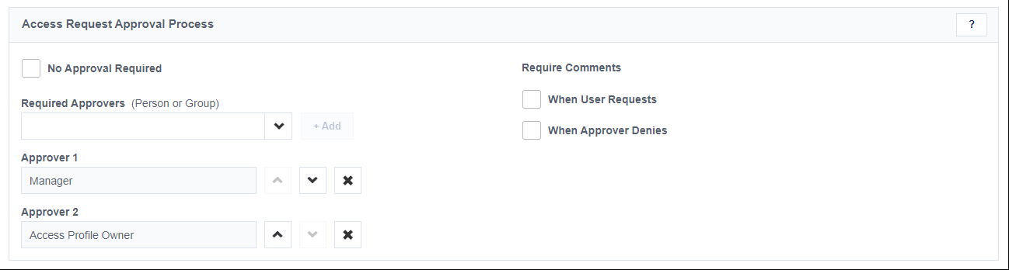

Figure 160: Access Profile Approval Process

### Certifications

1. See Access Review/Certification to open a certification campaign.
2. To set email configuration for search base campaign.
3. On the **Certification Campaign** page, select (put a checkmark) **Email Notification** to enable the feature. 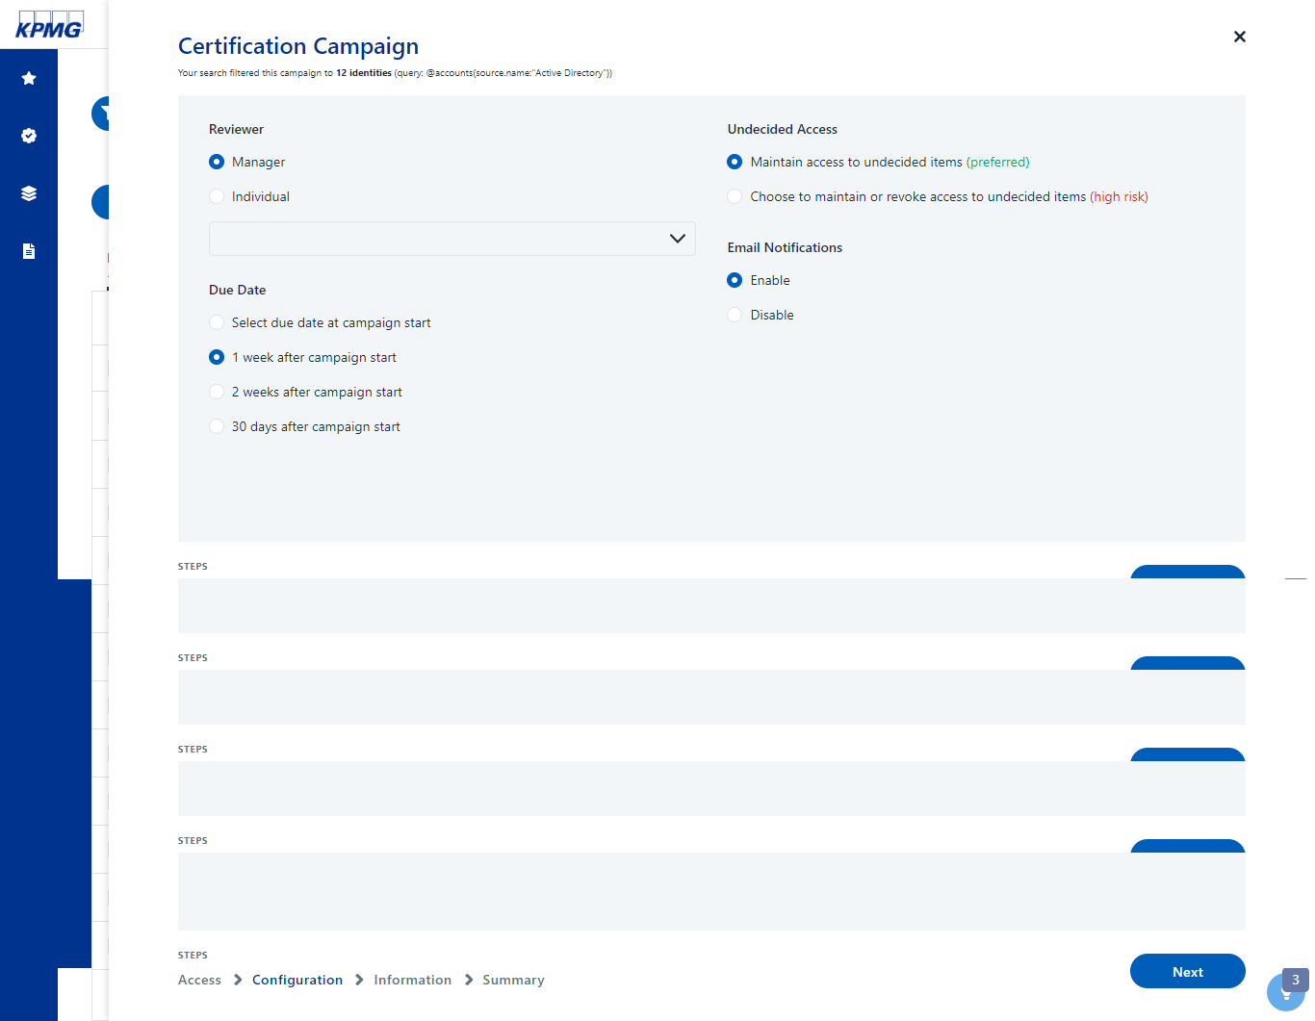

Figure 161: Configure Campaign

### User Life Cycle Events

1. Sign into IDN as an Admin.
2. Point to **Admin**, click **Identities**, then click I**dentity Profiles**

The **Identify Profiles** screen displays.

1. Select **HR Source Identity Profile** and click the **Provisioning** tab.
2. Select **Active** life cycle state.
3. In the **Email Notification List** section select (put a checkmark) **Manager**.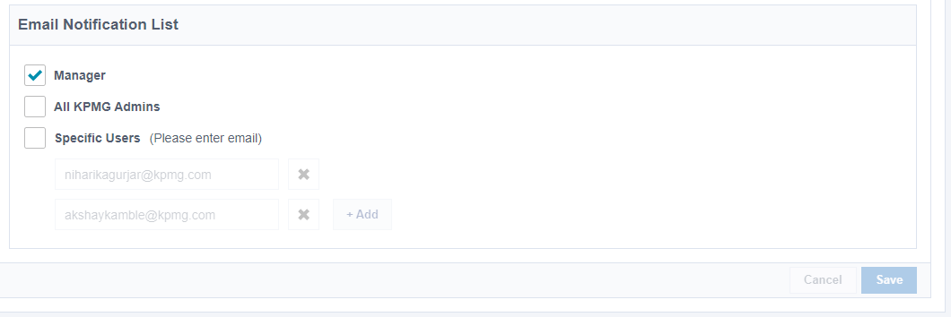

Figure 162: Configure Email Notification List

1. Click the **Save** button.
2. Repeat step 3 to step 5 for **loa** and **termination.**

## Capabilities/User Permission

This section is a configuration overview of various user permissions that can be defined for users in IDN.

Complete the following steps:

1. From the Admin interface and point to **Admin**, click **Identities**, then click **Identity List.**

The **Identity List** screen displays.

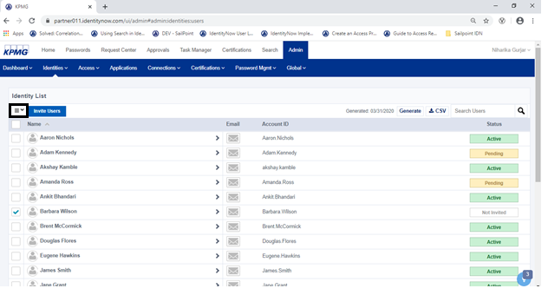

Figure 163: Select Identity

1. Click an identity to grant/revoke access to or select the check box to the left of multiple identities to assign them all the same user level at one time.
2. Click the **Permissions** action drop-down menu and select **Grant <user level>** for the specific user level wants to grant. Select **Remove <user level>** to revoke permission.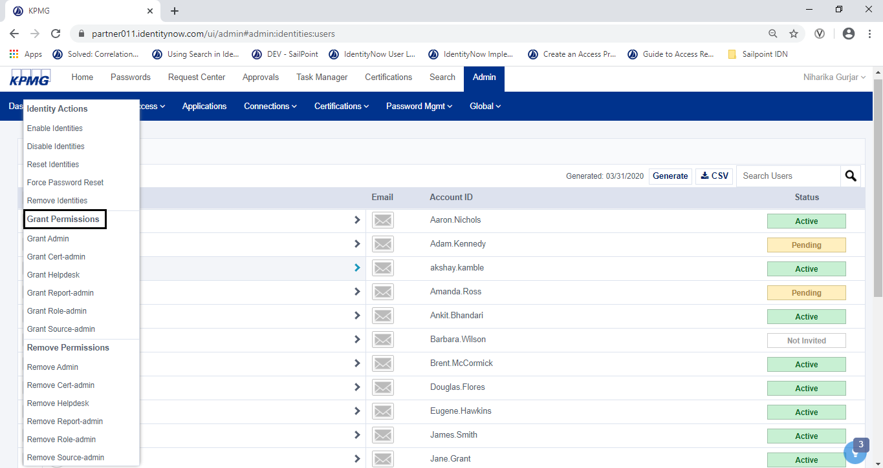

Figure 164: Permissions

1. Notify the user that their user level has changed and instruct them to log out and log back in to IDN for the changes to take effect.

# Limitations

## Manage Service Account

* IDN does not provide a feature to mark an account as a Service Account. Although the accounts can be configured to make it work like a Service Account (E.g. Granting User with Admin rights)

## Target Update

* IDN does not provide an out of the box feature to update identity attribute in target system.
* However, we can use IDN APIs to configure this case.
* There are some update profile and create/update transformation API provide by IDN, we can use this APIs for configuration.

## Task & Report scheduling

* IDN do not have API support for task scheduling and report scheduling.
* IDN provide API to do aggregation of source. Below Is the API detail.

*Method – POST*

*API - https://< orgName>.identitynow.com/api/source/loadAccounts/<SourceID>*

* Below are some SailPoint community link for more details

<https://community.sailpoint.com/t5/IdentityNow-Forum/Aggregation-scheduling/m-p/89962>

<https://community.sailpoint.com/t5/IdentityNow-Forum/IDN-Report-All-Source-Aggregation-Schedule-frequency/m-p/3687>

## Process Mover Event

### Requirement

Configure IDN system in such a way that, if user’s department change then the certification will lunch to certify user’s access.

### Limitation

Out of the box IDN does not provide workflowor feature like custom task to configure a flow where we can trigger a certification for user on user’s Departmentor any other attributechange.

## Update Application/Access Profile Owner

### Requirement

If user is terminated from the system and that user is an owner of application or access profile, IDN should automatically set a new owner to access profile or application.

### Limitation

Out of the box IDN does not provide a way to define a **custom task** to update the application or access profile owner so we need to perform this activity manually.

# Appendix

## Virtual Appliance Debugging

In virtual appliance cluster configurations, the **Enable Debugging** check box has been added that allows users to tail the logs on the virtual appliance: For example:

*tail -f /home/sailpoint/log/ccg.log*

Enabling debugging will give you visibility into all the virtual appliances on the cluster if you need to troubleshoot issues related to source connectors.

* By default, debug mode times out after 24 hours.
* In addition, IDN support the following commands:

*sudo reboot*

*ldapsearch*

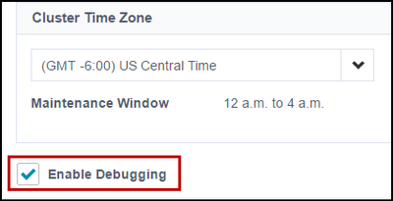

Figure 165: Enable Debugging

### Log Files on the VA

Use *journalctl* to view the following log files on the VA:

|  |  |
| --- | --- |
| ****Log File**** | ****Description**** |
| /home/sailpoint/log/ccg.log | Contains all details involving a source connector (connection, aggregation, authentication, provisioning, etc). |
| /home/sailpoint/log/va_agent.log | Contains details about the virtual appliance agent, which handles communication between the virtual appliance and IdentityNow. |
| /home/sailpoint/log/fluent.log | Contains details about the logging aggregator services on the virtual appliance. |
| /home/sailpoint/log/charon.log | Contains details about the virtual appliance master service, which runs all other services. |
| /home/sailpoint/log/canal.log | Contains details about the [Secure Tunnel](https://community.sailpoint.com/docs/DOC-8840) service on the virtual appliance. |
| /home/sailpoint/log/relay.log | Contains details about the IdentityNow proxy relay for [Password Interceptor​](https://community.sailpoint.com/t5/Connectors/Configuring-Sources-and-Virtual-Appliances-to-Support-the/ta-p/76693). |

Table 30: Log Files on VA

### VA and Source Configuration Status Definitions

#### VA Clusters

VA Clusters status:

* **Connected** – All virtual appliances are operating as expected.
* **Configuring** – At least one of the cluster’s virtual appliances is in the configuring state.
* **Warning** – At least one of the cluster’s virtual appliances is in the Warning state, has a configuration warning, or has failed.

**NOTE**: The Limited Resources alert indicates that you need at least two virtual appliances in the cluster for it to operate effectively.

* **Failed** – All of the cluster’s clients are in the Failed state.

#### VAs

When creating virtual appliances, you can click Test Appliance to verify that the configuration was successful. You can also see the state of a virtual appliance by clicking on the cluster it belongs to. In this case, you might see any of the following status messages:

* **Warning** – There was a configuration error of some kind but the VA may still be able to process requests
* **Failed** – The VA reported back as healthy at one time but has not been heard from in more than 5 minutes
* **Connected** – Everything is working as expected
* **Not Configured** – One might see this status if the key passphrase, API Username or API key are incorrect in the config.yaml file

#### Source Configuration

When you click Test Connection after on a source's Configuration panel, you might see any of the following status messages:

**NOTE**: You might also see these messages when reviewing the list of virtual appliances on a cluster.

* **Connected** – The Virtual Appliance can communicate with the source.
* **Unknown** – The state of the virtual appliance cluster is undefined.
* **Connection Failed** – The virtual appliance cluster is not connected to SailPoint. This might be caused by an incorrect key passphrase in the config.yaml file.
* **Cluster Configuring** – The source's connection test failed which may or may not have been a result of the cluster configuring. Generally it means be sure the cluster is healthy and try again.
* **Cluster Failed** – The source's connection was successfully tested and the test failed. This indicates that the virtual appliance cluster is not the issue and that the source configuration likely has an issue.
* **Timed Out** – This indicates that the test has waited more than 15 seconds to complete and has not received a response. It usually means the AD server is unreachable for some reason.
* **Cluster Warning** – This could indicate a number of things from having only one virtual appliance in the cluster to having one of the clients report a configuration error.

### Reference Link

Virtual Appliance Troubleshooting Guide- <https://community.sailpoint.com/t5/Connectors/Virtual-Appliance-Troubleshooting-Guide/ta-p/78735>

|  |  |
| --- | --- |
| **Contact us**  **Bhandari, Ankit**  Specialist Dir, Advisory, Cyber Security  +1 469 996 0582  [ankitbhandari1@XYZ.com](mailto:ankitbhandari1@KPMG.com)  **Hatjiyannis, Michael**  Director, Advisory, Cyber Security  +1 303 382 7166  mhatjiyannis@XYZ.Com  **Jason Wilson**  Technical Writer, Advisory, Cyber Security  +1 214 207 9345  jasonwilson3@XYZ.com  www.XYZ.com | |
|  |  | |
| **kpmg.com/socialmedia**  **kpmg.com/socialmedia**  **kpmg.com/app** | | | |
| © 2018 XYZ LLP, a Delaware limited liability partnership and the U.S. member firm of the XYZ network of independent member firms affiliated with XYZ International Cooperative (“XYZ International”), a Swiss entity. All rights reserved. Printed in the U.S.A. NDPPS 810225  The XYZ name and logo are registered trademarks or trademarks of XYZ International. | | | |
|  | | | |